SOMERSET INTEGRATED DIGITAL e-RECORD (SIDeR) PROGRAMME UPDATE
APRIL 2019
What is the aim of SIDeR?
The aim is to ensure that the right information is available at the right time to the right person. It is a clinically led, digitally enabled programme to improve health and care information sharing in Somerset for the purposes of direct care. Dr Justin Harrington, Chief Clinical Information Officer at Somerset CCG, has been the Clinical Lead for the SIDeR Programme from the start.

EMIS Viewer – the story so far
Since October 2016, GP records have been available to view by all clinical staff in Musgrove Park Hospital, Yeovil District Hospital, Somerset Partnership, NHS 111 and Out of Hours, Shepton Mallet Treatment Centre and St Margaret’s Hospice via EMIS Viewer. This was the first step to improved information sharing and there have been many benefits identified and associated, together with lots of positive feedback from staff and patients. EMIS Viewer has been accessed over 65,000 times. Somerset County Council clinical staff will also have access to EMIS Viewer shortly and it is being rolled out to a number of community pharmacies.

EMIS Viewer provides real time access to GP information on Somerset patients. Recent enhancements to EMIS Viewer include publishing GP notes (referred to as free text) and the patient consent process has been removed to bring the system in line with GDPR 2018.
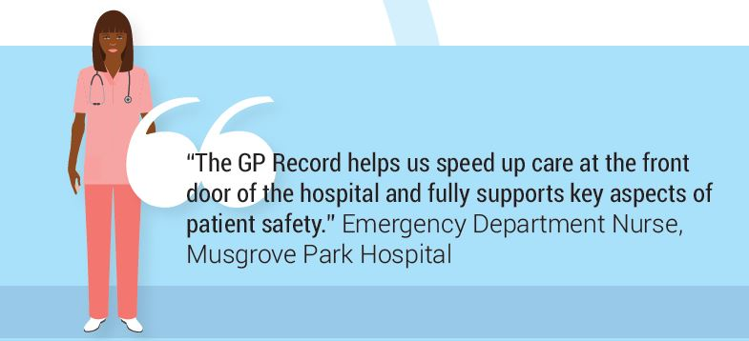

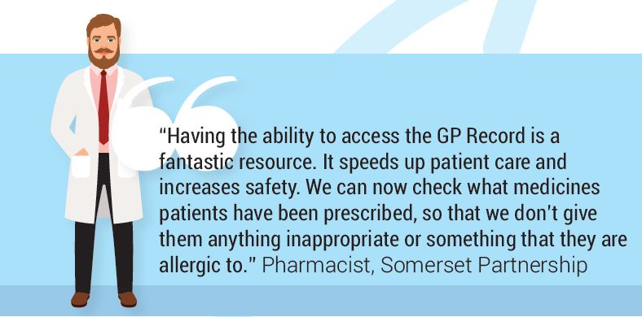

Electronic Palliative and Care Coordination System (EPaCCS)
In response to feedback and requests from GPs, the first official SIDeR service will deliver a more effective, improved way to create and share records for people with life limiting conditions and for people who are at the end of their life.

The new EPaCCS process delivered by our SIDeR technology partner, Black Pear Software Ltd, will record and make available people’s clinical information and their end of life wishes to those delivering care. It will also support appropriate treatment decisions to be recorded and shared to help more people to experience a “good death” (i.e. in the place that they wish to be and with the appropriate level of care and support).

From April 2019, all Somerset GP Practices, St Margaret’s Hospice, Dorothy House Hospice, District Nurses, NHS 111 and GP Out of Hours, plus the End of Life Care Coordination Service, have access to this first SIDeR service.

Licences are also available to key staff in Musgrove and Yeovil Hospitals and Somerset Partnership.

What’s next?....The SIDeR Shared Care Record
From summer 2019, work will start to connect GP Practices, Taunton and Somerset Hospital, Yeovil District Hospital, Somerset Partnership Hospitals, Community & Mental Health Services, and Somerset County Council to SIDeR so that they can begin to view each other’s records.

The aim is for SIDeR to provide a ‘single sign on’ service using existing staff login details, removing the need for staff to have to separately login to SIDeR. There will a link to the SIDeR Shared Care Record from your organisation’s main electronic patient record system.
Examples of information that will be made available in SIDeR include: active medications, active allergies, active conditions, active care plans, clinical encounters, responsible clinical and social care contacts, home support details, next of kin, resuscitation status, communication needs and alerts.

Please contact jess.brown@nhs.net or Justin.harrington1@nhs.net (latter for clinical queries) if you want to know more about SIDeR or EPaCCS.
