EPaCCS Practice Implementation Bulletin

This bulletin is a step-by-step guide to the implementation of the SIDeR Electronic Palliative Care Co-ordination System (EPaCCS) that enables the recording and sharing of people’s care preference summaries and key details about their care at the end of life.

This bulletin is aimed primarily at the Practice Leads for EPaCCS but is also relevant to GPs, Nurse Practitioners, Practice Managers and all those concerned with supporting the collection of key palliative care information.

Please ensure it is circulated throughout the Practice.

The Purpose Of EPaCCS

EPaCCS, underpinned by an information set, is intended to improve the service provided to people approaching the end of life, their families, carers and the clinicians that look after them. Such systems record and make available people’s clinical information, preferences and wishes to those delivering care. This information, available 24 hours a day, facilitates co-ordination of care. It also supports appropriate treatment decisions to allow more people to experience a “good death”, in the place that they wish and with the appropriate level of support and intervention.
The current EPaCCS system is based on Adastra software from an IT company called OneAdvanced and has been in place since 2008. The process for creating or updating a new record relies on a user in the community logging in through a separate portal and entering all the details manually. By contrast the new system provided by Black Pear (the SIDeR Technology Partner), as part of the SIDeR (Somerset Integrated Digital e-Record) programme, integrates with EMIS. This offers advantages in that users do not need to put in user names and passwords, other than the very first time they use it and patient and Practice details are automatically pulled through from EMIS.
A new EPaCCS record can be created in as little as 60 seconds compared to approximately 15 minutes in Adastra. The new EPaCCS integrates with the Out Of Hours (OOH) service electronic records and will be available to clinicians at the Hospices as well as District Nurses. Future plans are to make this available to Acute Trusts too, as they currently do not use Adastra.

How Will EPaCCS Be Rolled Out Across Somerset?

EPaCCS will be gradually rolled out in phases across Somerset providers. The key steps to achieving this are as follows:

GP Practices – Practices are paramount, as they initiate the EPaCCS records for the vast majority of patients. EPaCCS offers a quick and structured way for clinicians to capture end of life information.
All key information is automatically coded back into the patient’s GP record alongside a PDF copy of the EPaCCS record, also visible in other provider settings via EMIS Viewer.

Community Services – will have access to the system. This will enable much more efficient joint up care for patients, plus patient wishes will be more effectively communicated between clinicians.

Devon Doctors – will have access to a summary of the patient’s EPaCCS record. This will ensure they can assist in line with the patient’s wishes to ensure more effective care. The EPaCCS summary is automatically populated from the EPaCCS record when a patient calls Devon Doctors. GP Practices will no longer have to log into Adastra to add this information.

Devon Doctors View – EPaCCS Summary
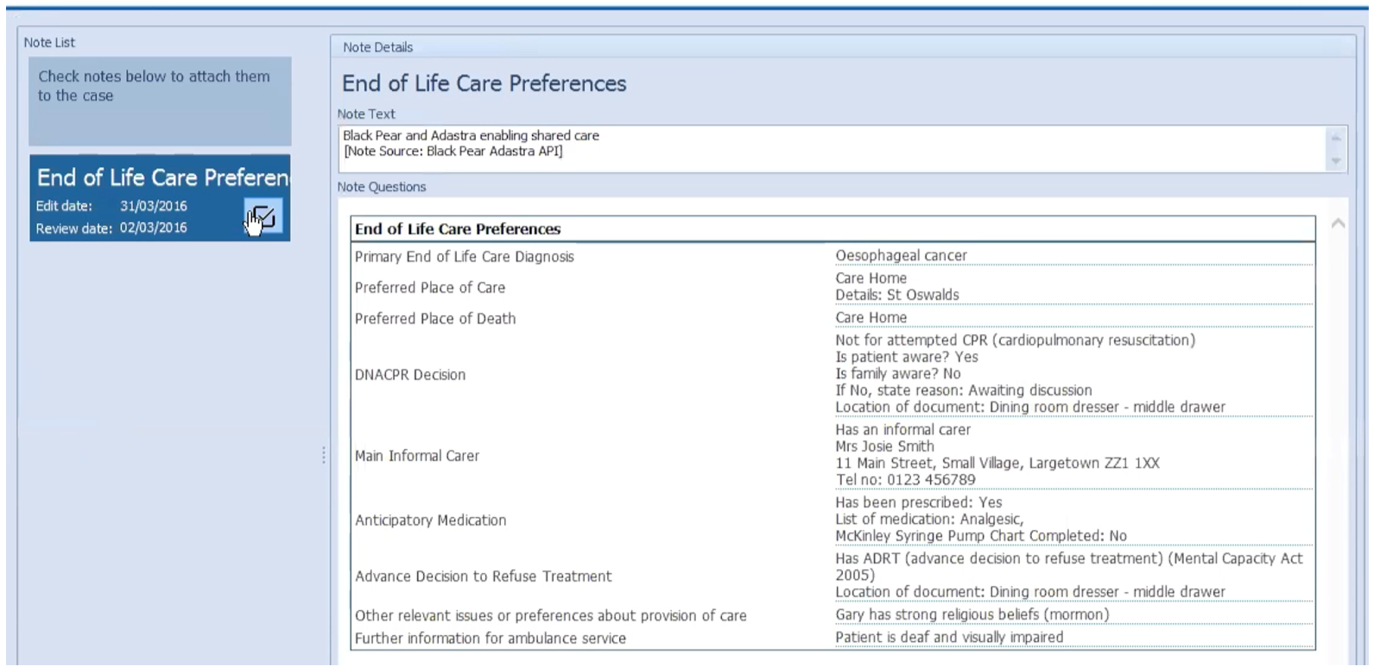

Guide to the Implementation of EPaCCS

Things To Do Before Starting To Use EPaCCS

By following these steps you will soon be ready to use EPaCCS.

Get prepared by undertaking EPaCCS IT Training (Section 2)

Each clinician and member of the administration team you want to use EPaCCS need to be licensed before they can use it (Section 3)

- All users will need their username and password to hand.

EPaCCS IT Training

EPaCCS is user friendly and intuitive to use but before you start we advise:

- that you watch a short video clip of how to create an EPaCCS, starting from a test patient’s EMIS record (this was created by Dr Justin Harrington, Chief Clinical Information Officer at Somerset CCG)
https://www.youtube.com/watch?v=cR0BCWnjHG4&t=93s

ii. you click on the link below, and read the Black Pear EPaCCS user guide

Black Pear Licensing

Black Pear authorise user requests and issue the licenses to allow each user to access, view and in most cases create / update EPaCCS.

All users must have an individual valid username and password before they can use EPaCCS. This should have already been provided to you as part of the preparatory work for EPaCCS go live in April 2019, but new accounts will be required for any new staff that join the Practice.

The Practice EPaCCS Administrator should email support@blackpear.com with:

SUBJECT: SIDeR EPaCCS + <Practice code> + <Practice name>
(e.g. EPaCCS L12345 Wood Surgery)

List each EPaCCS user including the following details:
1) Name (title, forenames, and surname)
2) Email address
3) Access Level (i.e. read/write or read-only)
(e.g. Dr Fred Bloggs, f.bloggs@nhs.net, read/write)

Users will be sent credentials (username and password) from Black Pear with instructions on how to change their password to one of their choosing
http://www.pyrusium.com/downloads/docs/changing_passwords.pdf

EMIS Web Practices

Once users have their credentials, EMIS Web users will be required to enter those credentials for the first login only. During this process the credentials will be linked to their EMIS Web login so that in future the credentials will be picked up from EMIS Web, mimicking a single sign-on process.

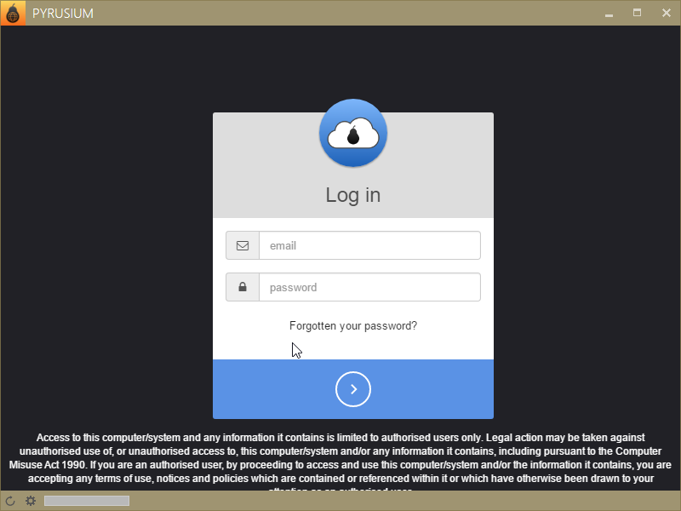

Once logged in, the user will see the Black Pear (Pyrusium) suite of Apps

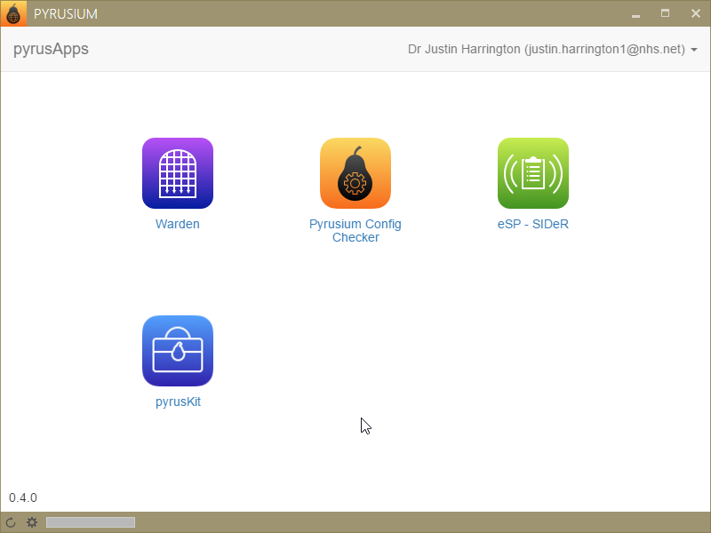

Clicking on the ”eSP-SIDeR” icon gives the following

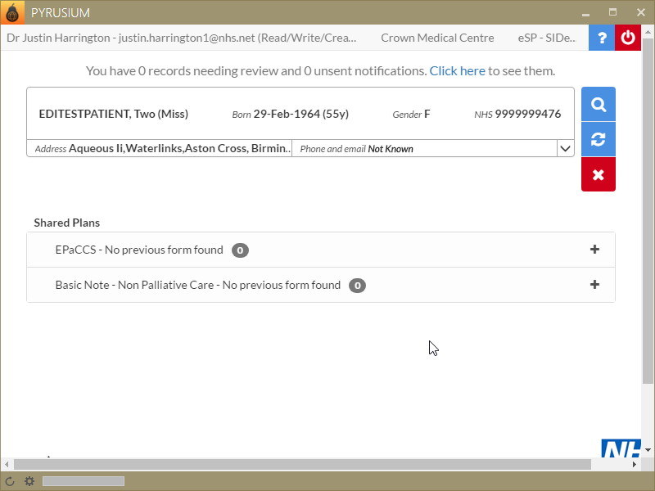

EPaCCS Helpdesk

In the first instance, users should call the Somerset GP IT support desk on 0300 101 0080

For second line support, the first line support team can email: support@blackpear.com or telephone: 0845 4506271

Please provide Practice details (ODS code, Practice name, contact and telephone number and email address) and describe the problem as fully as possible adding a screenshot if appropriate. You will contacted by email or telephone to deliver the resolution.

Clinical Safety Related Incidents

If a user experiences a clinical safety incident as a result of using EPaCCS please email: clinical.safety@blackpear.com In your email outline a detailed description of the incident and the clinical impact.

Frequently Asked Questions

This section outlines the most common questions asked regarding EPaCCS

What Is EPaCCS?

EPaCCS is an Electronic Palliative Care Co-ordination System (EPaCCS) that enables the recording and sharing of patient’s care preferences and key details about their care at the end of life. As it is electronic it can easily be shared between professionals involved in the patient’s care across provider and geographical boundaries.

Why Is An Electronic System Needed?
The electronic system supports effective end of life care planning as it enables assessment, pro-active identification of patients planning and decision making. Information is shared across health care boundaries and is available 24hrs a day.

How Does The Information Get Into EPaCCS?
Some of the data is automatically populated from that already stored in the patient’s GP record. Examples are patient demographics, GP Practice details, current repeat medications and diagnoses / problems. This both saves time and improves the accuracy of health information.

More data can be added when appropriate (e.g. focus of care, prognosis, advance care planning information, anticipatory medication details, main carer / care worker details). Data entry is easy and straightforward. The rationale being that EPaCCS information is built up over time.

What About Patient Confidentiality?
The record is not initiated until the patient has been informed. A data field records this has taken place.

Who Will Access EPaCCS?
An EPaCCS administrator in each provider / Practice is responsible for granting appropriate colleagues’ access. Permissions will allow either the creation / update of an EPaCCS record, or read-only access. They will use the Black Pear licensing tool, which controls access. In time this will include the following health care professionals:
- GPs, Nurse Practitioners, Practice Nurses and Admin Support
- Community and District Nurses
- Palliative Care Teams
- Hospice Doctors and Nurses
- Acute, Community and Mental Health Clinicians
- Devon Doctors will automatically see a summary of each EPaCCS record

Does EPaCCS Link To EMIS Web?
Yes. As soon as you are licensed to use EPaCCS and the Pyrusium software has been installed on your workstation, it will connect to EMIS. First, log on to EMIS Web, find the patient you wish to record information about, click on the Pyrusium icon in your ‘start’ menu and choose the ‘SIDeR EPaCCS’ icon. The service is intuitive and easy to use.

I Don’t Have Pyrusium On My Workstation. What Should I Do?

Please contact the SCW CSU support desk and provide details of your workstation asset number etc and they will ensure Pyrusium is loaded shortly afterwards.

I Am A GP: Do I Have To Fill Out Everything In The EPaCCS End Of Life Plan?
No, it is expected that the GP will initiate the plan and complete the three mandatory fields (e.g. informing the patient that the EPaCCS will be shared, the patient’s primary end of life diagnoses and the CPR decision). Other providers will also contribute to the EPaCCS plan over time (e.g. community teams, hospices etc). The GP Practice will be notified of any updates to the plan and a new version of the EPaCCS will write back into the patient’s EMIS record.

