Carers flu vaccination
toolkit
Contents

1 Acknowledgement & Contact Details 1
1.1 Acknowledgement 1
1.2 Contact Details 1
2 Introduction 2
2.1 The seasonal flu vaccination programme 2
2.2 Purpose of this toolkit & who is it for? 2
3 Promotional Resources 4
3.1 Carers flu vaccination A6 postcard 4
3.2 A video about Rosie – a carer’s case study 5
4 Communication templates and resources 6
4.1 Social media messages 6
4.1.1 Tweets aimed at all carers 6
4.1.2 Tweets aimed at young carers who are students 7
4.2 Press release templates 8
4.3 Newsletter content 10
4.4 Website content 11
5 Facts & Myths 12
5.1 Flu Fact Sheet 12
5.2 Myth Busters 14
6 Pharmaceutical Services Negotiating Committee (PSNC) Resources 17

Acknowledgement & Contact Details

Acknowledgement

Thanks to all the members of the Bath and North East Somerset, Swindon and Wiltshire Sustainability and Transformation Partnership (STP), Flu Steering Group, who have helped to produce this toolkit.

Contact Details

For any further information please contact:
Becky Reynolds,
Chair of the STP Flu Steering Group & Consultant in Public Health,
Bath & North East Somerset Council
Public Health Department
St Martin’s Hospital
Bath
BA2 5RP
E. public_health@bathnes.gov.uk

Introduction

The seasonal flu vaccination programme

Flu vaccination is available every year, free on the NHS, to help protect adults and children at risk of flu and its complications. The best time to have a flu vaccine is in the autumn, from the beginning of October to end of November before the flu season starts (December to March).
Flu can be unpleasant, but if you are otherwise healthy it will usually clear up on its own within a week.
The flu vaccine is routinely given on the NHS to:
- adults 65 and over
- people with certain medical conditions (including children in at-risk groups from 6 months of age)
- unpaid carers
- pregnant women
- children aged 2 and 3 (nasal spray)
- children in reception class and school years 1, 2, 3, 4 and 5 (nasal spray)

Purpose of this toolkit & who is it for?

This aim of this toolkit is to bring together all the information and resources available to encourage unpaid carers to have the flu vaccination.
As most people do not identify themselves as carers, as “they just look after mum” or “help gran around the house”, the definition of a carer we are using is ‘anyone who identifies themselves as looking after someone that couldn’t manage without that persons help if they got ill’.
Eligible carers also include those who are in receipt of a carers allowance and young carers (there are no age restrictions).
This toolkit is for use by any professional or persons who will have contact with carers. The information provided will help enable professionals/persons to advise carers or the person they care for that they are eligible for a free NHS flu vaccination and why it’s recommended that they have it.
In chapter 2 of this pack you will find promotional resources that you can use to raise awareness about carers eligibility for the flu vaccine. Chapter 3 contains a variety of resources and communications templates such as; newsletter and website material, press release templates and example tweets. Chapter 4 addresses facts and myths to aid conversations about the flu vaccine and to help answer any questions. Finally, the last chapter is a dedicated section to help staff working in pharmacies to encourage carers to have the vaccination.
This pack can be used by a wide variety of professionals and persons for example:
- GP Practice staff e.g. GPs, practice nurses, health care workers, receptionists
- Clinical Commissioning Groups
- Local authorities
- Frontline health and social care staff e.g. district nurses, occupational therapists, health visitors
- Pharmacies
- Avon & Wiltshire Mental Health Partnership
- Acute Trusts e.g. clinicians & health care workers
- Sustainability & Transformation Partnerships (STP)
- Voluntary Sector e.g. Carer’s Centres, Age UK & Alzheimer’s Support
- Therapy centres
- Schools – focusing on young carers
- Media; local magazines
- Parish Councils & faith groups
- Local Councillors and local MP
- Healthwatch
- Community venues e.g. libraries, leisure centres

Promotional Resources

Carers flu vaccination A6 postcard

This postcard has been designed to raise awareness amongst carers of their eligibility to have the free NHS flu vaccination. Examples of where and when this postcard can be used include:
- By frontline health and social care professionals when they meet a carer through contact with their patients;
- On display in venues where carers visit for them to take away;
- In Carer Centre’s registration packs.
To obtain free hard copies of this A6 postcard please email your local Council’s Public Health Department:
- Bath & North East Somerset: public_health@bathnes.gov.uk
- Swindon: publichealth@swindon.gov.uk
- Wiltshire: publichealth@wiltshire.gov.uk
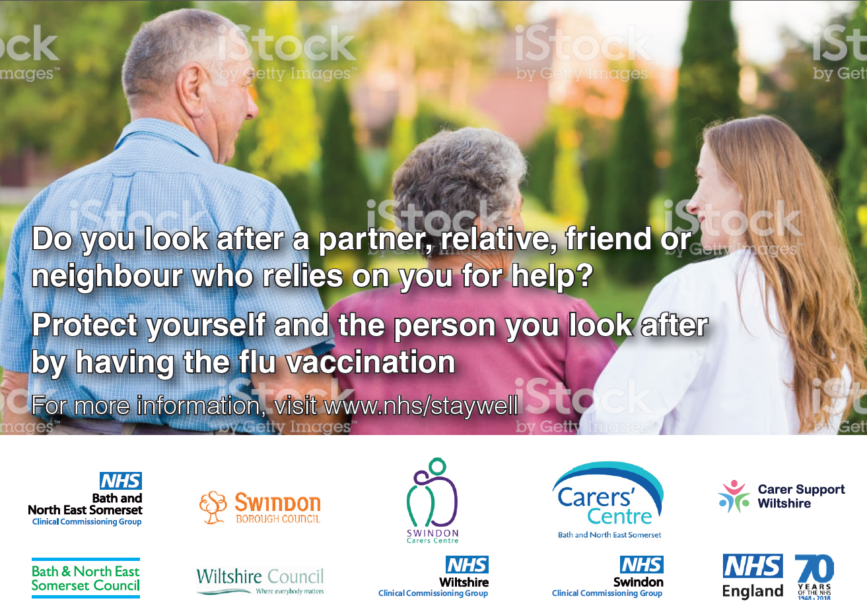
Front of postcard
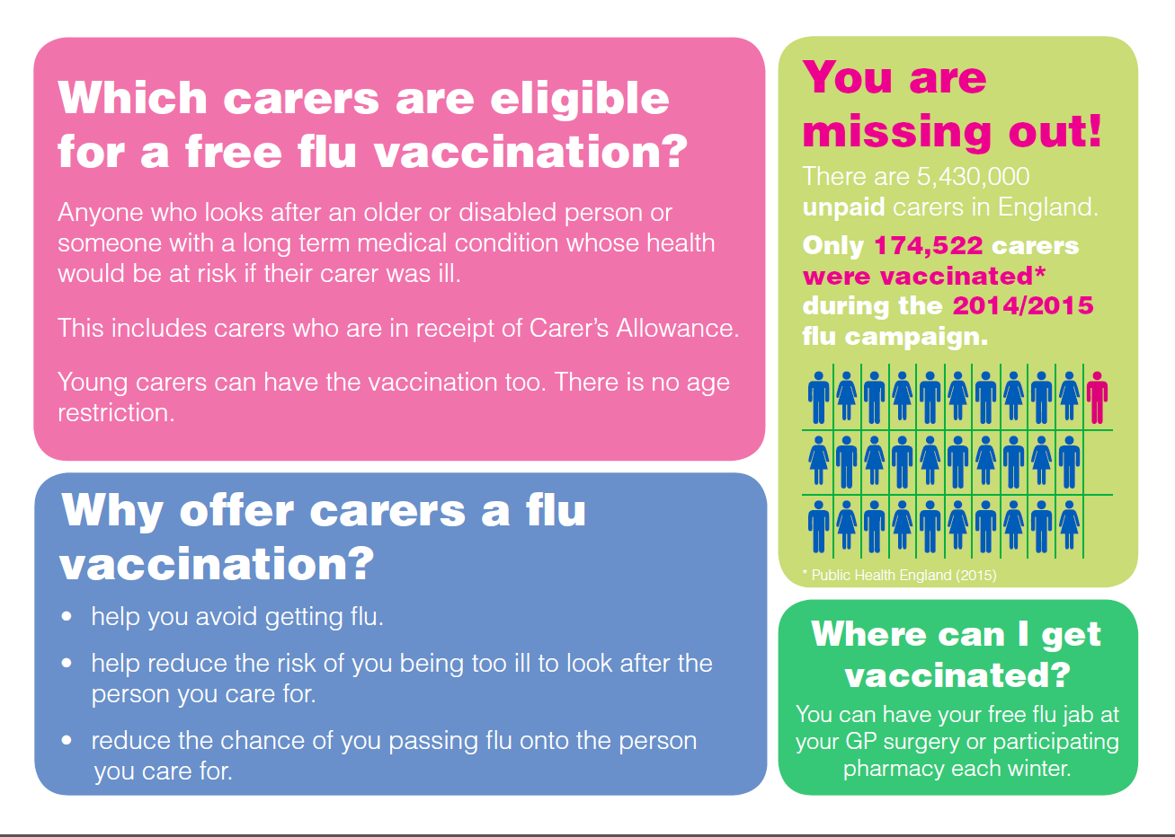
Back of postcard

A video about Rosie – a carer’s case study

This YouTube video is about Rosie, a carer, who has the flu vaccination to make sure she can always care for her husband.
The video can be used on social media or on TV screens in community and health and social care venues to promote the flu vaccination to carers.
Please find the video here: https://youtu.be/j8AEya5-kNA
There is also a shorter, more social media friendly version here: https://youtu.be/TMrY0le1Kdw

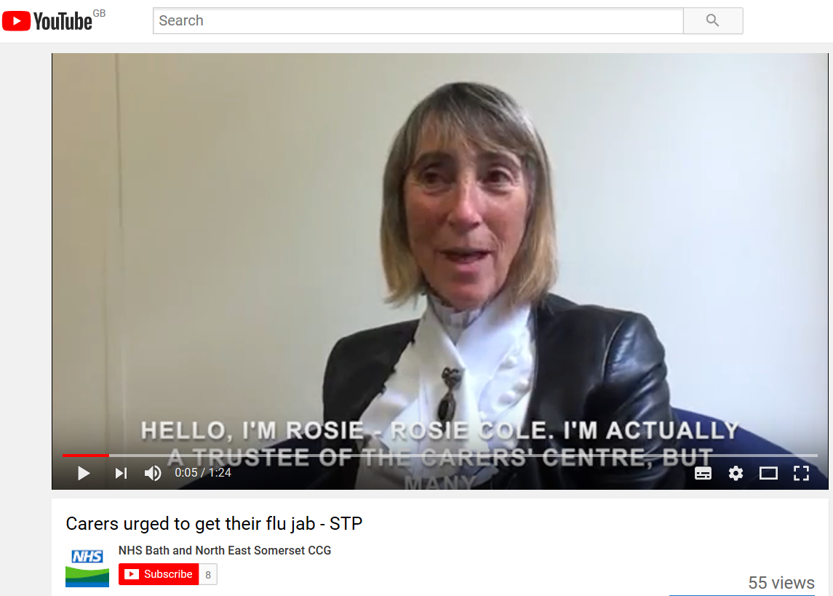

Communication templates and resources

Social media messages

Social media platforms can be used to promote the flu vaccination, as a key way to engage with a large audience. Below are a number of example tweets that can be used on social media profiles. It’s recommended to use these regularly between October and January.

Tweets aimed at all carers

If you're a carer, your flu jab is free! Don't keep delaying. Get the #flu jab now. #helpushelpyou
Look after someone who can’t get by without your help? Ask your GP or pharmacist about a free #flu jab and cut the risk of being too ill to care. #carersflujab
Look after someone who can’t get by without your help? Ask about a free #flu jab from your GP surgery or pharmacy. Ring them for details. #carersflujab
Do you care for someone with a learning disability? They will need to get a flu jab as they're at higher risk of serious #flu complications.
Carers are eligible to receive a free seasonal flu vaccine each year, to reduce the risk of passing #flu on to the person they look after.
Find out why it's important for carers to take up the offer of a free #flu vaccine via @CarersUK http://ow.ly/mHrS3043yzY #helpushelpyou
If you care for an older or disabled person, then you need a free #flu jab. Contact your GP or pharmacist for more info. #helpushelpyou
Know someone who’s a family carer? Tell them they’re entitled to ask their GP or pharmacist for a free #flu jab to cut the risk of illness. #carersflujab
Unpaid carers save the country £119bn a yr yet many miss out on benefits. Contact your local carers centre for details. #carersflujab
Worry about how the person you look after would cope if you were ill? Ask your GP or pharmacist about a free #flu jab for your own peace of mind. #carersflujab
Is there an unpaid carer in your family? Make sure they ask for a free #fluvaccine from their GP practice this winter. #carersflujab

Tweets aimed at young carers who are students

Juggling school or college with looking after someone? Can’t risk getting #flu this winter? Tell your GP or pharmacist you’re a carer and ask for a free flu jab. #carersflujab
Got caring responsibilities plus exams to cope with? Don't take chances. Make sure you get a free flu jab from your GP or pharmacist. #carersflujab
Look after a sick or disabled relative? Exams coming up & can’t afford to be ill? Cut your risk of getting ill with a free flu jab from your GP or pharmacist. #carersflujab
Flu jab not just for ppl who are old, ill or disabled. Look after someone who can’t cope without your help? Ask your GP or pharmacist about a free flu jab for you. #helpushelpyou

Press release templates

Press releases can be used to promote the flu vaccination through local media; newspapers and radio etc. Below are two template press releases, they have a reference to Swindon but can be adapted for other areas.
Template 1:
A good time to think about staying well this winter
Carers in Swindon are being encouraged to book their free flu jab, as the annual NHS vaccination programme gets underway.
NHS Swindon CCG and Swindon Carers Centre want to encourage people who look after a friend or relative to stay well this winter. Susanna Jones, Chief Executive, Swindon Carers Centre said: “If you’re looking after someone who is ill, frail or disabled and you go down with flu or another bug, it’s not only unpleasant for you but it affects your ability to look after the person you’re caring for. Winter ailments can also have a more serious effect on people who are older, have a disability or an existing health condition.”
Paul Clark, Associate Director Medicines Optimisation, from NHS Swindon CCG says it’s a good idea to seek advice from your local pharmacist if you have any concerns: “If you’re looking after someone it’s important that you look after yourself too and take advantage of the fact that pharmacies are open extended hours and at weekends for advice that’s free and without the need for an appointment.”
The best time to have the flu jab is in the autumn – from the beginning of October to early November. You can read more about who is eligible for a free vaccination here. (www.nhs.uk/Conditions/vaccinations/Pages/flu-influenza-vaccine.aspx)
Here are some top tips for carers to stay well:
Get a flu jab – a number of pharmacies and all GP practices offer the flu jab, which is free if you’re 65 or over. Anyone who looks after an older or disabled person or someone with a long term medical condition whose health would be at risk if their carer was ill is also eligible.
If you’re 65 or over you may also be able to get a vaccine to protect you from pneumonia and other similar diseases. Just speak to your GP.
Visit your local pharmacist as soon you start to feel unwell; if you think you are going down with something, a cough or cold, don’t wait until it gets worse. Pharmacists can advise on the best course of action to help you recover more quickly, and advise on which medicines you should have in your cabinet to help you and the person you are looking after.

Template 2:
Carers encouraged to have a flu jab
NHS Swindon CCG and Swindon Carers Centre are calling on all carers to see if they are eligible for a flu jab.
Every winter, says Susanna Jones, Chief Executive, Swindon Carers Centre, the vast majority of unpaid carers miss out on a free flu jab, despite the fact that they are entitled to request one. If you receive a carer’s allowance or you look after somebody who would not be able to manage without your support if you fall ill, speak to your GP or pharmacist about getting vaccinated - along with the person you care for.”

Dr Peter Mack, Clinical Chair for NHS Swindon CCG and local GP, adds: “Outbreaks of flu also often occur in health and social care settings where people are in close contact with each other. I had my flu jab last week and it’s vital that you have this every year as the vaccine protects against different strains of flu.”

Flu is a common infectious viral illness spread by coughs and sneezes. It can be very unpleasant. It's not the same as the common cold and is caused by a different group of viruses. The symptoms tend to start more suddenly, be more severe and last longer.

For more information about flu jabs for carers, visit Carers UK at www.carersuk.org/ and for general information around staying well this winter, visit: http://www.nhs.uk/staywell/

Newsletter content

If your organisation produces a newsletter, here is a template you can use to promote the flu vaccination to carers.
Free flu jabs for carers
As we move in to autumn, we are keen to remind everyone that carers are entitled to a free flu jab.
Flu is an unpredictable virus that can cause mild or unpleasant illness in most people. However, it can cause severe illness among vulnerable groups.
The seasonal flu vaccine is the best way to protect yourself and the person you care for from the virus.
If you are looking after someone with an illness or disability, you may be concerned about how being ill will affect you and the person you care for. If you look after somebody who would not be able to manage without your support if you fall ill, you should be offered a free flu jab.
Other groups of people also eligible for a free flu jab include those aged over 65, those who are pregnant, and those with certain health conditions.
To arrange for a free flu jab, just ask your GP practice or pharmacy.
If you are a carer and want more information about the free flu jab, contact :{insert details of local carers centre}.

Website content

This information can be put on organisation’s websites to promote the flu vaccination to carers.

If you’re a carer, you need the flu jab
As a carer for someone else, it can be easy to overlook your own health. Flu can knock even the healthiest people off their feet for a couple of weeks, making it impossible for a carer to look after the person in their care. This is why the NHS offers a free flu vaccination for those either in receipt of a carer’s allowance and/or look after someone who is elderly, disabled, or somebody who lives with a serious long term condition who couldn’t manage without their help.
It’s not just about protecting you as a carer from getting flu, but also preventing you from passing the virus onto the vulnerable person you care for.
Flu is a highly infectious disease which is easily spread from one person to another. Getting flu when you already have a long-term condition can lead to serious complications, and it can even be a killer.
For those who already have a long term health condition, are pregnant or are over 65, it can be even more dangerous as your body will struggle more to fight off the illness and you are more at risk of complications such as bronchitis or pneumonia. Children are also more at risk.
There are a lot of myths about flu that have circulated over the years. Many people worry that the vaccine can give you the flu. Please be assured that this isn’t possible as there is no live influenza virus in the vaccine.
Unlike other medication for long term conditions, the flu jab is an annual vaccination. The flu vaccine changes every year to fight the latest strains of flu, so even if you had a jab last winter you need another one this year to stay flu safe. Please contact your GP or local pharmacist to enquire about a free flu jab.
Please take the time to look after yourself and have the flu jab if you are a carer.

Facts & Myths

Flu Fact Sheet

This flu fact sheet provides general information to help you in your conversations with carers about flu vaccination. If a carer has questions that need the input of a health care professional, please advise them to contact a pharmacist or their GP.
_________________________________________________________________________________
Flu Fact Sheet
1. Introduction
Flu vaccination is available every year on the NHS to help protect adults and children at risk of flu and its complications.
Flu can be unpleasant, but if you are otherwise healthy it will usually clear up on its own within a week.
However, flu can be more severe in certain people, such as:
- anyone aged 65 and over
- pregnant women
- children and adults with an underlying health condition (such as long-term heart or respiratory disease)
- children and adults with weakened immune systems
Anyone in these risk groups is more likely to develop potentially serious complications of flu, such as pneumonia (a lung infection), so it's recommended that they have a flu vaccine every year to protect them.
2. Who is eligible?
If you look after a friend or relative who can’t get by without your help, you will be eligible for the flu vaccine for FREE.

3. When to have the flu vaccine?
The best time to have a flu vaccine is in the autumn, from the beginning of October, but don't worry if you've missed it then, you can have the vaccine later in winter. Ask your GP or pharmacist.
4. Where can I get vaccinated?
You can have your free flu jab at your GP surgery or participating pharmacy from October each year. Ask your GP when they are running clinics or your local pharmacy if they are offering this service.
5. Who should seek advice before having the jab?
If you have had a previous allergic reaction to a flu vaccination or you have a hen’s egg allergy you should seek advice before having the flu jab.
6. What side effects may I experience?
After the flu jab you may get a mild fever and slight muscle aches for a day or so.
If you have a sore arm after the vaccination, try these tips to ease the discomfort:
- continue to move your arm regularly – don't let it get stiff and sore
- take a painkiller, such as paracetamol or ibuprofen – pregnant women shouldn't take ibuprofen unless a doctor recommends and prescribes it
- do not give aspirin to children under 16
Serious allergic reactions (anaphylaxis) to flu vaccines are very rare. Healthcare staff giving vaccinations are fully trained to deal with anaphylaxis and, with prompt treatment, individuals make a quick and complete recovery.
Contact a pharmacist or your GP if you experience severe side effects that are not improving over time.
7. Who is entitled to a nasal spray vaccination?
- Children aged 2 and 3 on August 31 2018 – that is, children born between September 1 2014 and August 31 2016
- Children in reception class and school years 1, 2, 3, 4 and 5
- Children aged two to 17 years with certain long-term health conditions

Myth Busters

There are many myths surrounding flu and the flu vaccine. Here are the most common flu myths and the truths behind them. If a carer has further questions you could ask the carer to discuss these with their local pharmacy or GP.
1. ‘Flu isn’t a serious illness, people don’t die of flu, flu is just a bad cold’
A bad bout of flu is much worse than a heavy cold.
For the majority of people who catch it, flu is unpleasant but not life-threatening. Flu symptoms come on suddenly and sometimes severely. They include fever, chills, headaches and aching muscles, as well as coughs and a sore throat. You’re likely to spend two or three days in bed.
However, for some people, it can lead to chest infections, severe complications and even death. Flu spreads very easily.
2. ‘The flu vaccine gives me flu’
It’s impossible to get flu from having the flu vaccine because the vaccine doesn’t contain live viruses. A very small number of people experience side effects.
For the most part, flu vaccine side effects are mild. The most common side effect is soreness around the site of the injection and, occasionally, aching muscles. These symptoms are a lot less serious than flu symptoms.
3. ‘The flu vaccine doesn’t work’
The World Health Organization says that clean water and vaccination are the two interventions that have the greatest impact on public health – vaccination works. Flu vaccination is the best protection we have against an unpredictable virus that can cause unpleasant illness in children and severe illness and death among at-risk groups, including older people, pregnant women and those with an underlying medical health condition. Flu vaccines generally give 60–80 per cent protection against infection.
Flu is unpredictable and over time, protection from the injected flu vaccine gradually decreases and flu strains often change. So new flu vaccines are produced each year which is why people advised to have the flu jab need it every year too. It is not possible to fully predict the strains that will circulate each year, and there is always a risk of change in the virus as was seen in 2014/15. However, this does not happen very often. The vaccine still provides the best protection we have against an unpredictable virus that can cause severe illness.
4. ‘The flu vaccine isn’t safe’
The vaccine is one of the safest in the world; the risk of having a serious (anaphylactic) reaction to the flu vaccine is less than one in a million, much lower than the risk of getting seriously ill from actually catching flu. If you have had a serious allergic reaction (anaphylaxis) to a flu vaccine before, please talk to a clinician before getting vaccinated. If you have a serious allergic reaction (anaphylaxis) to hens’ eggs, you should ask about vaccines with a very low egg content and be vaccinated under clinical supervision.
Seasonal flu vaccine is given to millions of people in the UK each year. The specific strains of flu that are included may change from one year to the next, but vaccines are still thoroughly tested and are safe.
5. ‘I only need to have the flu vaccine once in my lifetime as it protects me for life’ / ‘I’ve already had flu this year so I don’t need a vaccination’ / ‘ All health professionals do not need flu vaccination as they build up a resistance to it’
There’s no such thing as natural immunity to flu.
As flu is caused by several viruses that can change each year, you will only be protected by the immunity you developed naturally against one of them. You could go on to catch another strain, so it’s recommended you have the jab even if you’ve recently had flu and that you have the vaccine every year so that it matches the new virus strain.
6. ‘If you haven’t been vaccinated by November, it’s too late’ / ‘The flu vaccine provides immediate protection against the flu’
It’s not too late and it may take 10-14 days for your immunity to build up fully after you have had a flu vaccination.
It’s better to have the flu vaccine as soon as it becomes available, usually in October, but it’s always worth getting vaccinated before flu comes around right up until March.
7. ‘I feel fine so I don’t have flu and people can only spread the flu when they are showing symptoms such as sneezing or feeling unwell.’
Not everyone who catches the flu is ill. Some people have no symptoms at all but can still pass the virus on.
Vaccination isn’t just about keeping yourself safe, it’s also about protecting your family, your friends, neighbours, and people you work or volunteer with. You can carry and pass the virus on to others without having any symptoms yourself so, even if you consider yourself healthy, you may be risking the lives of others.
8. ‘The flu vaccine cannot be given to pregnant women’
Pregnant women can have the flu vaccination at any stage of their pregnancy. There is good evidence that pregnant women have a higher chance of developing complications if they get flu, particularly in the later stages of pregnancy. Women who have had the flu vaccine while pregnant also pass some protection on to their babies, which lasts for the first few months of their lives.
9. ‘Washing my hands does not stops me spreading the flu virus’
It’s vital to follow universal infection prevention procedures and wash your hands regularly. Although, once flu has been passed on to your family, colleagues or your patients, clean hands won’t keep flu at bay.
10. ‘Flu can be treated with antibiotics and antivirals are replacing the flu vaccine’
Flu can’t be treated with antibiotics. Antibiotics only work against bacteria, and flu is caused by viruses. A bacterial infection may occur as a result of having flu, in which case you may be given antibiotics.
You may be prescribed antiviral medicine to treat your flu. Antivirals do not cure flu, but they can make you less infectious to others and reduce the length of time you may be ill. To be effective, antivirals have to be given within a day or two of your symptoms appearing.
11. ‘A healthy diet and vitamin C can prevent flu’
Your diet could help to boost your immune system, but eating well will not protect you from flu. Many people think that taking daily vitamin C supplements will stop them getting flu, but there’s no evidence to prove this.

Source: NHS Choices website

Pharmaceutical Services Negotiating Committee (PSNC) Resources

PSNC has worked with the Carers Trust to produce resources to assist pharmacy teams in identifying carers who may be eligible for a flu vaccination. The resources can be found here:
https://psnc.org.uk/services-commissioning/advanced-services/flu-vaccination-service/identifying-carers-eligible-for-a-flu-vaccination/
The resources include:
- a flu vaccination poster – this poster is specifically aimed at carers
- the 60-second pharmacy flu chat – this suggests how you can engage someone you think might be a carer in a quick conversation about why they should consider getting vaccinated
- a small double-sided carer flu flyer which can be attached to prescription bags. This can be used as a conversation starter to encourage carers to have a flu vaccination
2.
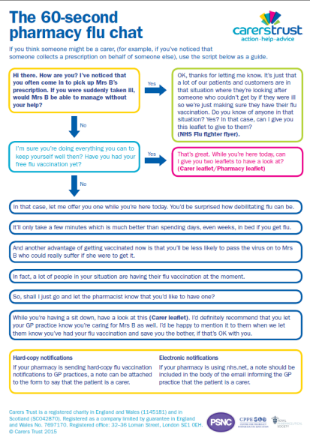
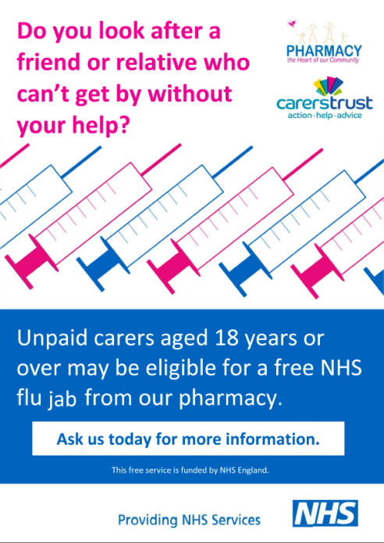
1.

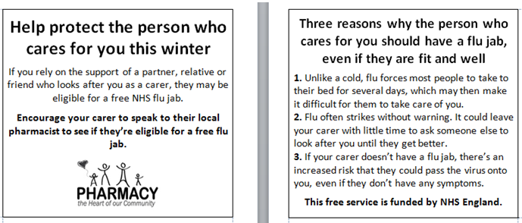
3.

