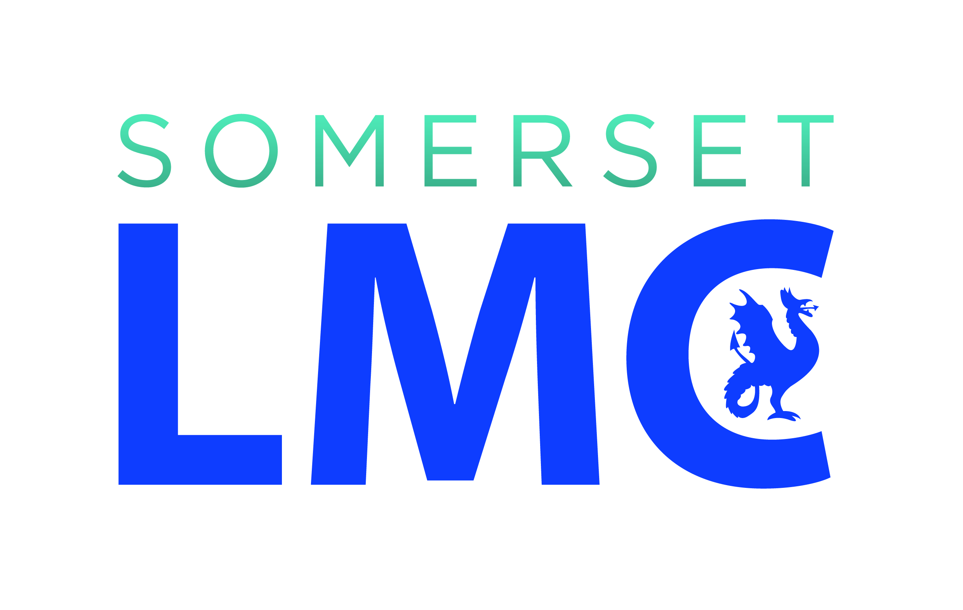

[Care Home Address]

[Practice Address]

[Date]

Dear Colleague,

NON-PRESCRIPTION ITEMS AND OVER-THE-COUNTER ITEMS IN CARE HOMES

We are writing to you about the provision of non-prescription (over-the counter) medications which do not require a GP’s signature or authorisation.

We would like to remind you about NICE guidance Managing medicines in care homes (Social care guidelines [SC1] March 2014. This says, “Non-prescription medicines and over-the-counter products are known as homely remedies. These can be bought without a prescription from a pharmacy or supermarket (examples include mild pain killers and cough medicines). People in care homes may be offered homely remedies for treating minor ailments…”

There is no requirement for GPs to prescribe medication which can be obtained without a prescription solely so that it can be administered in a care home. Doing so is not only a waste of everyone’s time but also a waste of NHS resources. Somerset CCG, in its paper “Prescribing of medicines for minor ailments more suitable for self-care” (2016) said that implementing the policy could save £1 million a year in the county. Successive governments have supported the move towards self-care by moving a number of medicines from prescription only status to pharmacy sale and then to over-the-counter.

We hope that referring to the NICE guidelines and CCG policy will give you and your staff more confidences in administering and recording over-the-counter medicines without contacting the practice.

Please direct any individual response to this letter to the GP practice.

Yours faithfully,

