Appraisal Toolkit for Practice Managers
We have worked with Fourteen Fish to update their Practice Manager Appraisal Toolkit in line with how our PM Supporters run the peer appraisals for PMs.
There is no obligation at all to use it, but you might find it helpful to keep all your info electronically. There is a charge for using this toolkit ( currently £42 which is charged only when you have completed the toolkit and are ready to send to your appraiser)
You need to be registered with FourteenFish to access this toolkit.
Log in and then go to www.fourteenfish.com/appraisals and start a new appraisal

You then get to this page to start on the appraisal. If you have set up your details correctly, you will have access to the Practice Manager appraisal. You need to change your account details on fourteen fish if you have not set your role as a PM. Press ‘continue’ .

You then need to set the dates for your appraisal:
You then get to the dashboard – which is a very busy screen, but, once you get used to it, a very useful summary of all your appraisal info
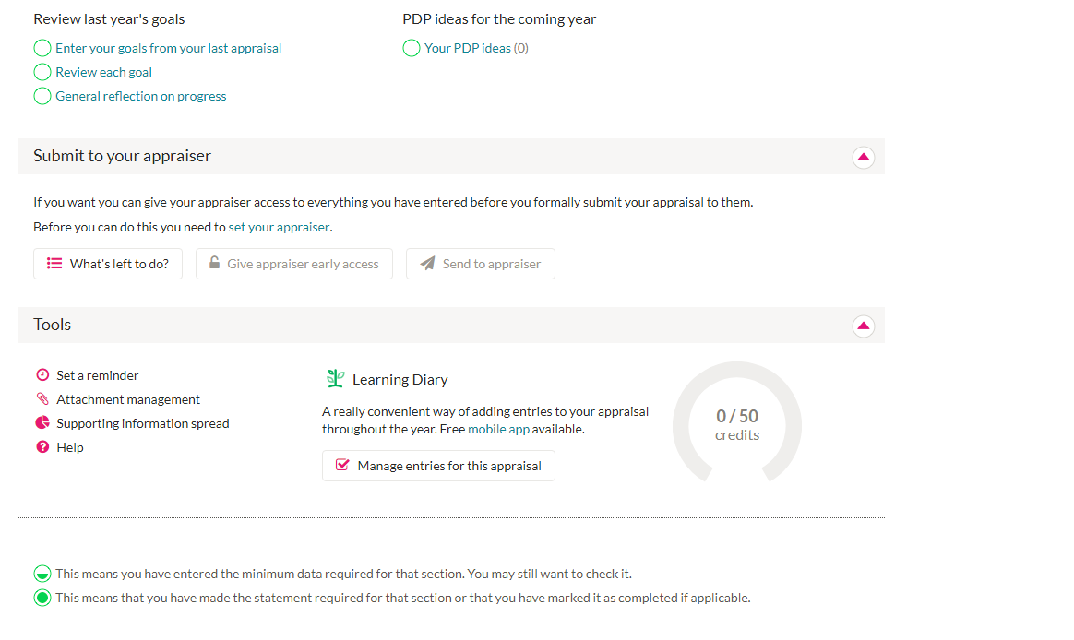
.

Firstly, enter the name of your appraiser here:
They will be able to access your appraisal info once you have completed it and submitted it to them.
Go into each of the 4 sections here and record relevant info:
Once you have completed each section, they empty circles turn green:
Click on any of the next sections and you can enter the relevant info:

Click on the CPD section and then you can bring in items from your learning diary

You can add any new items of CPD here and also attach relevant documents

You can use the online survey for the feedback if you wish to. More info is here: https://www.fourteenfish.com/videos#c2bBa_a2bsM

Use the Personal Development Plan section to add thoughts from last year, reflections on progress from last year’s appraisal and ideas going forward.
The ‘what’s left to do’ button produces a list of anything you may have overlooked
When you are happy that your appraisal is complete, you can then ‘send to appraiser’

