IMPROVING THE FLOW OF DOCUMENTS – CONTENTS

1. Outline of sessions 2
2. Background, aims and objectives 2
3. Exercise 1 - Where are you now? 4
4. Optimising workflow model 5
5. Direct filing of documents 7
6. Actions contained within documents and resource table 8
7. Coding - How to develop a practice protocol 10
8. Exercise 2 - A sample of documents to review 11
9. Governance 11
10. Medicolegal perspective 13
11. Exercise 3 - Group discussion about the model 13
12. Managing change 14
13. Exercise 4 - Next steps/planning 16
14. Appendices 17
    1. Appendix 1 - A practice worked example of ‘documents to file directly’
    2. Appendix 2 - A practice protocol of agreed actions to be taken when processing documents
    3. Appendix 3 - A standard protocol for communicating and allocating
    4. Appendix 4- A practice worked example of ‘top 200 codes’
15. Copy of Slides
16. Feedback form

**Outline of sessions**

Session 1: Introductions, background, aims and objectives

Session 2: Your current workflow model

Sessions 3: Optimising workflow model

Session 4: Future planning and next steps

**Responsibilities**

This seminar represents a working practice model for optimising document workflow. We expect that participants, as responsible professionals, will exercise individual judgement in the application of this model in their own work in their practice. We accept no clinical liability in this respect.

**Background**

Incoming paperwork to General Practice has increased dramatically over recent years. These documents contain information important for patient care: information to code, requests for follow up, investigations, prescribing and onwards referrals. A typical GP spends 1-2 hours (sometimes even more) each day processing this paperwork. The Primary Care Workforce Commission1 estimated GP’s spend 11% of their time on paperwork. As workloads rise, the sustainability of General Practice will be threatened.

**As part of their Primary Care 5 year Forward View (5YFV), NHSE identified 10 high impact actions for primary care. Two of these were concerned with productive work streams and developing teams, stating:**

*“This is not about practices achieving more by working harder, longer or faster - nor is it about restricting care for patients. Rather, these are all ways of working that have been found to simultaneously release clinician time and improve care for patients”*

We believe that by developing a practice wide, systematic approach to managing documents it is possible to improve the sustainability of your general practice.

**Aims of the course**

1. To improve the flow of documents through the practice
2. To enhance patient care and safety through systematic processes
3. To develop staff skills
4. To reduce GP workload

**Objectives**

1. Reflect on your current document system
2. Introduce a model to optimise document workflow
3. Review the impact, risks and benefits of system change
4. Identify next steps for you and your practice
5. Introduce resources to facilitate safe change
6. A chance to share ideas and experiences

Exercise 1- Where are you now?

**Your current document management system**

Aim

1. Consider how your current document management system works
2. Identify what works well and what you want to keep
3. Consider ways in which this might be streamlined or changed
4. What might your wish list be?
5. Do both admin and GPs have a similar vision?

Method

* How are documents currently managed in your practice?
* 3 minutes on your own- please make brief notes using the table below.
* With your practice colleagues, spend 3 minutes sharing thoughts.

|  |  |
| --- | --- |
| What goes well? | Frustrations/ challenges |
| *e.g. practice system to manage DNA outpatient appointments* | *e.g. read duplicate letters sent from outpatient appointments* |

**Optimising workflow model-** 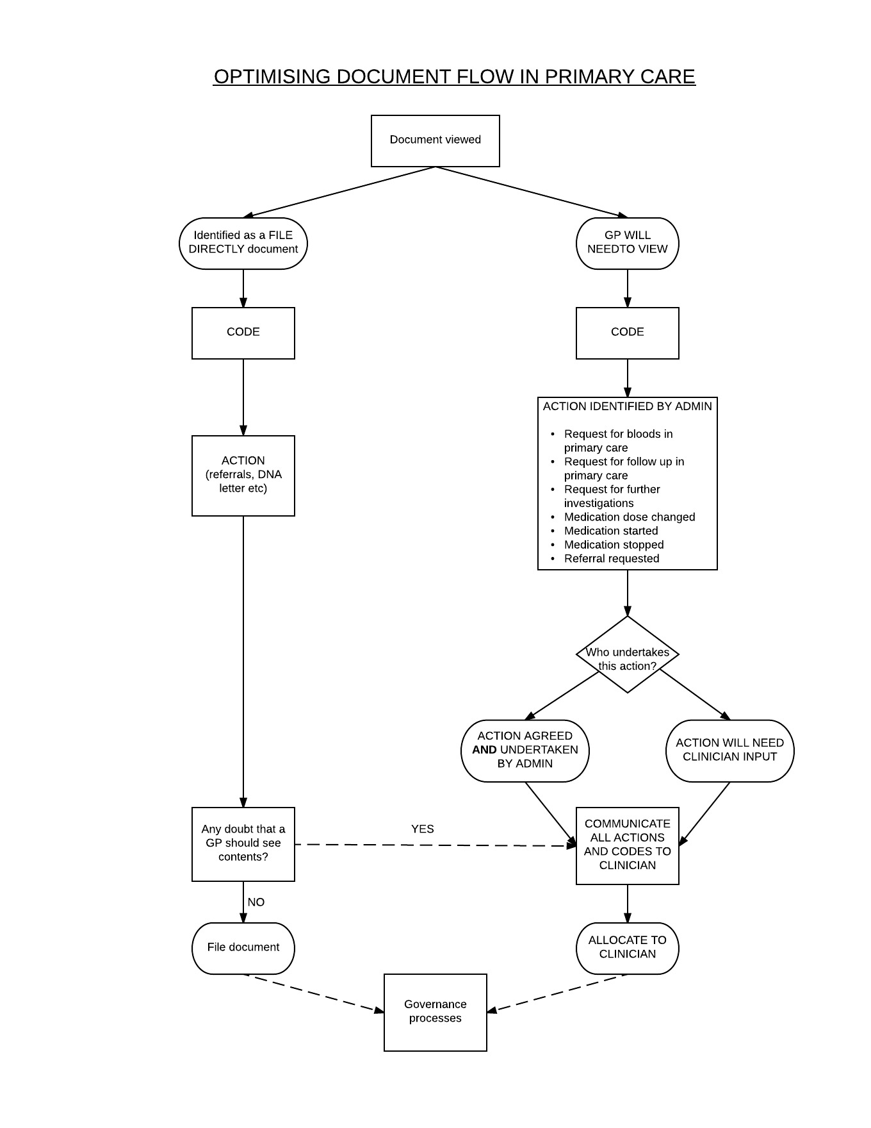

**The ‘Optimising Document Flow in Primary Care’ model:**

* Is administration led
* Is systematic
* Allows documents to be actioned ahead of GP view
* Allows some documents to be filed directly
* Provides standard protocols for each step
* Provides a system to allow allocation to the correct GP
* Has a robust governance process

**The proposed model can be summarised with 5 main action points:**

READ

CODE

ACTION

COMMUNICATE

ALLOCATE

**Direct filing of documents**

**Which documents could be filed directly by the admin team?**

We believe that GPs receive a significant number of documents that they do not need to see. After appropriate coding by administrators, these documents could be directly filed. Such documents should be low risk and of little or no clinical significance.

The questions below are designed to help you and your team identify such letters and draw up a protocol to deal with these.

1. Would your practice consider defining a list of documents that can be acted on and filed

without GP input?

2. **Review your current system** for dealing with incoming correspondence- are there any letters that are automatically dealt with already?

These might include:

* normal results from screening programmes
* follow-up fracture clinic letters
* A+E reviews/attendances with a discharge without a diagnosis, investigations or prescription
* an optician request for a cataract referral which is dealt with by secretaries.

3. Consider involving your GP colleagues and experienced administrators in **identifying documents that could be filed directly** over a defined period of 3 months. These document types should then be discussed and agreed.

4. The practice needs to draw up a robust **protocol** detailing:

1. exactly which letters can be filed directly and
2. a defined list of actions that must be taken ahead of filing.

Such a list needs to be practice specific and carefully monitored. It will need to be refined over coming months and is likely to expand.

5. Are there any rules that need to be in place for certain documents that must never be filed? What about **minors and vulnerable adults**?

**Actions contained within documents**

**CODE**

Within letters there might be codes relating to a new diagnosis, clinical findings or investigations. These are important for a patient’s clinical record but may also facilitate primary care funding streams. The aspiration is that letters are coded systematically (the same letter would be dealt with the same way regardless of whose inbox it ends up).

**REQUEST FOR FURTHER INVESTIGATIONS**

Repeat blood tests are frequently requested in documents, some of these are more common than others e.g. U&Es. There are occasionally requests for referrals to radiology. The aspiration is that all these requests are identified and that a good number are arranged by administration. Identified actions and actions undertaken are then communicated to the GP. A systematic approach supported by standard protocols is the aspiration.

**REQUESTS FOR REFERRAL**

Letters often request that the GP refers a patient to a specialty service. Some of these are very routine e.g. routine cataract referral advised by an optician, and with appropriate training can be undertaken by an administrative team. All requests for referral are identified by an administrative team and communicated to the GP when the document is viewed. Any referral undertaken by administration is also communicated to the viewing GP (or recorded on the document if it is a directly filed document)

**REQUEST FOR FOLLOW UP IN PRIMARY CARE**

Any request for primary care follow-up should be communicated to the GP to decide on next steps: who in the primary care team is best placed to undertake the follow up and when?

**REQUEST FOR MEDICATION CHANGES**

Letters often contain changes in medications - stopping, editing, starting or changing a formulation.

There is benefit to clinicians to have all these changes identified to them ahead of viewing the document. Depending on the skill mix in your surgery, these tasks could be undertaken by a team member prior to the GP seeing the letter. For example, a practice pharmacist would be well placed to check, edit and prescribe medication as needed. The model also suggests a method in which experienced administrators can play a role in this process.

**Resources to support practices when developing the ‘action’ step of the Optimising Workflow Model**

|  |  |
| --- | --- |
| Action identified | Resource to support |
| Coding | A practice tool to develop a coding protocol (p.10)  Top 200 codes practice worked protocol (appendix 4) |
| Request for investigations | Practice worked example of protocol re actions (p.22) |
| Request for referral | Practice worked example of protocol re actions (p.22) |
| Request for follow up | Practice worked example of protocol re actions (p.22) |
| Request for medication changes | Practice worked example of protocol re actions (p.22) |

**Coding - How to develop a practice protocol**

**A practice resource to develop a coding standard protocol**

We believe that GPs do not necessarily need to be involved in coding. Your practice may well have a system in place to ensure coding is efficiently undertaken in a robust and uniform way.

Some practices lack a standardised approach as different clinicians or administrators will use different codes. This can have implications for patient care, record transfer and sharing of clinical information. Accurate coding is essential for audit, research and QoF work (or equivalent).

**Robust coding ensures patient safety, care and might affect your pay!**

**Training administrators to code:**

1. The practice should agree a list of commonly used codes
2. Offer formal coding training, either online or through local organisations such as the LMC. Focus this training on understanding ‘Read coding’, code hierarchy and how to code within the clinical record (e.g. acute vs chronic; significant vs minor)
3. These codes need to be reviewed to ensure:

* uniformity across conditions
* avoiding local or system codes
* using codes as high in the code hierarchy as possible
* fulfilling QoF or equivalent requirements
* prompts are added appropriately to ensure completeness of records and that targets are completed for funding e.g. if coding ‘CVA’- has the imaging result been coded?

1. Is there a robust system to ensure allergies are accurately noted and coded?

**Exercise 2- A sample of documents to review**

Resource- 3 letters to be distributed at the workshop

Aim

1. To review some documents and consider how a process such as ‘read, code, action, communicate, allocate’ might be used in your practice
2. To consider if some of these documents could be safely filed by an administrator

Method

* To annotate the documents provided using the table below as a guide
* 3 minutes per letter- working with your practice colleague
* Share ideas with another practice pairing (5 minutes)

|  |  |
| --- | --- |
| **READ** | Who could do this? |
| **CODE** | What needs coding? Problems? Who could do this? |
| **ACTION** | What is needed? Who can undertake these tasks? Does the GP need to make decisions? |
| **COMMUNICATE** | What needs to be communicated to the GP? Does the GP need to see this document? |
| **ALLOCATE** | Who to? How can the correct GP be identified? |

**Governance**

The major priority when introducing a new system such as this is the need to ensure that the system is of high quality and is safe. Establishing a process for ensuring this quality is crucial to developing this system and needs to involve all team players in an open and constructive way.

Experience shows that the development of agreed standards is an important initial step but that ongoing experiential learning will help a team and a system become ever refined.

**Optimising Document Management – Governance 2017**

A practice worked example of some suggested audits.

|  |  |  |
| --- | --- | --- |
| **Governance process** | **Detail of process** | **Who and when** |
| **Use of agreed standards for document management** | Standard codes for clinical records  Standard protocol for filing documents without GP involvement.  Standard protocols for actions that can be taken by admin team.  Standard protocols for communicating results to clinicians | GP champion and document team at training and available for daily use |
| **Audit of documents filed without clinicians input** | Weekly audit of 20 random documents filed without GP involvement.  Any lessons learned (errors in coding/process) are fed back to the document team on a weekly basis and recorded for ongoing review and to check lessons are being learned. | GP champion and a 2nd GP for clinical opinion. Documented on a shared drive. Fed back to Document team. |
| **Face to face review of process** | On introduction of process – meetings weekly for a month then monthly until process established  Initially involves going through a complete cycle of document workflow with the team to go through all steps involved.  Explicit understanding that these meetings must be open, two way and lessons learned are shared with wider team. Feedback to GPs about how they can improve their use of the system.  Open approach to all queries or concerns | GP champion and Document team |
| **An agreed system for how clinicians feedback to document team re additional or erroneous actions**  **An audit of ‘returned’ documents** | Standard guidance about how GPs should communicate concerns about documents where issues are identified e.g. wrongly allocated, codes wrong, missing or repeated, actions not taken or actions requiring refining.  These are all filtered back into a dedicated workflow inbox checked daily by the document team.  An audit process for reviewing this inbox – can lessons learned be incorporated into evolving standard protocols?  A GP champion for staff to raise concerns if this process is not sufficient  Consideration of Key Performance Indicators to drive weekly or monthly audit. | All clinicians reviewing inboxes  Document team  Document management team  GP champion  GP champion |
| **Significant Event analysis** | A significant error or near misses to be reviewed by a standard SEA process.  Establishing early an open and supportive approach to lessons learned is crucial to this being successful and being seen as a non- threatening process by non-clinical staff. | All teams involved including Document team. |

We have learned that an organisation will develop this process over 6 to 12 months and that an iterative and formative approach to continually refining the process will result in a more sophisticated system. This applies to governance and we remain open to considering new ways of continual improvement.

**Medicolegal perspective**

Medicolegal aspects are discussed in the workshop. Once a practice system has been agreed, a GP champion identified and a governance system in place, we would recommend you discuss any system change with your practice indemnity organisation so they can review your processes.

**Exercise 3- Group discussion about the model**

Aim

1. Consider the presented model for optimising document workflow
2. To identify and discuss the benefits and any concerns/barriers to changes in your system

Method

* Split into groups of 4
* Each group discuss the benefits of the model and concerns/barriers you foresee
* 5 minutes discussion and then to present back 1-2 main points to the group

**Managing change**

**Introduction of a new system of document management**

1. **Introducing the concept** – *getting buy in*

* To all teams involved
* Assess response/appetite
* Barriers and challenges identified early
* Planning - steps and timeframes

Gather some pre-change data (number of documents/time spent/SEA/errors)

2. **A needs assessment**

Where do we want to get to and what do we need to get there?

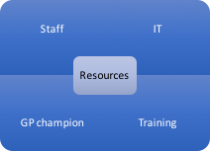

•Training

**3. Development of agreed protocols for each step**

* Letters to be filed directly and actions ahead of filing
* Coding process
* Actions and who undertakes them
* Communication of all actions
* Allocation to GPs or other clinicians
* Governance including indemnity view

**4. Timing**

* Development stage/Needs assessment 6 weeks
* Training and engagement with staff 1-4 weeks
* Embedding new model/systems 3-6 months

**5. Governance and support**

* GP champion and Doctor team meet weekly for at least 6 months
* Review of process monthly for 6 weeks
* Governance audits/SEA weekly/monthly/as needed

Suggest weekly reviews are focused on current development needs (e.g. - correct allocation, missed codes, medication accuracy)

**Exercise 4 – Planning /Next steps**

Please work together with your practice colleague to consider next steps for your practice.

What of the presented material might you be keen to adopt in your practice? We suggest you identify 3 priorities.



* Identify 5 next steps for you and your practice

*(Things to consider: introducing the concept, resources, staff development, protocols,*

*governance, timeframes, threats, and opportunities*)

|  |  |  |
| --- | --- | --- |
| Identified next steps | Resources needed | Barriers or challenges to overcome |
|  |  |  |
|  |  |  |
|  |  |  |
|  |  |  |
|  |  |  |

**Appendices**

a. Appendix 1 - practice worked example of ‘documents to file directly’

Document management updated Feb 2017

|  |  |  |  |
| --- | --- | --- | --- |
| **Document** | **Pathway** | **Who to action/what action** | **Who to action** |
| A&E letters >18yrs old | Attendance letters without formal diagnosis    Overdoses/DSH    (those admitted will have discharge letters, those to # clinic will have separate letter | Post to host (file directly)      Send to appropriate GP    If uncertain whether a code might be necessary -> forward to GP | Document team |
| A&E letters for children <18yrs age | All go to be seen by a GP |  |  |
| Lymphedema clinic letters |  | Post to host | Document team |
| Antenatal letters – new pregnancy | 1) If standard care    2) Intensive and shared care | Code pregnancy and post to host    Code to pass to GP | Document team |
| **Document** | **Pathway** | **Who to action/what action** | **Who to action** |
| BEH glaucoma and ongoing care clinics | New diagnosis    Review | Code and Pass to GP  Check drops against those on EMIS   * If no change – file * If change – edit on EMIS and pass to GP to check | GP    Document management |
| Audiology | Check if further action for GP (on p.2)    Check if hearing aid fitted | If yes -> forward. If no -> file    Code hearing aid fitted | Document team and GP |
| Opticians letters requesting onward referral  Cataract or otherwise  Urgent ref. request | Forward directly to Secretarial team to use standard letter  Allocate to GP or duty if not in. |  | Document team and secretarial team |
| Fracture clinic follow up | Check fracture is coded  If action requested of GP  If no action | If not coded -> code  Forward to GP  Post to host | Document team |
| Dental letters | Brief scan ?any action or new code (GP if Yes) | Post to host | Document team |
| Homeopathy letters | Brief scan ?any action or new code (GP if Yes) | Post to host | Document team |
| **Document** | **Pathway** | **Who to action/what action** | **Who to action** |
| Physio letters | Brief scan? any action or new code (GP if Yes) | Post to host | Document team |
| LIFT letters of assessment/discharge  (IAPs) | Brief scan No action or risk identified  new code or risk identified | Post to host  GP to see | Document team  GP |
| BCRM (fertility) ongoing care letters | Brief scan? any action or new code (GP if Yes) | Post to host | Document team |
| Offer of appointments various departments |  | Post to host | Document team |
| Cervical screening | If normal -> code using template  If abnormal/HPV -> code using template | Code and post to host  Code and forward to GP | Document team |
| Radiology results | Has this result already arrived on ICE and been seen by a GP (almost always ahead of paper copy) | If yes -> post to host  If no -> forward to requesting GP (check who requested) | Document team |
| Mammogram screening | Normal -> code normal    Abnormal -> code abnormal | Post to host    Pass to GP | Document team  GP |
| **Document** | **Pathway** | **Who to action/what action** | **Who to action** |
| Letters from patients requesting re-referral for missed appts. | Direct to secretarial team to re-refer using standard letter |  | Document team |
| Hospital DNA letters | >18yrs of age (non 2ww)    <18 yrs. of age. Pass to secretarial team to check address & send practice DNA letter | Post to host - use practice DNA policy    Send standard child DNA letter | Document team    Secretarial team |
| Spirometry from secondary care |  | Pass to Chronic disease nurses to code | Document management and Nursing team |
| Post-surgery follow up in 2ndry care | If diagnosis coded and no actions    Check action - undertake if on list of actions agreed or pass to GP | Post to host    Action or pass to GP | Document team      Document team and GP |
| **Document** | **Pathway** | **Who to action/what action** | **Who to action** |
| Opt out letters from secondary care |  | Post to host |  |
| Walk in centre attendances | Check content.  Code diagnosis if significant or emergency contraception | Code and post to host  Action and GP to see | Document team  GP |
| Documents passed to scanning team by GP directly (GPCOG/ radiology results printed off ICE/ | GP to annotate wishes re coding | Action and post to host. | GP and document team |

**B. Appendix 2 Protocol of agreed actions to be taken when processing documents.**

1. **Request for bloods in primary care**

* Post discharge bloods
  + contact patient,
  + book blood test appointment (or phlebotomy)
  + add to ICE (agree FBC/U&Es/ferritin/TFT if requested).
  + Record action and pass to GP
* Other blood requests, please pass to GP to review request.
* New drug monitoring request. Do not add to ICE but pass to GP for action

1. **Request for follow up in primary care – ‘GP to review in….’**

* Highlight to GP and ask GP for response and type of appointment if appropriate (tel, face to face, nurse, community matron, district nurses)
* Passed back to reception to liaise directly with patient and appropriate teams

1. **Request for onwards referral**

* Optician requesting routine referral to Eye hospital -> send directly to secretaries to refer using standard letter
* Optician requesting urgent referral -> pass to GP (Duty Doctor if requesting referral same day)
* Request by patient for referral as missed/did not hear about appt -> send directly to secretarial team to use standard letter.
* All other referrals highlight in actions and redirect to GP

**4) Medication related actions**

These will depend on the skill mix in your surgery and could include:

* All medication related actions identified in the letters (e.g. to start, stop or change regimes) are to be highlighted and communicated to the GP.
* If you have a pharmacist- the pharmacist could be asked to make all changes (exceptions are amber and red drugs) and communicate these to the GP.
* An experienced **administrator** could be asked to have a role in medication changes

If using an experienced administrator, protocol to be:

**Medications added**

* Agree experienced coders can add new medications started in secondary care
* GP will review **all** medication changes
* Coders to add new medication to acute **only**
* 1 tablet/capsule supply only
* GP to edit to repeat if appropriate and alter amount.
* Exceptions are amber/red drugs. Do not add these.
* Communicate medications added and request for GP to check
* No medications issued until a GP has reviewed medications
* ***Care needed: GP issuing subsequent scripts will not get EMIS pop ups highlighting interactions/allergies etc.***
* **Medications Changed.**
* Agree medications can be edited by experienced coders.
* 1 tablet/capsule supply only
* Any change in dose or regimen **MUST** be communicated to GPs for careful review
* No medications issued until a GP has reviewed changes.
* Exceptions are amber/red drugs which must not be edited. Refer these to GP to action
* Communicate medications edited and request GP to check.
* **Medications stopped in hospital or in clinic.**
* Agree that experienced coders/pharmacist can remove medications from medication lists.
* All meds stopped are documented and communicated to GP on the document.
* Liaise with pharmacy as appropriate (dosette/mid batch etc.)

**C. Appendix 3- A Standard protocol for communicating and allocating**

A practice worked example

**Communication**

AIM

**All coding and actions identified and undertaken within a document should be recorded clearly on the document and communicated to the GP.**

**Every document that a clinician views should be annotated clearly detailing why the GP needs to view it (even simply ‘for info’).**

* All **new codes** added will be clearly documented and communicated regardless of whether they are filed directly (allows for audit later)
* All **actions** identified will be clearly documented and communicated regardless of whether they are filed directly (allows for audit later)
* All actions agreed for **admin to undertake,** that have been processed, will be documented regardless of whether they are filed directly (allows for audit later)
* All actions that require a **GP to undertake** will be highlighted, documented and communicated to the GP to action (allows for audit later)
* In the case of any **uncertainty**, a query should be documented clearly.
* A ‘**for info only**’ communication can be used if no action is needed but a GP is to view

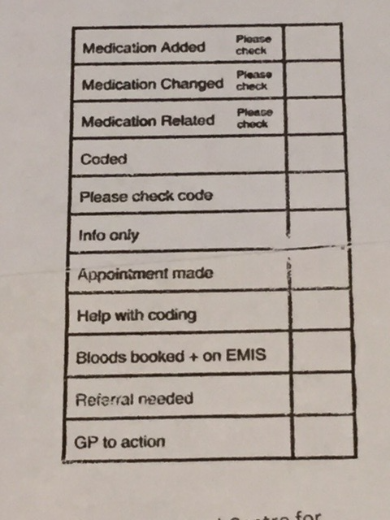

Systematic communication – achieved through development of standardised stamps (for paper documents) that exactly match electronic stamps that can be used in document management software.

In practices using systems where stamps cannot be developed, the GP champion will need to work with the admin teams to find the best way of highlighting and communicating actions embedded in documents (free text as a last resort).

**Allocation of documents**

Clinicians can spend many hours reallocating documents to colleagues who are more appropriate to view or action a document.

**AIM**

**A document should be initially allocated to the most appropriate clinician and this may require some scrutiny to establish.**

Ideally a stepwise process to establish the most appropriate clinician might be:

1. Who made the initial referral?
2. Who sees the patient for this problem?
3. Who sees the patient most regularly?
4. Who is the ‘usual doctor’ recorded in the clinical system?
5. Who is the registered doctor in the clinical system?

**Final note**

We hope that the workshop and workbook prove to have been helpful and might facilitate you and your colleagues in reviewing your current system of document management. We believe that this system once introduced is best developed and refined by your own practice team to suit your practice needs. It may be that you can adopt some or all of the steps introduced but we know that each one of these steps can enhance your working lives, develop your team and offer enhanced care for your patients.

**Copyright**

**Reference**

1. **https://www.hee.nhs.uk/our-work/hospitals-primary-community-care/primary-community-care/primary-care-workforce-commission**