Frailty Guide update

Emis Issues with Importing Protocols due to patching updates in last week.

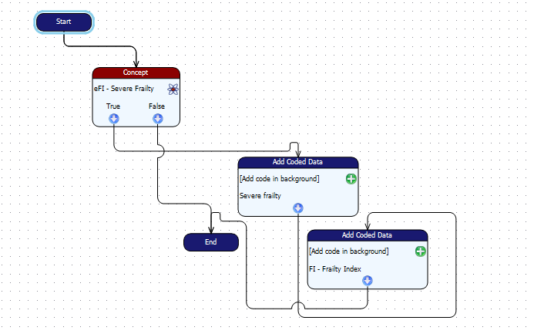

Load the EFI Frailty Register score and code severe protocol which runs the efi severe frailty concept and if true adds the read code severe frailty with associated text of {eFI Score.Value}

Due to a bug within Emis since they have sent patches out in the last week it may be that the protocols will not import into your system. Emis have unfortunately said this will not be put right for a couple of months.
The protocol above can be built by the practice and will then run as per the guide.
In the Add Coded data please use Read Code 2Jd2
And
Frailty Index 38QI.
If you have any problems please contact Amanda.mason@prestongrovemc.nhs.uk or maria.chapman@stjamesmc.nhs.uk

