SPH
Somerset Primary Healthcare Limited

GP Payments Timetable
The attached spreadsheet has been put together to help clarify many of the payment streams and codes for practices this will evolve over time as contract changes come into place, if you do notice anything that is missing from the table please do let us know. The spreadsheet contains various links to documents and specifications that support the contract, and there is also a link to the quarterly submission template that has to be sent to the Area Team by the 9th working day of each month in order for practices to receive payment.

The spreadsheet contains comments and advice where it was felt was necessary, if a cell has a red triangle in the corner (screenshot below) hover over it and the comment will appear, Practice Managers will also be able to print off the spreadsheet with the comments listed,
we have also included those comments and more in this document.

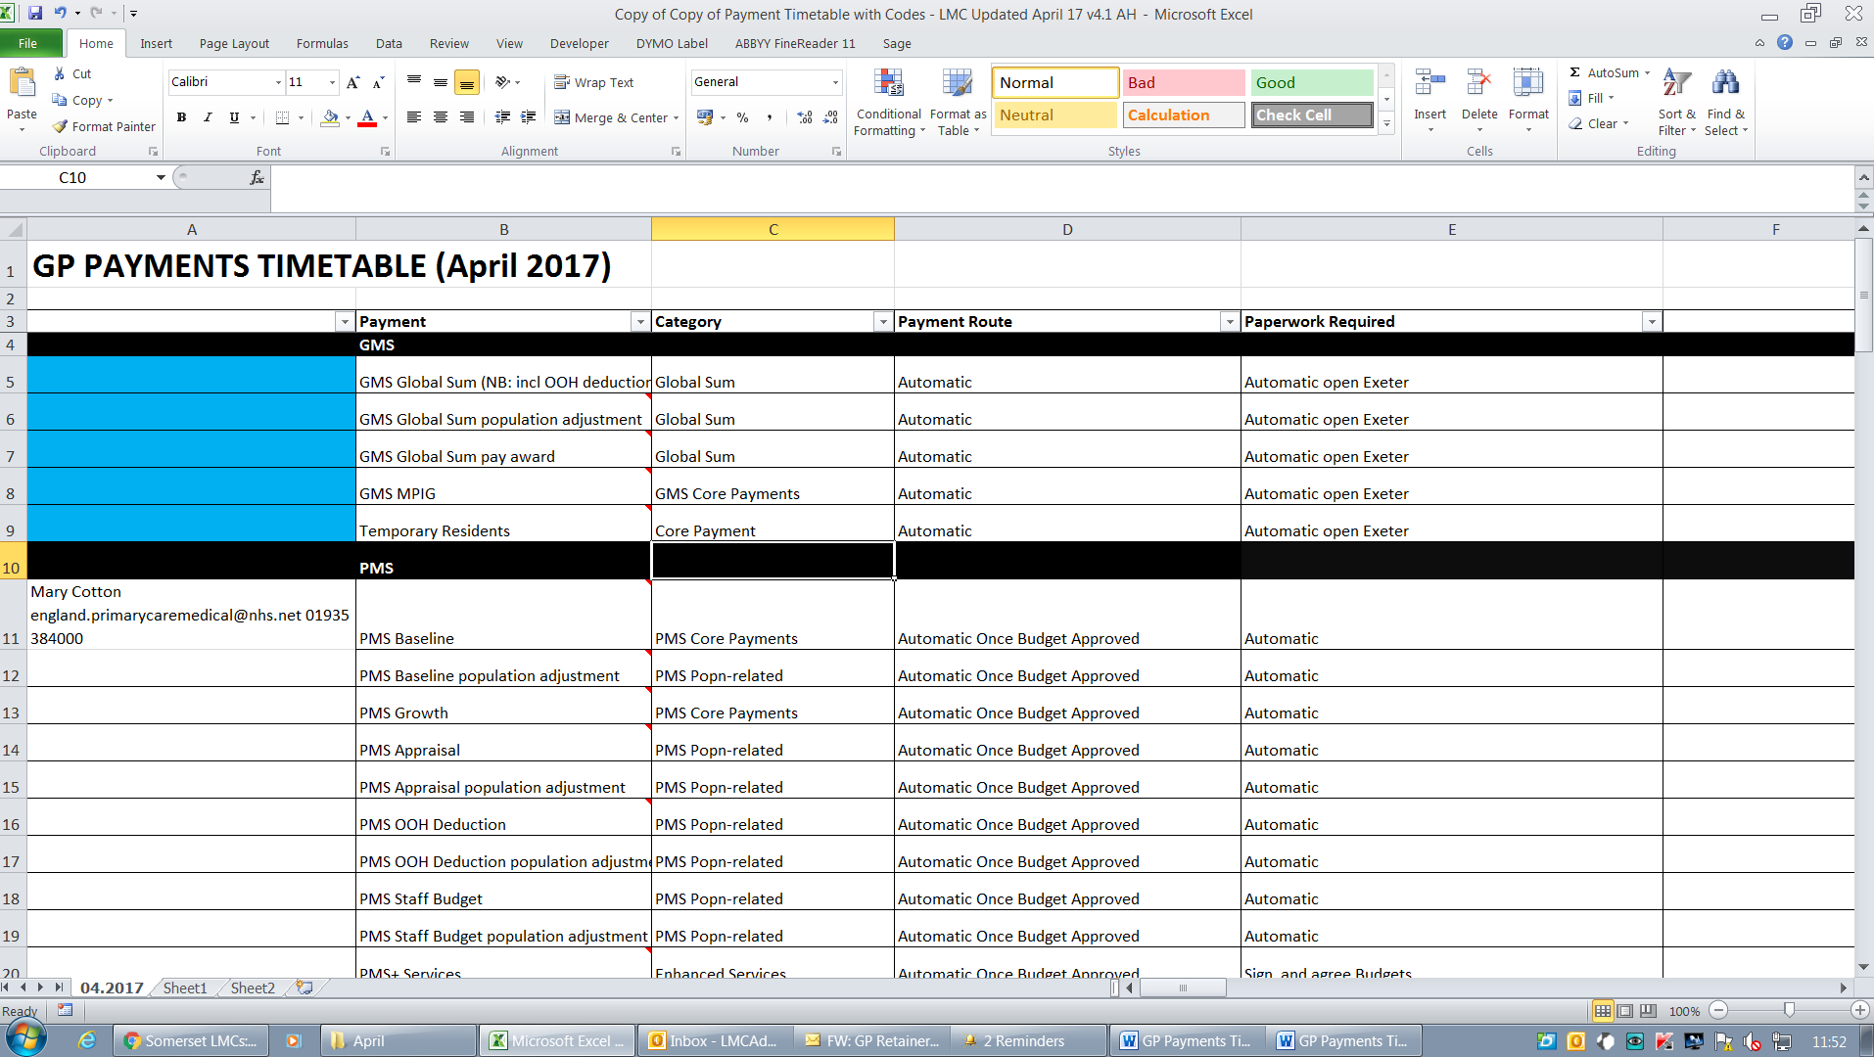

GMS Baseline
Check your GMS Global sum and correction factor quarterly statement as these can be incorrect and will not otherwise be picked up until your annual accounts review by the practice accountant.

- Check the Raw practice list size (page 2 of statement) to see if it is reasonable based on practice records, if variant is more than 1% raise with the Area Team.
- Check the number of patients listed in nursing and residential care, these are often wrong and cannot be corrected at year end. Practices need to add a Residential Institution code to these patients on their clinical system for this to be picked up by Exeter.
- GMS pay award 17/18; Global Sum payments, which are increasing a result of resources funding streams being reinvested into Global Sum payments plus an uplift following the other contract agreements. The increase is from £80.59 to £85.35 from 1 April 2017.
- MPIG is reduced by 1/7 for 17/18.
- Temporary resident’s figures are based on 2003 activity; they are fixed and paid monthly, not inflated.
- Rurality is based on the main surgery postcode; if working from a split site it can be beneficial to change the main surgery address, speak to your accountant.

PMS Baseline
NHS England should be e mailing PMS practices a contract statement every quarter, the funding has shifted onto weighted population, there is still a need to check that the weighted population agrees to the quarterly global sum statement – see checks 1-2 above.

- PMS have had a £4.27 weighted capitation rise
- The OOH opt out has risen to £4.20 per weighted capita
- PMS growth is a fixed amount and included in the PCIS reducing
- PMS+ is not funded as part of the core contract it will be an individual contract for an extra service e.g. extended minor surgery

National QOF
16/17 QOF saw a reduction in points, payment based on 13/14 achievement for those doing QOF. 17/18 payment increases to £171.20 per point.

- The average practice list size (CPI) had risen from 7,460 as at 1 January 2016 to 7,732 at 1 January 2017.
- The value of a QOF point will increase by £6.02 or 3.6 per cent from £165.18 in 2016/17 to £171.20 in 2017/18.
Calculate as follows:

Aspiration payment
Total money 17/18 ÷ 559 x 559 x 70% ÷ 12 with the final 30% paid in June following year, subject to achievement. (The points for 16/17 and 17/18 are the same so no adjustment is needed).

Example CPI = total practice population 10,000 / Average list size 7483 = 1.34
Total Money 17/18 Pounds per point * Total points possible * CPI
171.20 * 559 * 1.34 = 127,890.95

Total Money ÷ total points for 17/18 * total points for 16/17 * 70% = Aspiration payment for year 127,890.95 /559 *559 * 70% = 89523.66

Monthly 89523.66/12 = £7460.31 (See Open Exeter)

Achievement payment is currently under review by NHS England.

The formula used to calculate the achievement of indicators in the clinical domain is: actual achievement maximum potential achievement | x | number of points available for indicator | x | £xx (value of a QOF point

SPQS
The funding arrangements for practices seek to support this innovation without destabilising practice finances. Monthly aspiration payments will continue but the achievement payment will be split into four 7.5% sums that will be paid after the end of each quarter The level of achievement is set out at the beginning of the year and represents 2012/13 achievement corrected to the 2017-18 QOF points value adjusted for changes in population and prevalence.
SPQS will be adjusted after the end of the year for practice list size changes and prevalence changes Example CPI = total practice population / Average list size 7732 (17/18)

Calculated by (Total QoF points for each domain* Practice prevalence factor x £171.20 ) x CPI X Practice % Points achieved in 12/13 – Total amount paid in year as of (17/18)
For GMS Practices, the calculation for aspiration and quarterly payments is as follows;
- 2013/14 monthly aspiration *12 = total aspiration for 2013/14 (70% of achievement)
- Total aspiration for 2013/14*62.11% = adjustment for change in points (900 to 559)
- Adjustment for change in points / 12 = monthly aspiration now paid
- (Adjustment for change in points/70)*30 = 30% achievement
- 30% achievement/4 = quarterly payments
An Example would be as follows:
- £15,686.07 * 12 = £188,232.84
- £188,232.84 * 62.11% = £116,911.42
- £116,911.42 / 12 = £9,742.62 monthly aspiration
- (£116,911.42/70)*30 = £50,104.89
- £50,104.89 / 4 = £12,526.22 quarterly payment
PMS is slightly more complicated as the PMS point’s deduction, which would have been in place when the 2013/14 aspiration was calculated, needs to be added back in:
- 13,050 * (Weighted List Size at 1 January 2013/5,891) = PMS Points Deduction
- 2012/13 QOF Achievement + PMS Points Deduction = 2012/13 Achievement before PMS Points Deduction
- 2012/13 Achievement before PMS Points Deduction * 90% = adjustment for change in points (1000 to 900)
- adjustment for change in points * 70% = Total Aspiration on 2012/13 Achievement
- Total Aspiration on 2012/13 Achievement is then used in place of the total aspiration for 2013/14 in the calculation above
An Example would be as follows:
- 13,050 * (11,989.83/5,891) = £26,560.39
- £278,138.19 = £26,560.39 = £304,698.58
- £304,698.58 * 90% = £274,228.73
- £274,228.73 * 70% = £191,960.11
- £191,960.11 * 62.11% = £119,226.42
- £119,226.42 / 12 = £9,935.54 monthly aspiration
- (£119,226.42/70)*30 = £51,097.04
- £51,097.04 / 4 = £12,774.26 quarterly payment
Trainee Grants
Check on statement that the correct number of registrars is listed; a full training grant is awarded even if part time.

A practice will also receive an educational payment if looking after another practices Registrar.
Dispensing Practices Drug Cost
Advance is paid monthly in advance based on the RX submitted in the prior month, but priced on monthly average and is clawed back the following month. Check that the clawback matches the previous months advance.

Non Dispensing Practices Prescriptions
Paid two months in arrears for non-dispensing practices, check the number of scripts and items submitted to the reimbursement on Open Exeter. Claims must reach the PPA by 5th of the following month to ensure payment is made. Payment is made once the practice has submitted the FP34D for bulk vaccinations and also FP10’s for practice purchased claimable items. With prescriptions going electronically to pharmacies it is important to check you have all of the FP10’s and they haven’t inadvertently been sent to the pharmacy. Practices should run their own searches and not rely on the FP34D report on Emis as this has errors in it and money can be lost.

Flu Submissions
The automatic discount applied to the drug cost reimbursement increases with the amount of scripts submitted each month; therefore it is best to spread the submission of flus over the period and across all the GP’s in order to get a lower discount charged.

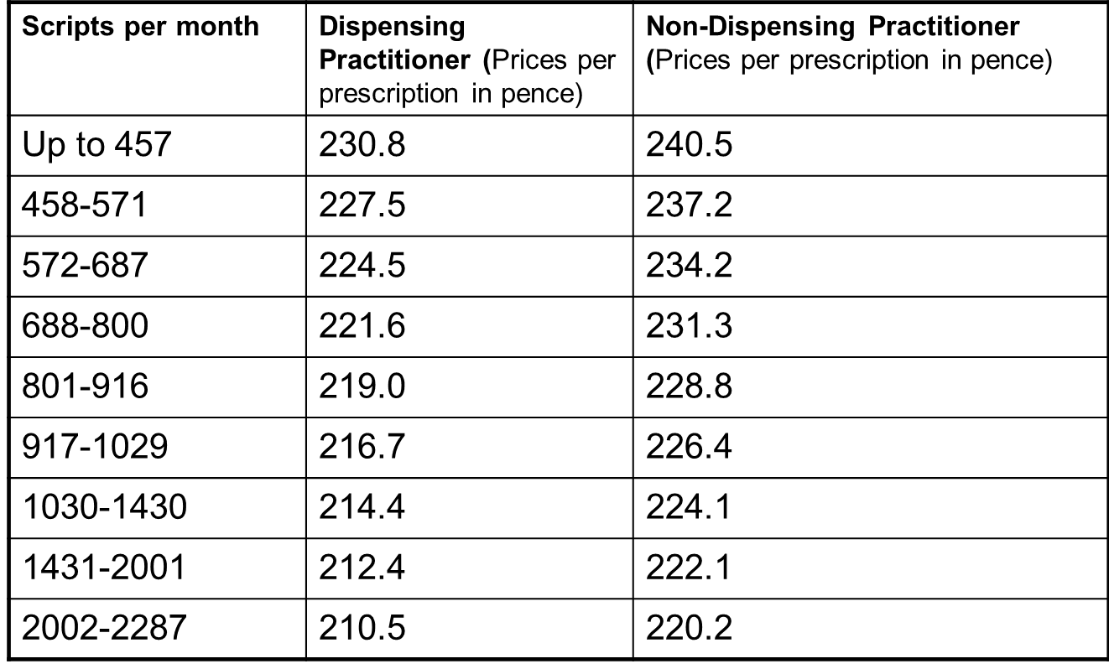
This is as of 1st October and scripts per month is per GP not per practice.

Seniority
Seniority payments are being phased out. The seniority scheme will end completely on 31 March 2020.During the six year phasing out period, those who were in receipt of seniority on 31 March 2014 will continue to receive payments. GPs not already in receipt of seniority on 31 March 2014 will generally not be eligible1. Each year the seniority payment scales in the Statement of Financial Entitlements will change to require an additional year’s reckonable service before qualifying for payment. The current qualifying arrangements will continue for those in receipt of payments. All funding released from the seniority pot will be reinvested in core funding for general practice through an annual increase to the global sum with no out of hours deduction applied From the GP Contract 17/18 Seniority reinvestment is a redistribution of existing GMS and PMS funds.

Enhanced Services (submission method and payment frequency included in spreadsheet)
- The CCG has held a single licence with the suppliers of INR Star since January 2016 and therefore practices should not receive invoices for payment, directly from the company. For the one or two practices using alternative software, practices should forward a copy of their paid invoice to the enhanced services email box at esreports@somersetccg.nhs.uk for reimbursement.
- Practices are reimbursed for the software licence for INR star, send the invoice to the CCG–WHO.
- Extended hours payment is based on actual list size not weighted – this should be on the list size at the start of the year.
- Practices are required to sign up using the local forms which are emailed to practice Managers annually.
- Practices can refer http://nhsemployers.org/your-workforce/primary-care-contacts/general-medical-services/enhanced-services

PCIS
The £3 per head (weighted) includes the money we already get for Pre / Post-Operative Care, Neo-natal, Hep B and Risperidone. Strip this this out and you are down to £2.39 per weight patient per annum.

Year | £ per weighted patient | Gross worth | Less MPIG | Net gain from the scheme
16.17 | £2.39
17.18 | £4.78
18.19 | £7.17
19.20 | £9.56
20.21 | £11.95

The specification includes work to be undertaken in 7 categories which are:

- Specified non-core contract work.
- Previous commissioned enhanced services – Risperidone, neonatal checks, pre and post op checks and hep B vaccinations – at present practice receive 60.9p per patients for pre and post op checks as well as payment for the other services. Check how reconciliation for the others will be paid.
- 7 day access to primary care (awaiting confirmation).
- Appropriate skill mix models.
- Improvement in quality and resource utilisation (medicines management).
- Collaboration with commissioners.
The calculation for PCIS should be as follows:-
Weighted list from April 2017 (as they did not have 2017 figures but it will be reconciled)
Example
PCIS 13955.9 (weighted list size Apr 2017) x £2.39 = £33,354.60
Plus pre and post op – registered list Apr 2017 x £0.609 = £9,036.95
(Improved access £6 x weighted population Apr 17) – NHS England DES £1.90 reg population Apr 17 = £55,541.30 Payment under PCIS:
PCIS + IA – MPIG + Pre and Post Op = Payment
£33,354.60 + £55,541.30 - £30,859.34 + £9,036.95 = £67,073.51

=Monthly payment
= £5,589.46
Practice should see this payment on the CCG Enhanced service statement

CQRS
Claims on CQRS are made either manually or automated from the clinical system. It is essential that practices check the figures for the automated claims against their system as CQRS only extracts currently registered patients as of the last day of the month.

If the automated extraction is incorrect please complete the CQRS Data amendment request form and return to To england.primarycaremedical@nhs.net adding please could you let me know when this is complete then I can add the register and declare.
Once the data has been corrected they will send a confirmation email and you should then check CQRS and if you agree with the figure it can be declared for payment.
Once the data is on CQRS you will get an email to say please declare for payment. This must be done for every service including those which are 0.
Practices should ensure staff have read https://training.cqrs.nhs.uk/web/training/online-training as this explains how to use CQRS.
Practices should also check the 17/18 extracts timetable found on CQRS home page. When this is opened the enhanced services have hyperlinks to the main specifications .This is updated monthly.

Ad Hoc
Superannuation deductions based on superannuable profits and estimated returns, practices need to adjust ad hoc when there is a change in partnership.
The superannuation reconciliation is done annually, in the month following submission of certificate of superannuable profits.
Locum reimbursement (contribution towards costs - sickness, maternity, paternity etc.) these will no longer be discretionary from 2017.Application form and claim form are available to download from this website: there is also a procedure available at this website http://www.avon.nhs.uk/pcsa/procedures/payments/. For support with form completion, the contact is Eileen Grindey (0117 900 2492 or Eileen.Grindey@brs-pcsa.nhs.uk)
Invoices sent to SBS – queries regarding remittance can be made directly to SBS, tel: 0303 123 177 (option 2), they should be able to review the relevant payment advise who it was made by if this is unclear. If this doesn’t resolve the query, Area Team invoice queries can be sent to England.bnsssg-finance@nhs.net , CCG invoice queries can be sent to Lisa.Jones@somersetccg.nhs.uk.

Enhanced services paid by Somerset County Council
Smoking Cessation – This should be paid quarterly and the searches supplied by Somerset County Council, the searches need to be verified by the practice and payment should show on a BACS payment. Contact is JChetland@somerset.gov.uk

LARC - Practices are paid monthly In the next financial year the baseline figures will be formulated on last year’s activity, therefore it is anticipated that your first monthly payment will be on the 15th May and will include your April and May payment. Return forms should be returned to Andrew Wilson, Health Promotion Manager (Sexual Health), (ANWilson@somerset.gov.uk) . If you or phone (Tel. 01823 357239; Mobile 07585 983371).

Enhanced services paid by Somerset Partnership
Chlamydia – This is now paid yearly as of 1.4.16. Practices should have signed and returned their contract for 16/17. Check this has been done as many practices have not sent it back. Once it is sent back 16/17 payment £150 for signing up and then £3 a test returned. There is no claim form to be completed as Somerset Partnership keep the records. If practices are unsure if they have signed their contract or haven’t received the £150 sign up they should contact Emma.O’Connell@sompar.nhs.uk 07795237608 or Kerry.Lucas@sompar.nhs.uk 01749 836704/ 07500096347
This will be paid by BACS. A new contract for 17/18 will be sent to practices soon.

CQC fees
2017-18 contract changes - on receipt of an invoice, NHS England will reimburse CQC fees directly. The claim form is within the calendar and practices will need to complete for reimbursement of CQC fees. This must be completed and returned together with the CQC invoice to england.pcfinancesw@nhs.net

