Service Specification No. | 11X-35-3
Service | Teledermatology
Commissioner Lead | Sheryl Vincent, Commissioning Manager
Provider Lead
Period | 1 April 2015 –31 December 2016
Date of Review | 31/05/15

1. Population Needs
National/local context and evidence base

  - Skin disease is a common and distressing problem. It is estimated that of the nearly 13 million people presenting to General Practitioners with a skin problem each year in England and Wales, around 6.1% (0.8 million) are referred for specialist advice. Most (92%) are referred to NHS specialists rather than private dermatologists.
  - Whilst there are some 3000 dermatological diseases, 10 of them (eczema, psoriasis, acne, urticaria, rosacea, infections/ infestations, leg ulcers and gravitational disorders, lichen planus and drug rashes) account for 80% of consultations for skin disease in General Practice.
  - Although it is the case that the commonest disorders are not life threatening, if not treated appropriately, patients can suffer harm and longer term health problems. Many of the rare and some of the severe common skin conditions have an associated morbidity and mortality, thus early and accurate diagnosis is critical to appropriate management. For those disorders that are not life threatening, the psychological impact on everyday life, work, social interactions and healthy living are substantial.
  - Evidence from past audit and lessons learned from other NHS organisations across the country have identified that many patients with dermatological conditions do not necessarily require the intervention of acute services. Most patients can be managed in a primary care setting or by self-care with support from a primary care clinician. By implementing a teledermatology project, more patients can be managed in a primary care setting by having a virtual consultation with a dermatologist.
  - A store and forward teledermatology service will allow experienced dermatology clinicians to review images and ensure patients are seen at the right time, in the right place, first time.
  - Teledermatology can be offered using three models of care:
- Full teledermatology - an alternative to face-to-face consultation. Patients are not seen in person. Instead the provider of the teledermatology service (the reporting specialist clinician) offers a management plan to be explained and implemented by the referring clinician.
- Triage teledermatology – a triage tool to ensure the right person sees patients in the right place promptly. All patients are seen but an image with accompanying history is used to direct the referral appropriately.
- Intermediate teledermatology – a mix of both of the above according to patient need. Some patients are triaged to an appropriate specialist appointment while others receive (through the referring clinician) diagnostic and management advice to obviate the need for face-to-face specialist consultation.
1.7 This pilot will use intermediate teledermatology with the ambition to prevent avoidable attendances in to dermatology secondary care services.

2. Outcomes
2.1 NHS Outcomes Framework Domains & Indicators

Domain 1 | Preventing people from dying prematurely
Domain 2 | Enhancing quality of life for people with long-term conditions
Domain 3 | Helping people to recover from episodes of ill-health or following injury
Domain 4 | Ensuring people have a positive experience of care
Domain 5 | Treating and caring for people in safe environment and protecting them from avoidable harm

- More patients to be managed in primary care and prevent avoidable attendances in to the dermatology secondary care services. (NHS Outcome Framework domain 2, 4, 5).
- Financial savings as a result of a reduction in face-to-face referrals.
- Reduced waiting times for patients who need to access specialist consultations (The current waiting time is 10-12 weeks). (NHS Outcome Framework domain 1, 2, 4, 5)
- Increased confidence in GPs to treat more patients within primary care as a result of up-skilling. (NHS Outcome Framework domain 1, 2, 3, 4, 5)
- Elimination of non-attendance at clinics and loss of outpatient clinic letters. (NHS Outcome Framework 1, 2, 3, 4, 5)
- Improved communication between providers. (NHS Outcome Framework 1, 2, 3, 4, 5)
2.2 Local defined outcomes

Expected outcomes including improving prevention:

- Equitable access and treatment of dermatology patients within different levels of deprivation
- A reduction in inappropriate first outpatient referrals to secondary care services to meet local QIPP initiatives
- Increased overall patient satisfaction with dermatology services
- Services closer to patient’s home
- Improved communication between provider specialist clinicians and GPs
- Improved access to advice and information and increased knowledge and the awareness of the management of dermatology
- Reduced waiting times for patient access to specialist care
3. Scope
Aims and objectives of service

  - Teledermatology involves referring an image of the skin or the skin appendages of a patient together with relevant history of the condition to a clinician for advice.

  - The aim of the intermediate teledermatology service is to prevent avoidable attendances in the dermatology secondary care and reduce the time taken for patients to access specialist services.

Scope of the Service

  - Where appropriate and available, routine dermatology patients should be referred, in the first instance, to the Community Dermatology GPwSI Service.

  - Where not in place, the patient should be assessed for suitability against the Tele-dermatology criteria at paragraphs 3.47 – 3.49.

  - This Service is available to all patients aged 18 years and over registered with participating GP practices.

  - Providers will use software, specialised digital cameras, other agreed equipment and the secure IT system and platform for storing and forwarding patient data, provided by the Service host, Care UK, on behalf of Kysos Telemedical Centre.

  - The service is to be provided within the normal surgery hours of the Provider.

Service description/care pathway

  - The patient is to be given a copy of the patient leaflet. Refer to Appendix A.
  - Where presenting skin lesions are managed through this Service, dermatoscopy must be undertaken. Refer to paragraphs 3.32 and 3.48 - 3.50
  - GP or practice nurse to take photographs and upload onto KYSOS portal. Please refer to paragraphs 3.28 – 3.31 ‘Consent’.
  - Photos may be taken using the camera supplied or via the provided iPhone App.
  - In the event of failure of the camera and/or software or dermatoscope, please refer to paragraphs 3.25 and 3.27.
  - GP to add a clinical assessment of the patient, using the teledermatology referral proforma as guidance, to ensure all relevant and necessary information is included, hence facilitating a safe and successful teledermatology consultation.
  - Patient demographics, medication history etc. shall be added as a file, from the GP Clinical System (where possible).
  - The above information shall be forwarded via the KYSOS software Portal within 2 working days.
  - The on-line survey, accessible following a referral being made, shall be completed as often as possible, and as a minimum, at least once during the course of the pilot service.
  - All images shall be deleted from the camera after uploading onto the KYSOS software Portal.
  - The Provider will be alerted via email within 3 working days, that there is an answer pending.
  - Where the patient is suitable for teledermatology management, a report with the outcome of the teleconsultation will be sent to the referring GP within three working days. This report will then be printed by practice staff, scanned and then added to the patient record.
  - The Provider shall them arrange to communicate the Care Plan, either verbally or face to face with the patient in a further appointment, within 5 working days.
  - Where the patient cannot be managed by teledermatology, either due to criteria or feedback from KYSOS service, the Provider will send the referral via e-referral, listing the secondary care choices, within 2 working days.
  - A flow diagram of the tele-dermatology pathway is available as Appendix B.
Equipment

  - The Provider will be issued with 1 camera between 3 GPs or 1 per practice (whichever is appropriate) for the term of this pilot service.
  - Providers will be issued with one dermatoscope per practice unless the Provider expresses a wish to use and maintain its own equipment.
Contingency in the instance of an IT/camera failure

  - Should a camera or the IT system fail then a replacement camera will be provided, and an engineer will re-establish the links within 2 working days. Should there be a service failure to the KYSOS portal GPs will be able to send images and patient data to a secure KYSOS email account.
  - In the event of failure or unavailability of a dermatoscope, skin lesions shall be managed as set out in paragraph 3.
Patient Experience

  - Patients will be issued with a flyer that clearly explains the teledermatology process and the referring GP will be required to ensure that the patient understands and consents to the process. The full care pathway for the patient will be explained to the patient by the referring clinician. Full consideration will be given to patient’s dignity, modesty and privacy at all times and should the patient refuse the teledermatology consultation they will be referred via the conventional pathway (Refer 3.3). Patients will be issued with a questionnaire asking them to feedback on their experience of the service.
Consent

  - The patient shall be fully informed of the process, consented and willing to participate.
  - The legal consent requirements for teledermatology include consent regarding the taking and subsequent use of images. It is recommended that specific consent is taken and recorded before the photographic session and that a record of consent given is retained for as long as the images are held.
  - Informed consent also implies that the patient is made fully aware of the potential limitations of teledermatology compared to a face-to-face consultation.²
  - Please refer to Appendix C for the template consent form to be used. Obtained consent forms will be kept securely by the referring clinician and added to the patient’s file. If consent is gained via the KYSOS portal this will need to be printed and added to the patient’s record at their GP practice.
Training

  - GPs will receive training on how to use the service by KYSOS. Using the KYSOS train the trainer system, trained clinicians will be enabled to train any remaining clinicians within their practice. Where Providers have been given a dermatoscope by KYSOS for provision of this Service, training in its use will also be provided. Providers using their own dermatoscopes must be confident in the use of this equipment.
Quality Requirements

  - As per the teledermatology standards² it is expected that all staff involved in a teledermatology service should have the appropriate knowledge, skills and competence to provide the service.
  - The referring clinician shall be able to interpret and act on a teledermatology response and provide appropriate patient care or triage based on the management plan provided by the reporting specialist.
  - The photo quality must be of a high standard that can be read easily by the consultant dermatologist. When taking the images, referring clinicians must comply with quality standards by using bright light, a neutral coloured plain background and a measuring tape to indicate the size of the affected area. Four photos will be taken comprising three close-up images and one taken to identify the area of the body. Macro focusing (no closer than a focussing distance of 20cm) must be used to capture individual lesions. Images that are not of a high standard will be returned to the referring clinician and they will be asked to retake the images.
  - Providers must have infection control policies that are compliant with national guidelines and current handling protocols, including but not limited to The Health and Social Care Act 2008 Hygiene Code and which takes into account:
- disposal of clinical waste
- environmental cleanliness
- standard precautions, including hand washing
Data Protection, information governance and security of information

  - All patient data and information will be managed in compliance with UK teledermatology quality standards, and NHS data management legislation.
Patient Records

  - All teledermatology records should remain accessible for audit or clinical review by both referring clinician and reporting specialist, in primary and specialist care and should be retained for the duration of the patient record and for time periods required by national guidance (GP records lifetime, hospital records 20 years) for purposes of comparative audit. All guidance in the teledermatology quality standards must be adhered to with regards to storing and searching for patient records (refer to standard 7).
Reporting of Significant/Adverse Events

  - The Department of Health emphasises the importance of collected incidents nationally to ensure that lessons are learned across the NHS. A proactive approach to the prevention of recurrence is fundamental to making improvements in patient safety.
  - The Provider should be aware of (and use as appropriate) the various reporting systems such as:
- the NHS England National Reporting and Learning System
- the Medicines and Healthcare products Regulatory Agency reporting systems for adverse reactions to medication (yellow card system), and accidents involving medical devices; and
- the legal obligation to report certain incidents to the Health and Safety Executive under the Reporting of Injuries, Diseases and Dangerous Occurrences Regulations (RIDDOR)
  - In addition to any regulatory requirements the CCG wishes the Provider to use a Significant Event Audit system (agreed with the Clinical Commissioning Group) to facilitate the dissemination of learning, minimising risk and improving patient care and safety. Providers shall report all significant events to the CCG, via the link http://wyndatix.xdshc.nhs.uk/Datix/GGC/index.php
- within 2 working days of being brought to the attention of the Provider and
- undertake a significant event audit (SEA) using a tool approved by the CCG and forward the completed SEA report to the CCG within one month of the event.
Reporting of Activity

  - Activity information will be collated by KYSOS and provided directly to the Commissioner.
Review, Monitoring, audit and Key Performance Indicators

  - Providers shall participate in the evaluation of the pilot as appropriate.

  - As this is a pilot there are not targets in place that will penalise Providers. However the accuracy of the data collected will be used to inform commissioning decisions as to whether this service will be commissioned post the pilot, making it imperative that this information is provided accurately.
 | Activity Performance indicator - outcome | Measure | Method | Annual Target | Monthly Target | Frequency of monitoring
Quality | GPs will participate in the online survey, on a minimum of one occasion, during the pilot of the service. |  | Feedback from Questionnaires | N/A | N/A | Data will be collected throughout the pilot with an analysis of findings post the completion of the pilot.
Quality | How many images where deemed to be of too poor quality to effectively diagnose |  | KYSOS data and provided to CCG | N/A | N/A | This will reported on a monthly basis by KYSOS.

Payment

  - This service is subject to a local price per patient, which is set out in Schedule 3 Part A of the NHS Standard Contract.
Interdependences with Other Services /Providers

  - The agencies involved in this pilot are:
- 12 selected GP practices
- Royal United Hospitals Bath NHS Foundation Trust
- Care UK – Shepton Mallet Treatment Centre
- KSYOS Telemedical Centre

Acceptance criteria and thresholds

  - This service is available to all patients aged 18 years and over registered with participating GP practices. A range of conditions are suitable for referral into the tele-dermatology service in order to avoid physical referral into a secondary care service or in order to obtain advice; these include, but are not necessarily limited to:
- Eczema / Dermatitis
- Infectious Diseases (Including fungal infections, impetigo, herpes)
- Erythematosquamous Diseases (Including psoriasis, pityriasis rosea)
- Acneiform Conditions (Including rosacea, folliculitis, acne vulgaris)
- Vascular Disorders (including vasculitis, capillaritis
  - The following conditions are suitable for referral only in conjunction with the use of dermatoscopy
- Benign lesions including vascular and seborrheic keratoses

- Suspect Basal Cell Carcinoma’s (BCC) and actinic/solar keratoses
Exclusion Criteria

  - Patients should not be referred to this service if:
- they are already under the care of a dermatologist in secondary care
- a total skin examination is indicated
- the patient is a dermatological emergency (e.g. exfolliative dermatitis, blistering skin disorders)
- any obvious malignancy including SCC’s and suspicious naevi.the patient has experienced a recent change in a mole or melanocytic cyst
- the patient has lesions in an area of the body that would be inappropriate to photograph (e.g. genital area, breasts)
  - In addition, in the absence of dermatoscopy:
  - Teledermatology is not advisable for undiagnosed or suspicious skin lesions that typically may be referred under the two-week-wait pathway, for naevi, for pre-malignant conditions such as Bowen’s disease or for suspected skin cancers such as basal cell carcinoma, squamous cell carcinoma or melanoma.
  - Teledermatology referral is also not considered suitable for lesions excluded from referral; this includes seborrhoeic keratosis, spider naevi, sebaceous cysts, viral warts, lipomas and benign naevi.

  - In addition, please refer to:
APPENDIX A Patient Leaflet
APPENDIX B Flow diagram of teledermatology model
APPENDIX C Consent Form

Population covered

  - The registered population of the practice.
Interdependence with other services/providers

Care UK
GP practices not providing the service

4. Applicable Service Standards
Applicable national standards (e.g. NICE)

  - The service will be managed in line with Quality Standards for Teledermatology: using store and forward images This guidance is a supplement to Quality Standards for Dermatology: Providing the Right Care for People with Skin Conditions, which was published by Primary Care Commissioning in 2011.
Where applicable to the pilot, the service will be delivered in compliance with the 8 quality standards that are detailed in the above guidance that are applicable to the intermediate teledermatology model. They are:

The 8 standards are:

Standard 1: Models of teledermatology services including links to other services:
Standard 2: Selecting patients for teledermatology
Standard 3: Gaining Patient’s informed consent
Standard 4: Competent Staff
Standard 5: The teledermatology referral: patient history and suitable images
Standard 6: Communication between referring and reporting clinicians
Standard 7: Information governance and record keeping
Standard 8: Audit and quality control

4.2 Applicable standards set out in Guidance and/or issued by a competent body (eg Royal Colleges)

None at present.
4.3 Applicable local standards

Not applicable

5. Applicable quality requirements and CQUIN goals
  - Applicable Quality Requirements (See Schedule 4A-D)
Not applicable
  - Applicable CQUIN goals (See Schedule 4E)
Not applicable
6. Location of Provider Premises
The Provider’s Premises are located at:

As defined in Schedule 5 Part A of the Contract Particulars

7. Individual Service User Placement
Not applicable

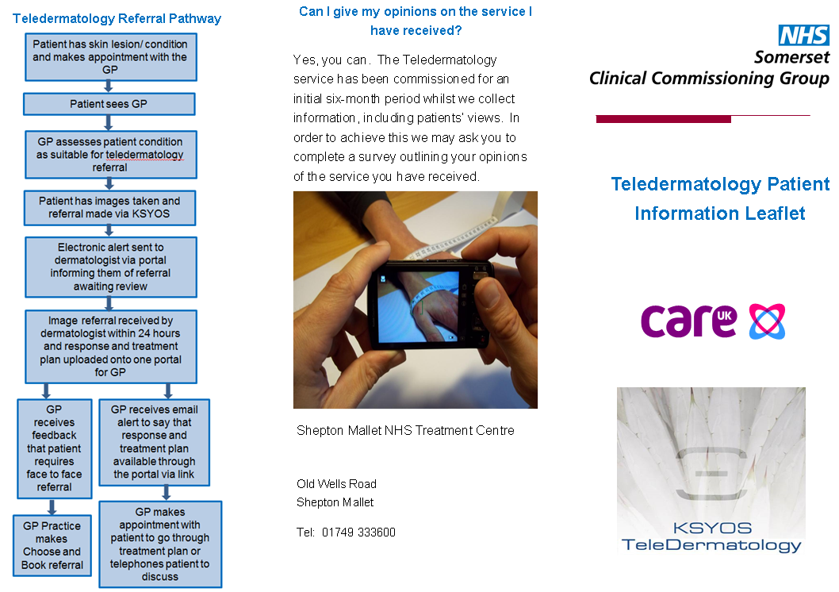
APPENDIX A

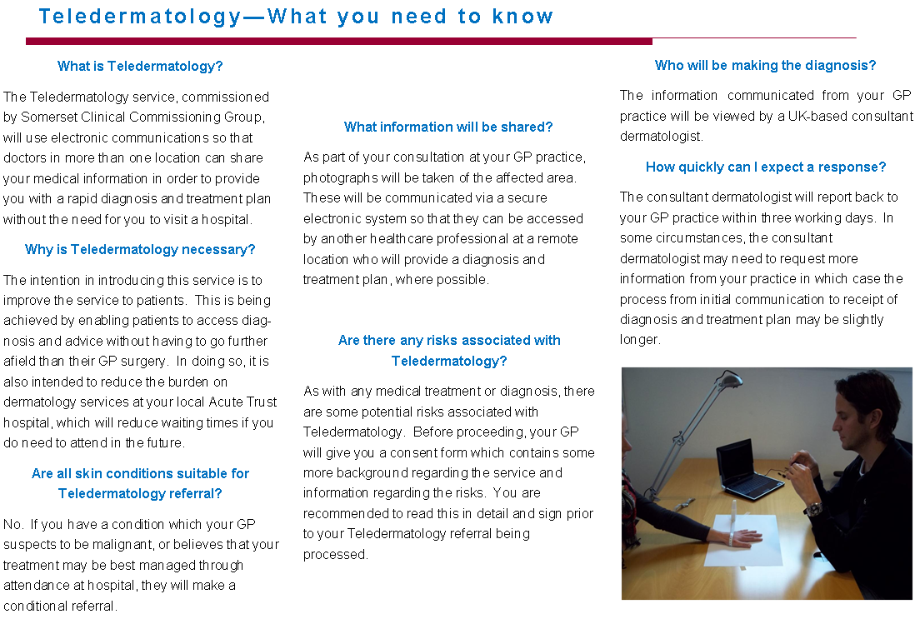
**Tele-dermatology is not advisable for (pre) malignant conditions such as basal cell
carcinoma, Bowen’s disease or melanoma

2nd tele-dermatology consultation can take place via response to treatment plan using portal.
GP receives email to say that response and treatment plan available through the portal via link.
Referral received by dermatologist within 24hours and response and treatment plan uploaded onto portal.
Message sent to dermatologist via portal
informing them of referral awaiting review.
Photographs and referral made via KSYOS portal.
Patient assessed as suitable for
Tele-dermatology referral.
GP attendance - patient has skin lesion/condition
Tele-dermatology Referral Pathway
APPENDIX B

Appendix C
Consent form for the use of digital images with referral for people with skin conditions

Statement of the patient
I confirm that I:
- Have had the process of teledermatology explained to me and I have had the
- opportunity to ask questions about the procedure
- Understand that I have the right to withhold or withdraw my consent at any time
- without this affecting my right to future care
- Am aware that teledermatology is not always a substitute for seeing a hospital
- consultant and that there may be a difference between the diagnostic accuracy of a face-to-face consultation and a teledermatology referral
- Understand that the images will be securely stored.

I consent to use of the recordings (please tick all boxes that apply):
- 1. For medical records only
- 2. To teach appropriate professional staff
- 3. To inform and educate other patients and their families, to whom the images are relevant
- 4. For clinical research and audit
- 5. In publications and electronic publication as long as I am not identifiable in the image. If images are potentially identifiable I will be contacted for specific consent before publication

Signature Date
Name
Relationship to patient if signed on behalf of patient

Statement of healthcare professional
I have discussed the teledermatology service with the patient and provided them with the opportunity to ask any questions.

Signature Date
Name

Photographer
Signature Date
Name

Skin Conditions in the UK: A Health Care Needs Assessment: Schofield, Grindlay, Williams 2009
Quality Standards for Teledermatology – using ‘store and forward’ images. Primary Care Commissioning.
The Health and Social care Act 2008: Code of practice on the prevention and control of infection and related guidance. https://www.gov.uk/government/uploads/system/uploads/attachment_data/file/216227/dh_123923.pdf

