Optimising the health and wellbeing of Somerset - "The Human Five"
I have a fascination about what it is to be human, and with this comes a belief that if we treat ourselves as humans then things are more likely to go right, and conversely if we neglect what it is to be human then things are more likely to go wrong. This is probably not a big revelation to anyone!
We as healthcare professionals are in the business of attempting to improve individuals' and populations' health, and maybe wellbeing. Primary care has the fortune of perhaps being the most "person-centred" [aka human-centred] discipline in medicine. Indeed many of us receive great job satisfaction from knowing our individual patients, and from knowing that our actions have had a positive benefit to patients' health.
With this in mind here is a question:
What can I offer Mrs Jones who is 77 year old, recently bereaved Mrs Jones, lives alone, has type 2 diabetes with an HbA1c of 64, a blood pressure of 152/80, OA of her right knee, anxiety, CKD 3, and a cholesterol of 5.2?
Answer:
metformin, amlodipine, paracetamol (and maybe some codeine), ramipril and atorvastatin (what a relief it is that we no longer throw aspirin in to the mix). Also she gets a blood test every 6 months, and a toe tickle and token dietary advice every 12 months. And I can write to Mrs Jones after receiving a letter from the retinopathy screening service when she DNA'd her annual appointment.
Why do we “manage Mrs Jones in this way?.....because if we didn't Mrs Jones might end up at some point in the future having a foot amputated, a stroke, an MI, going blind and having renal failure.....and all of these would lead to a higher future healthcare costs.....ah yes.....we're saving the NHS (admissions are expensive) and we're improving Mrs Jones's health.
Really?
A few years ago this scenario made me stop and think....could I do better for Mrs Jones and the NHS. I was sure the answer to this was "yes".....followed by "okay, what can I do?"
Around this time I was in the middle of post-grad studies in Sports and Exercise Medicine. I was learning how athletes excel. As I learnt about the biomechanics of running, the psychology or sport and performance, and the marginal gains employed by the British Cycling Team something dawned on me. Athletes excel by optimising all the facets of what it is to be human.
It then dawned on me that the linear "medical model" I was using to improve Mrs Jones's long term health was quite simply far too narrow and actually probably the completely wrong paradigm. No wonder I wasn't enjoying my job as a GP.....I was not only very busy, very tired and wondering how I could do another 30 years of GPing, I was also doing a really rubbish job of assisting Mrs Jones current or future health and wellbeing. (Although I was helping the practice to achieve near maximum QOF points and thus maintaining our business profits).
So, this got me thinking.....a simple solution or concept was needed that would enable Mrs Jones's health and wellbeing to be optimised in our complex healthcare system and even more complex world.
Combining my medical school training (evidence-based medicine and the bio-psycho-social model had been drummed in to me) together with the perspective of being human that studying Sports and Exercise Medicine had provided, and then the analysis of numerous "Mrs Jones's" a universal health and wellbeing model was formed....The Human Five.
It was called The Human Five after I read a book on choosing a catchy name.....start with "The", state what it's about "Human" and add a number "Five"! The number 5 was chosen as the complexity of being human was simplified down to 5 domains; Mind, Movement, Nutrition, World, Body.
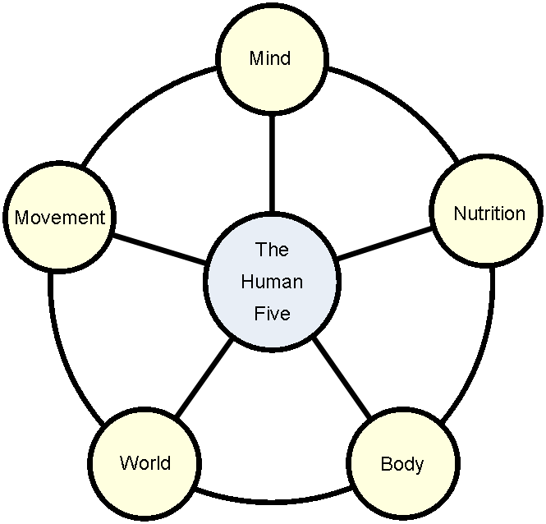
The Human Five framework is purely that....a universal framework in which to view individual and population health and wellbeing. It is a simple paradigm that is inclusive to everyone. It can be used at a individual person level and also on an organisational strategic level allowing numerous separate organisations to aim at a common purpose. It combines prevention and treatment. It lends itself to the adaptability needed in complex systems, whilst encouraging a simple solutions-focussed approach.
In Mrs Jones's case The Human Five framework offers a simple method of ensuring a "person-led" approach with any plans or solutions impacting on what matters most to her. It does not necessarily negate the importance of medical input, but it does ensure medical input is not a sole focus.

Attached to this newsletter is a simple tool......trial it on yourself or with a patient, and please send me any thoughts, ideas, or questions you have about the concept.

Here is a recent “Mrs Jones” case study on which The Human Five was used. It shows the blood results and blood pressure before and 8 weeks after using the model. She was on a statin from 2005 until earlier this year (see the recent cholesterol spike on stopping the statin, but also note her triglycerides were never helped by the statin).Prior to The Human Five "intervention" she was on simvastatin 40mg and indapamide, she stopped the medication prior to the "intervention". She now feels well, has lost 2 stone and is medication free. In this single case the simple approach encouraged by The Human Five has likely saved hundreds or thousands of pounds in NHS costs alone over the coming years.

(Note: total cholesterol is not a good surrogate marker of health, but this graph is included for comparison with the other lipid changes)

