**Lunch and Learn Training Resources from Wessex LMCs**

We are delighted to have arranged for your practices to purchase our Lunch and Learn Training Resources at a preferential rate.

These resources are a Wessex LMC initiative and provide a different way for practices to train their staff as it enables you, on behalf of the practice, to deliver training over the lunchtime period, by giving you all the materials you need.

When you purchase the Lunch and Learn package your payment will trigger access to a PowerPoint presentation and all the relevant accompanying training materials on line, through this page.

You can access the files of any purchased package as often as you like from this website, and we undertake to maintain and keep them up-to-date. We recommend, therefore, that you don’t save your own versions, as these will not be updated automatically.

Benefits of the Lunch & Learn packages:

* They are more cost effective than face to face training
* They can be run whenever & wherever suits you
* They can be run as a multi-disciplinary meeting, with specific groups of staff or with individuals
* When training is being done as a practice, useful practice-wide decisions and discussions can result
* They can be run with new staff as part of their induction
* The resources will be updated by the authors of the training package so you can feel reassured that you are delivering accurate training
* By using the package’s original material, a consistent message will be portrayed to staff who have the training sessions at different times.

Those that are already available to buy at £30 will remain at this price for all practices.

However, those that are currently free to Wessex LMCs’ practices will only cost £15 to your practices as opposed to £30 which is the current price.

The link to access these is here:  <https://www.wessexlmcs.com/lunchandlearn>

Click on the resource that you wish to purchase:

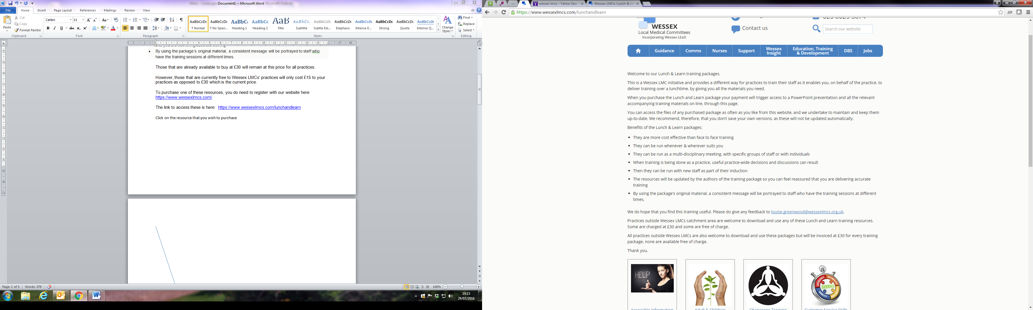

You will see the list of options to pay at the bottom of the page:

Click on the LMC that your practice belongs to so that you can pay the reduced price.

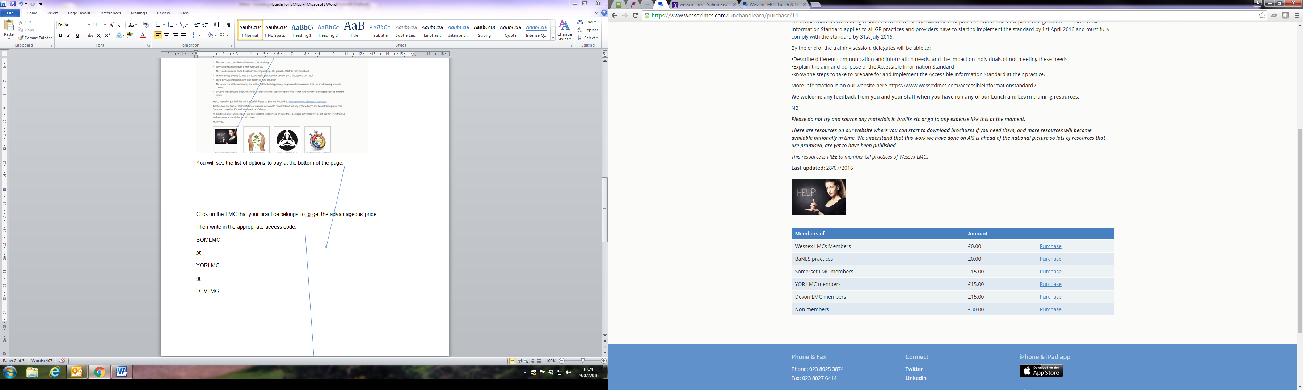

Then write in the appropriate access code here:

SOMLMC

or

YORLMC

or

DEVLMC

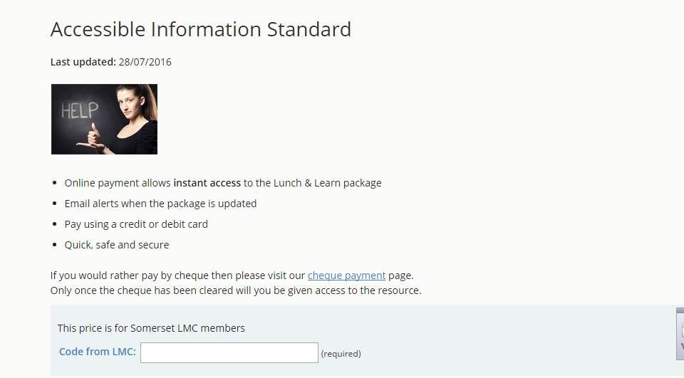

The code does not have a space in it and is not case sensitive

You now have the option to pay online or by cheque.

I do hope that your practices find these helpful

Any problems at all please contact me on [louise.greenwood@wessexlmcs.org.uk](mailto:louise.greenwood@wessexlmcs.org.uk)