**Connecting the Dots**



**February 2024** **Edition**

## **Dear Colleague**

Welcome to the February 2024 edition of this newsletter (previously PC Matters). As you know, our aim for this newsletter is for it to help us work together more easily.

~~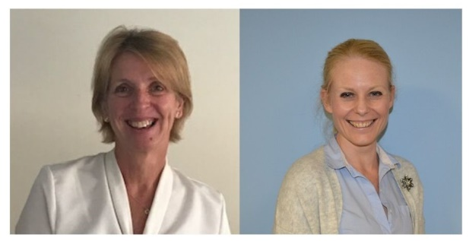~~

**Next Meetings**

Wednesday 28th February 1-2 pm

Tuesday 26th March 2024, 1-2 pm

[Click here to join the meeting](https://teams.microsoft.com/l/meetup-join/19%3ameeting_NjI1OWEyMTAtMzcxNi00NTRlLWFjYjUtMjI2ZTAyZTU0MTQ5%40thread.v2/0?context=%7b%22Tid%22%3a%2298ec91be-8de7-48a3-9e80-0f0180ed9219%22%2c%22Oid%22%3a%22778f8a6f-2dc7-492d-9e37-52f64039fb1a%22%7d)

**Podcast – Episode 1** Dermatology project

[Connecting the Dots - episode 1](https://soundcloud.com/somerset-nhs-foundation-trust/connecting-the-dots-episode-1?si=a56e8212c2e04ad8939a648032016d82&utm_source=clipboard&utm_medium=text&utm_campaign=social_sharing)

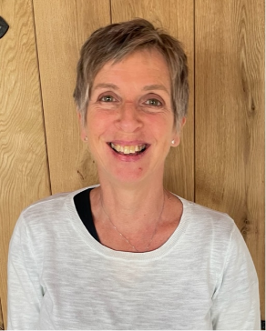

Dr Kathryn Patrick

Dr Andrea Trill

News

You may be able to tell that we’ve had a bit of a make-over (brand wise!) and we

now have three items which sit under the Connecting the Dots umbrella:

1. A monthly meeting via Teams (previously called the Primary Care-Secondary Care collaboration forum)
2. A podcast – as close to monthly as we can
3. This newsletter (previously called PC Matters) – see 2

The idea of the **meetings** it to give us a chance to share projects/ideas and discuss areas that impact on both primary care and SFT. They alternate between the last Tuesday and last Wednesday of the month and will share projects from both SFT, PCNs and practices.

They will be recorded and shortly we will find a way to share that recording via TeamNet.

By varying the days we hope we can encourage as many people as possible to click in - a wider attendance always gives a richer discussion. The meetings are informal and you can dip in and out with no worry about being late etc- videos can be on or off and you may just want to have it running whilst catching up on paperwork, with ‘ears up’ in case something feels more relevant. If you would like the regular invite please email [Beverley.peacey@somersetft.nhs.uk](mailto:Beverley.peacey@somersetft.nhs.uk) and she can send it to you. Why not give it a try and add it as a regular slot that you can make if you can?

The **podcast** is very new and the first edition is hot off the press (see above)! This is also likely to be hosted on TeamNet in the future. As this podcast develops we will have conversations to introduce people and/or work they are doing, ideally with others doing similar things. Let us know what you would like to hear. Apologies for the hesitation, repetitions etc etc – we’ll get better!

This **newsletter** - Kathryn and I try to get this out most months, but occasionally we are overtaken by time! We plan to link some topics in it back to conversations in the meeting and podcast where possible. We also aim to have this on TeamNet but for the time being the LMC are helpfully linking it in their bulletin. A big thank you to them.

If you would like to present at the meeting, have an idea for discussion, join us on the podcase, please do let us know – best way is through Bev on the address above.

At the last CtD meeting

We had a really interesting discussion about the new STEP form which is currently in draft form - hopefully ready in about May. Universally, it was thought to be an improvement, although obviously the challenges of how we share it and importantly how it is used to make sure a patient’s wishes are respected still need to be tackled. Here is a link where you can see two screenshots of the DRAFT new form.



I have picked out some key differences that struck me:

* There is a sentence which clearly states if a current STEP is in place, do not rewrite it unless necessary.
* The language feels more patient and family/carer friendly, especially in the sections ‘what matters to you’ and ‘where best to receive treatment’.
* The specific treatments section has been simplified
* The CPR decision section is quite different and includes a sentence that states “Your healthcare team may advise against a CPR attempt if they believe it would not be successful, considering your clinical situation”, followed up by “Your healthcare team will explain their CPR decision to you and if CPR has been offered, you can refuse it”.

Have a look and please give any feedback to the team via [Charles.davis@somersetft.nsh.uk](mailto:Charles.davis@somersetft.nsh.uk) or [dameon.caddy2@nhs.net](mailto:dameon.caddy2@nhs.net)

*……………………………………………………………………………………………………………*

**PC-SC Interface**

Over the last months and years we have put considerable effort into improving some ‘clunky pathways’ at the interface between general practice and the Trust. Most notably this involves, the issues of onward referrals and secondary care requests for investigations, but there are others. Kathryn and I have worked closely with the LMC and our teams in the Trust to try to improve this but perhaps we have not made as much headway as we would like. An often rapidly changing workforce and many sessional staff doesn’t always help.

So- we are trying a different approach, utilising a wider group from a variety of teams across the Trust to help promote and embed change. We are starting with onward referrals and again working closely with the LMC. Change won’t happen overnight, but we are determined to make a difference. We are lucky in Somerset that because our community, mental health and acute services all sit under one organisation, onward referrals can happen across all these services.

Please be mindful though that NHS guidance states that onward referrals are appropriate for **a non-urgent problem that relates to the initial referring problem or for urgent treatment**. We will bring both of these scenarios into the project, but the issue of referrals arising from outside of general practice may be too much for the start. So, watch this space and we will keep you informed of actions.

*……………………………………………………………………………………………………………*

**Urgent referrals**

Two issues to flag under this title – **paediatrics** and **cardiology**

**Paediatrics** – Despite the current wait for a non-urgent referral in paediatrics being only around 8-10 weeks, the team are finding that they are increasingly seeing non-urgent children referred urgently. This obviously increases the wait for those who truly need an urgent appointment. We appreciate that there are mixed paediatric skills in general practice and also that we all worry about children, but please could we ask that if you believe a referral is urgent, could you consider phoning consultant connect for advice, or checking with a more senior clinician in the team before clicking the urgent button. Thank you

**Cardiology** – Please be aware that if you refer a patient urgently to cardiology, they will need to book an appointment via choose and book and sometimes this appointment may be some months ahead, creating concern. Once the appointment is booked, it triggers the system and the cardiology team are able to triage the referral and upgrade those who need an urgent appointment. This is not ideal and the team are looking at ways to share information to patients about this process, but in the meantime please reassure your patients and encourage them to accept an appointment even if it is some way in the future.

**Practice contact details**

You may be surprised to hear that SFT does not hold a list of email addresses or x-directory telephone numbers for practices. This obviously makes it difficult when we are wanting to share information or make contact. (I’m not quite sure how all the documents reach you, I think they must be an embedded address somewhere). The ICBand the LMC cannot share the information with us, but we would very much like to create a document with the information on.

If you are happy for the Trust to have your practice email address and ideally your x-directory number, please send the details to [Hollie.cashmore@somersetft.nhs.uk](mailto:Hollie.cashmore@somersetft.nhs.uk)

What would also be great would be contacts for key people in your PCN to allow teams to build links to collaborate. Thank you

*……………………………………………………………………………………………………………*

**Ordercomms Update** – Dr Barney Kyle, on behalf of the Digital Team

When it was introduced over a decade ago, Ordercomms revolutionised the way we request and review radiology and pathology investigations. The system is used by healthcare professionals across the whole of Somerset (you may know it as T-quest when using EMIS).

We want to ensure that we have a system in place that will cope with the significant demands that are placed upon it, and that is best suited to the way its users work. As such, we will be replacing Ordercomms with Clinisys ICE (Integrated Clinical Environment). This is an order system linked through EMIS Web for practices to use when submitting pathology orders.

ICE is widely used across the South West region and the move allows us to work towards better information availability for our patients, joining up their care and improving quality and safety.

The switch to ICE is a complex one, with over 30 million pieces of data to move, and multiple other dependent systems to upgrade and integrate. The team have been working hard on this for over a year already, and we hope that our patients and clinical teams can start to benefit from ICE from July 2024.

To allow us to gain from the benefits of ICE as soon as possible, we will be switching to pathology ordering and viewing first, followed by radiology a few months later when the latest version of radiology information system is ready to be used.

We would like help from clinical colleagues across the county to help us ensure that ICE is set up to get the most out of it, and to ensure that it has been thoroughly tested. We hope that you and your teams will be able to contribute to making ICE a success. If you would like to help, please contact Tanya Fitzer who is managing the project. [tanya.fitzer@somersetft.nhs.uk](mailto:tanya.fitzer@somersetft.nhs.uk)

Nearer the time we will provide more details of how the change to ICE might affect you and your clinical areas.

……………………………………………………………………………………………………………

……………………………………………………………………………………………………………

**Ongoing support for patients to prepare for next steps after receiving a life limiting illness diagnosis**

**‘Have you thought about letter’ being piloted at SFT**

SFT is undertaking a pilot which is supporting patients to prepare for next steps after receiving a life limiting illness diagnosis by using the attached letter which offers advice and appropriate signposting. It is being trialled by the lung clinical nurse specialist team at MPH and YDH, heart failure, gynae oncology, upper GI and neurology teams. We are sharing this with you for awareness and in case there any queries from patients. Also, if primary care colleagues would like to join in the piloting of this letter (below), please do so and ask patients for their feedback using this QR code below.

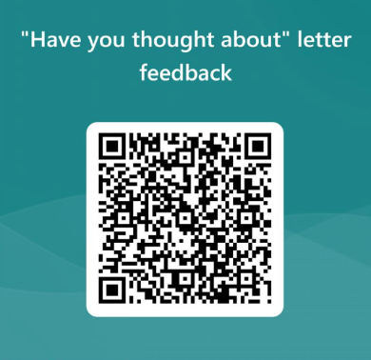



If anyone wants access to the ‘planning ahead’ document or Marie curie leaflet, please contact [amy.giles@SomersetFT.nhs.uk](mailto:amy.giles@SomersetFT.nhs.uk).

For further information, email [Fiona.robinson@SomersetFT.nhs.uk](mailto:Fiona.robinson@SomersetFT.nhs.uk)

……………………………………………………………………………………………………………

**SWISH - Mirena Coil**

The Mirena coil is now licenced as effective for contraception for eight years in the UK, a change in use that is endorsed by the Faculty of Sexual and Reproductive Healthcare.

For use as the progestogen component of HRT, the licence remains at 4 yrs (but used for up to 5yrs) and for the treatment of heavy menstrual bleeding, the licence remains at 5yrs.

For women seeking a coil change, SWISH will now only replace Mirena coils that have been in place for 7 ½ years and please note SWISH currently can only fit or replace Mirenas for contraception and not for HRT purposes

If you have any queries about this change in guidance, please email [SWISH@somersetft.nhs.uk](mailto:SWISH@somersetft.nhs.uk)

*……………………………………………………………………………………………………………*

**Snapshot Evidence – Roxanne Hart, Primary Care Knowledge Specialist**

The library (and Roxanne) are really helpful in finding research and evidence for you and would like to share snapshots of searches they have been asked to do. If you would like to make your own request, please email Roxanne Hart at [LibraryPrimaryCare@SomersetFT.NHS.uk](mailto:LibraryPrimaryCare@SomersetFT.NHS.uk)

**What was asked? “**We are interested in switching from a model where patients come into clinic for their B12 injections to one where we teach patients how to self-administer. Are there any lessons learned from other surgeries who made this change?” [Click for the answer](https://somersetft-nhs.libguides.com/ld.php?content_id=35150483)

*……………………………………………………………………………………………………………*

**Faster Diagnosis Standard for Cancer (and breast care)**

Did you know that across all cancer pathways the 2WW targets have been replaced by a Faster Diagnostic Standard? This target is for all patients to be seen *and* diagnosed within 28 days of referral.

The breast care team ask primary care not to advise patients that they will be seen within 2 weeks as this is often not the case. “We are currently unable to update the wording on the E-Referral system but are hoping this will be done by the national teams ASAP to avoid confusion”.

Breast Screening contact details: 01823 342425. Please update this on any contact lists you have.

Thank you