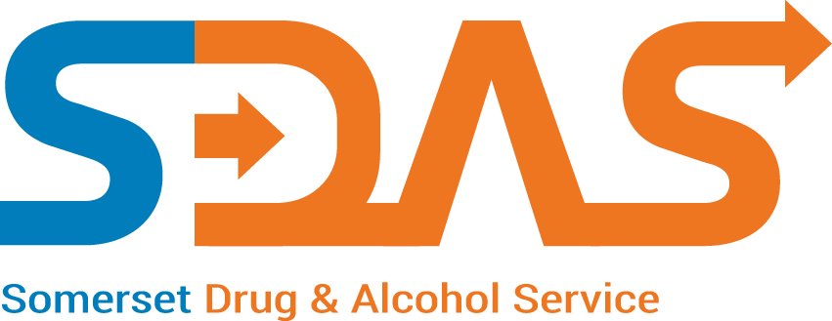
Practice Name
Shared Care Local Enhanced Service
Payment Claim Form
2023/2024
Name of person
Completing form
Claiming for Qtr

  - Start date means the first appointment with either the specialist drugs worker or GP after agreement has been reached with all parties including the patient to pursue this form of treatment

Invoice Number: ________ (SDAS use only)

Patient Initials | Date of Birth | Input date |  | Name of Specialist Drugs Worker i.e. Shared Care Nurse only
 |  | Start date (dd/mm/yy) of  shared care treatment | Finish date (dd/mm/yy) of shared care treatment or ‘ongoing’ if appropriate

Please complete and return to: Shared Care Payments, SDAS, 9 Westminster Way, Bridgwater, TA6 4GB or email to: Julie.barnard@turning-point.co.uk

