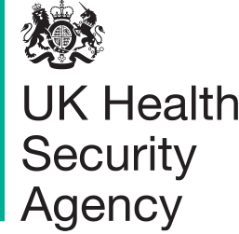

Measles
Communications toolkit for UKHSA stakeholders

The UK Health Security Agency (UKHSA) is working with partners in the NHS, local authorities and national government to protect people from measles, including the most vulnerable amongst us.
This toolkit aims to support stakeholders with messages to help protect people from measles. It contains background information, social media assets and suggested copy, resources for health professionals, and other useful information.
The information provided is correct as of 18 January 2024.

Further information:
For further information about our national communications please contact: externalaffairs@ukhsa.gov.uk
For further information about our regional support please contact your UKHSA regional communications lead.
Sign up to our Stakeholder Cascade to receive a weekly newsletter with the latest news, updates and guidance from UKHSA
Follow UKHSA on X (Twitter): @UKHSA
Visit our website at GOV.UK

Contents

Further information: 1
Measles general information 2
Key messages on MMR vaccine 3
NHS advice 3
MMR vaccine general information 3
Measles communications assets for raising awareness amongst the public 4
Information for health professionals 5
Suggested post copy social media assets 6
Statistics 12
Template UKHSA regional statement 12
Template communications article for internal / external channels on MMR vaccine call 13

Measles general information

Measles spreads very easily among those who are unvaccinated. It is particularly easy to catch in environments when in close contact with others, especially in nurseries and schools,

Measles can be a very unpleasant illness. In some children it can be very serious and lead to hospitalisation – and in rare cases tragically can cause death. People in certain at-risk groups including babies and young children, pregnant women, and people with weakened immunity, are at increased risk of complications from measles.

Symptoms include a high fever, sore red watery eyes and a blotchy red-brown rash.

Having two doses of the Measles, Mumps, Rubella (MMR) vaccine is the best way to prevent it.

There have been recent, localised outbreaks, including (at the time of writing) an ongoing outbreak centred around the West Midlands region of England. Uptake of MMR in the region is much lower than the 95% needed to protect the population, which is giving this serious disease a chance to get a foothold in our communities. Achieving high vaccination coverage across the population is important as it also indirectly helps protect very young infants (under one) and other vulnerable groups.
UKHSA is rapidly investigating the source of these infections and is following the epidemiology and the evidence of where transmission is occurring to target messaging; ensuring clear facts are communicated about increases in cases and what people need to do.
This communications toolkit is to support UKHSA and its partners with managing communications and signpost to the latest materials.

Key messages on MMR vaccine
- Measles spreads very easily among those who are unvaccinated, especially in nurseries and schools, and can be a very unpleasant illness and in some children can be very serious and lead to hospitalisation – and in rare cases tragically can cause death. Vaccines are our best line of defence against diseases like measles and help stop outbreaks occurring in the community.
- We are calling on all parents and guardians to make sure their children are up to date with their 2 MMR doses. To see if your child is up to date with their MMR vaccines, check your child’s personal child health record (PCHR), known as the red book, or contact your GP practice.
- It is never too late to catch up. The MMR vaccine is free on the NHS, whatever your age. If anyone has missed one or both doses of the MMR vaccine, contact your GP practice to book an appointment.

NHS advice
There is information on measles on the NHS website. This includes advice to parents and carers to check if their child has measles, including photos of the measles rash. The rash looks brown or red on white skin. It may be harder to see on brown and black skin.

Measles is a highly infectious viral illness, so anyone with symptoms is advised to stay at home and phone their GP or NHS 111 for advice, rather than visiting the surgery or A&E, to prevent the illness spreading further.

There is information available from the NHS on the MMR vaccine.

MMR vaccine general information

Vaccines are our best line of defence against diseases like measles and help stop outbreaks occurring in the community.

Children are offered the first dose of the MMR vaccine when aged one year and the second dose aged 3 years 4 months.

In recent years, the number of children vaccinated against measles has fallen. Uptake for the first dose of the MMR vaccine – which protects against measles, mumps and rubella – in children aged 2 years in England is 89% and uptake of 2 MMR doses in children aged 5 years is 85%. This is well below the 95% target set by the World Health Organization (WHO), which is necessary to achieve and maintain elimination.

We are calling on all parents and guardians to make sure their children are up to date with their 2 MMR doses. It’s never too late to catch up, and you can get the MMR vaccine for free on the NHS whatever your age.

Measles communications assets for raising awareness amongst the public

There is further information below which you may wish to use on your own channels:
- We have created a variety of social media assets which encourage people to check they and their children are up to date on their MMR vaccines.
- A video from Dr. Colin Campbell, Consultant Epidemiologist at UKHSA, who explains how infectious the measles virus is and information on the vaccine.
- We also have a blog on immunisations in which Vanessa Saliba, UKHSA's Consultant Epidemiologist for Immunisations, outlines the importance of protecting children through vaccination.
- Other publications and assets on MMR for can be downloaded and ordered for free by healthcare professionals on the health publications website.
- UKHSA resources on immunisation can be found on our website.
- We also have a blog on immunisations in which Vanessa Saliba, UKHSA's Consultant Epidemiologist for Immunisations, outlines the importance of protecting children through vaccination.

Example assets below:

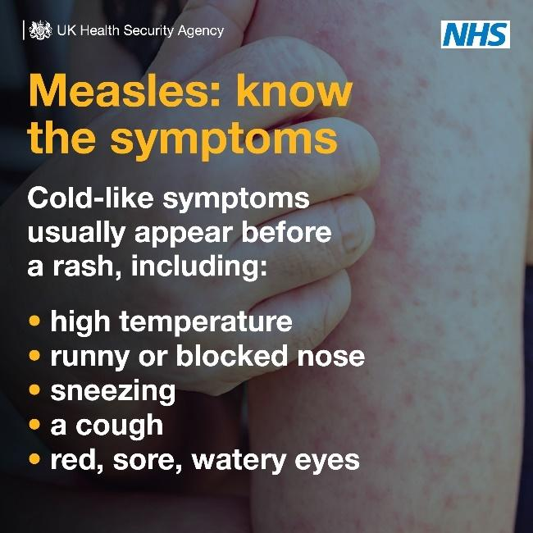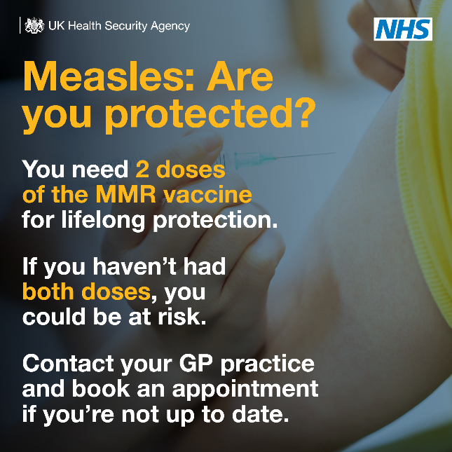

Information for health professionals

- Following UKHSA modelling published earlier in the year, a joint letter from UKHSA and NHS England was sent to health professionals and Directors of Public Health in England to remind colleagues of the risk of a measles outbreak in London due to the sub-optimal uptake of the MMR vaccine in the capital. The letter also notes that outside of London, there is high risk of cases linked to overseas travel in specific population groups.
- UKHSA has produced a new poster for health professionals in identifying measles, what to do if they suspect measles and ensuring staff are fully vaccinated. Health professionals can download and order the poster for free via the health publications website.
- Other publications and assets on MMR for can be downloaded and ordered for free by healthcare professionals on the Health Publications website. Many of these resources are available in translated community languages including: Afrikaans, Albanian, Arabic, Bengali, Brazilian Portuguese, Bulgarian, Cantonese, Chinese (simplified), Chinese (traditional), Estonian, Farsi, Greek, Gujarati, Hindi, Italian, Latvian, Lithuanian, Panjabi, Pashto, Polish, Portuguese, Romanian, Romany, Russian, Somali, Spanish, Tagalog, Turkish, Twi, Ukrainian, Urdu, Yiddish and Yoruba.
- UKHSA resources on immunisation can be found on our website.
- Health professionals are being reminded about what do in a suspected case of measles; details of the MMR vaccine and how best to reach under-vaccinated communities. Example of poster for health professionals to use in healthcare settings below:

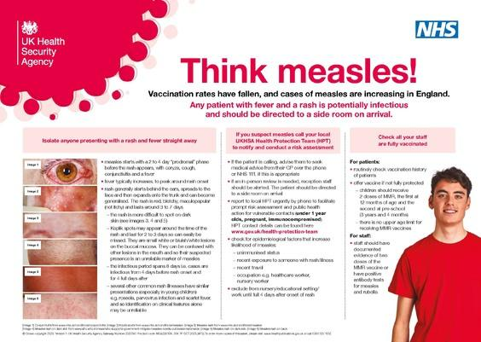

Suggested post copy social media assets

Measles
Suggested post copy | Graphic | Alt text
Measles spreads easily.  Anyone who is not vaccinated can catch it.  Measles can have serious and sometimes fatal consequences, so make sure you’re up to date with #MMR vaccinations, and ask your GP practice about catch up jabs if needed. |  | GIF. What is measles? It’s a viral illness that spreads very easily. It can be serious and sometimes fatal. Symptoms of measles: include high fever, runny nose, cough, red and watery eyes, small red spots with a bluish-white centre inside the mouth. A rash can appear later, usually on the face, upper neck, hands and feet, fading after 5 to 6 days. If you’ve not been vaccinated against measles you can be at risk, but it’s most common in young children. Someone with measles can spread the virus up to 4 days before a rash appears, and up to 4 days after.
Measles can kill.  But 2 doses of the #MMR vaccine can offer protection for life. Make sure you & your loved ones are up to date with their jabs, and if not, contact your GP practice for a catch up appointment. |  | GIF. Measles can kill. Is your child protected? Vaccinate to protect your child against measles, mumps and rubella. Two doses of MMR give protection for life. Make sure your child is up to date: At 1 year. At 3 years 4 months. Contact your GP if your child has missed any vaccinations. Adults who missed out on the MMR in childhood can catch up at any time. Visit nhs.uk/MMR for more information.
If you’re planning to travel abroad during the school holidays, make sure to check your child is up to date with their vaccinations, including the #MMR vaccine. Contact your GP practice to book any catch up jabs before you travel ✈🚢🚉 | 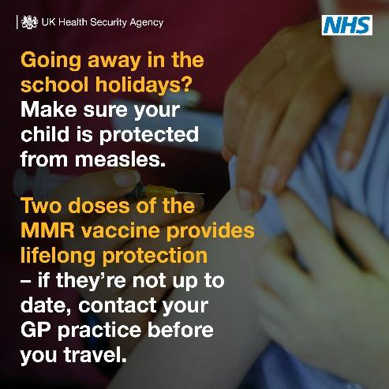 | Going away in the school holidays? Make sure your child is protected from measles. Two doses of the MMR vaccine provides lifelong protection – if they’re not up to date, contact your GP practice before you travel.
Measles can have serious and sometimes fatal consequences, and is still common in many countries worldwide. Before you travel, make sure you & your loved ones are up to date with #MMR vaccinations. | 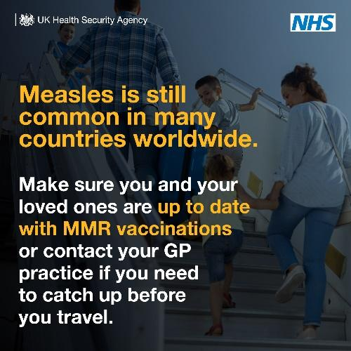 | Measles is still common in many countries worldwide. Make sure you and your loved ones are up to date with #MMR vaccinations or contact your GP practice if you need to catch up before you travel.
Getting lifelong protection against #measles is simple – you just need to have 2 doses of the #MMR vaccine. If you think you or a loved one isn’t up to date, contact your GP practice to book a catch up appointment. | 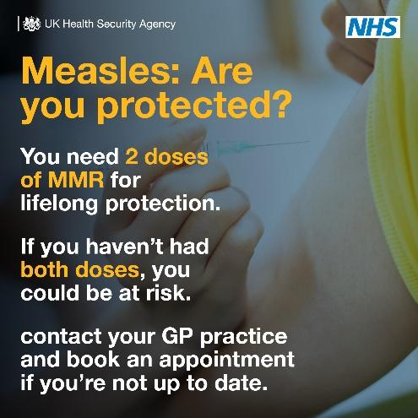 | Measles: Are you protected? You need 2 doses of MMR for lifelong protection. If you haven’t had both doses, you could be at risk. Contact your GP practice and book an appointment if you’re not up to date.
Here’s what you need to know about #measles, from the signs and symptoms to look for to what to do if you think you or your child has measles.  More info: https://www.nhs.uk/conditions/measles/ |  | GIF. Measles: know the symptoms  Cold-like symptoms usually appear before a rash, including:  - High temperature  - Runny ot blocked nose  - Sneezing  - A cough  - Red, sore, watery eyes  The measles rash. A rash usually appears a few days after the cold-like symptoms. The spots are sometimes raised and join together to form blotchy patches. They’re not usually itchy. The rash looks brown or red on white skin. It may be harder to see on brown and black skin. Spots in the mouth. Small white spots may appear inside the cheeks and on the back of the lips a few days later. These spots usually last a few days. Call ahead. If you think you or your child have measles, call your GP surgery or NHS 111 first, before turning up at a healthcare setting. This will help to stop the virus spreading.
*Please note: The following graphics are meant to be used as part of a carousel, and not as standalone graphics*
#Measles can be a serious infection that can lead to complications, especially in young children & those with weakened immune systems.  We’re reminding parents on what signs and symptoms to look out for and what to do if they think their child has measles.  Measles spreads easily but it is preventable. Make sure you & your loved ones are up to date with your #MMR jabs or catch up on any missed jabs.  More info: https://www.nhs.uk/conditions/measles/ | 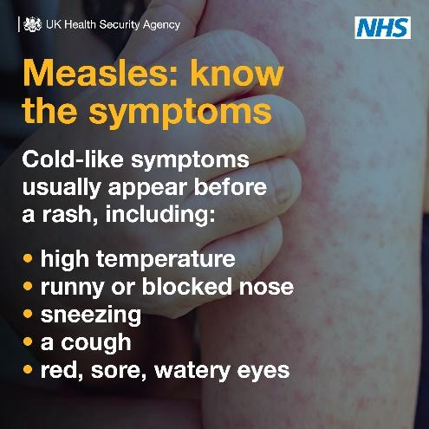 | Measles: know the symptoms  Cold-like symptoms usually appear before a rash, including:  - High temperature  - Runny ot blocked nose  - Sneezing  - A cough  - Red, sore, watery eyes
 | 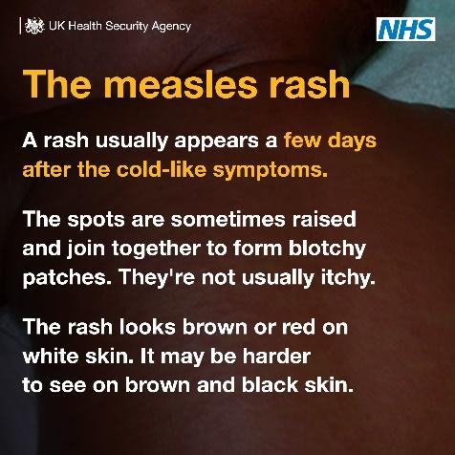 | The measles rash. A rash usually appears a few days after the cold-like symptoms. The spots are sometimes raised and join together to form blotchy patches. They’re not usually itchy. The rash looks brown or red on white skin. It may be harder to see on brown and black skin.
 | 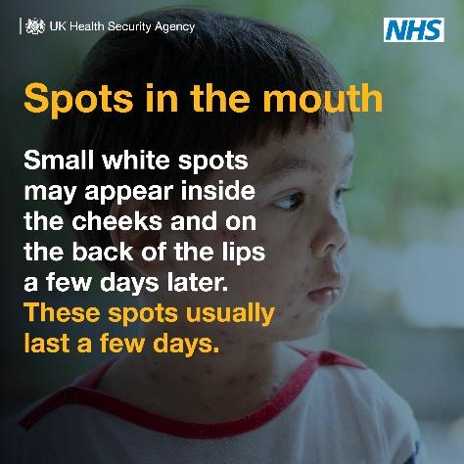 | Spots in the mouth. Small white spots may appear inside the cheeks and on the back of the lips a few days later. These spots usually last a few days.
 | 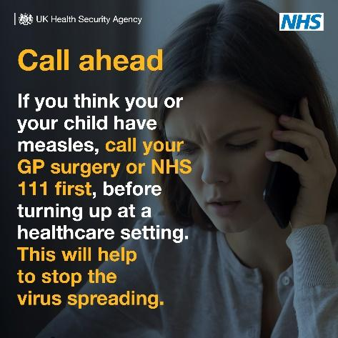 | Call ahead. If you think you or your child have measles, call your GP surgery or NHS 111 first, before turning up at a healthcare setting. This will help to stop the virus spreading.

Statistics

UKHSA publishes confirmed cases of measles in England by month, age and region: Measles epidemiology statistics. At the time of writing, this was last published on 15 January covering cases to November 2023.

Template UKHSA regional statement
Specialists from the UK Health Security Agency (UKHSA) are working with NHS and local authority partners following xx confirmed cases of measles in a (LA) school.
To help reduce the risk of further measles cases UKHSA is advising everyone to be alert to signs and symptoms and urge people to check their families are fully vaccinated against measles.
Measles is extremely infectious and sadly in some instances can have very serious long term and life changing consequences. The best protection against measles is the MMR vaccination.
It is important that anyone who hasn’t already had two doses of the MMR vaccine contacts their GP surgery for an appointment to get vaccinated.
The symptoms of measles can include cold-like symptoms, sore red eyes, a high temperature and a red-brown blotchy rash. If you experience these symptoms seek medical attention but be sure to phone ahead before you visit your GP surgery or other healthcare setting, so arrangements can be made to prevent others from being infected.
Notes to Editors
For further information about measles, please visit https://www.nhs.uk/conditions/measles/
Information about the MMR vaccine can be found by visiting https://www.nhs.uk/conditions/vaccinations/mmr-vaccine/

Local Authority media handling
Any media queries relating to measles or MMR please liaise closely with your UKHSA regional contact.

NHS media handling
NHS colleagues please liaise with your NHSE regional team.

Template communications article for internal / external channels on MMR vaccine call

Measles cases prompt MMR vaccine call

UKHSA has reported an increase in measles across the country including area and is encouraging people to check that they and their children have had two doses of the MMR vaccine.

The free MMR vaccine is a safe and effective way of protecting against measles, as well as mumps and rubella.

It’s important for parents to take up the offer of MMR vaccination for their children when offered at 1 year of age and as a pre-school booster at three years, four months of age. If children and young adults have missed these vaccinations in the past, it’s important to take up the vaccine now from GPs, particularly in light of the recent cases.

Check your child’s Red Book to see if they’ve received MMR vaccinations as scheduled or check with your GP surgery if you’re unsure. Most healthy adults will have developed some immunity to measles but can still receive two doses of the vaccine from their GP too.

Anyone with symptoms is also being advised to stay at home and phone their GP or NHS 111 for advice.

Measles symptoms to be aware of include:
- high fever
- sore, red, watery eyes
- coughing
- aching and feeling generally unwell
- a blotchy red brown rash, which usually appears after the initial symptoms.

For more information about measles, see the nhs.uk website.

