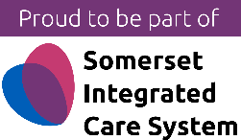
Wednesday 13th September | Strategy Discussions
Wednesday 27th September | Child Protection Conferences
Wednesday 11th October | Effective Support for Families Threshold Guidance and completing an EHA
Tuesday 31st October | Mental Capacity
Thursday 9th November | Vulnerable adults
Wednesday 22nd November | Domestic Abuse
Wednesday 6th December | Supporting families with neglect
Tuesday 19th December | Self-neglect
Wednesday 10th January | Effective Support for Families Threshold Guidance and completing an EHA
Wednesday 24th January | Strategy Discussions
Wednesday 7th February | Child Protection Conferences
Thursday 22nd February | Mental Capacity
Wednesday 6th March | Vulnerable adults
Wednesday 20th March | Domestic Abuse
Wednesday 10th April | Supporting families with neglect
Wednesday 24th April | Self-neglect

Back to Basic Safeguarding Lunch and Learn
Join us virtually for Back to Basic Safeguarding Lunch and Learn Sessions.
12.30-2pm (dates and topics listed above)
To book a place contact the ICB strategic safeguarding team: somicb.safeguardingandcla@nhs.net

