Thrombophilia Screening
Somerset Pathology Services are now screening thrombophilia screen:
BSH Guidelines:
- Testing for heritable thrombophilic traits after a venous thrombotic event is not recommended as a routine to guide management decisions (Grade 2B).
- We do not recommend offering routine thrombophilia testing to first-degree relatives of people with a history of VTE (Grade 2B).
- Testing for heritable thrombophilia is not recommended in patients with stroke, regardless of age (Grade 1A).
- We recommend against heritable thrombophilia screening in women with pregnancy complications, such as recurrent miscarriage or adverse pregnancy outcomes (Grade 1A).
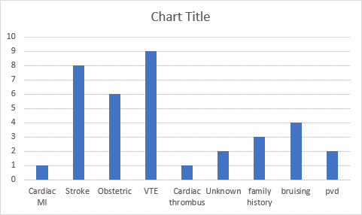
Take home messages- we would suggest discussion prior to requesting thrombophilia screening.
- Most common mutations (up to 5% of the population confer SMALL absolute increase in risk for first time VTE- most carriers never experience a VTE
- Not strong predictors of recurrent VTE
- Do not affect acute management and clinical risk factors generally guide long term management
- Family history associated with increased risk irrespective of mutations
Important harms: false reassurance by negative test, unnecessary anxiety. Insurability, cost
In our experience:
- Frequently the wrong test is ordered
- Wrong decision based on test result
- Cost of testing- approx. £200

