Media inquiries and interview bids to Helen Ashley, NHS Somerset Mobile 07825 681604. Email somicb.communications@nhs.net

Homelessness Health in Somerset - the Homeless and Rough Sleeper Nursing Service wins prestigious NHS Parliamentary Award as NHS celebrates its 75th birthday
News Release 5 July 2023
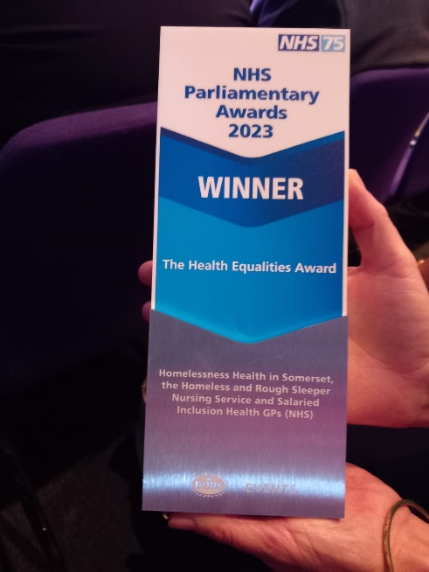

At the NHS Parliamentary Awards held in London this afternoon to coincide with the NHS 75th birthday, it was announced that Somerset’s Homelessness Health in Somerset - the Homeless and Rough Sleeper Nursing Service was the overall winner, in the Health Equalities Award category, after having been nominated by Taunton Deane MP Rebecca Pow.
In Somerset, hundreds of people are affected by homelessness every year; including those sleeping on the streets. They are some of the most vulnerable patients in our county, often with complex health needs.
People who are homeless, or vulnerably housed, face huge barriers to accessing healthcare and experience some of the most severe health inequalities, reporting much poorer health than the general population.
Drug and alcohol difficulties are common amongst the homeless population who are also more likely to struggle with their mental health and have experienced significant trauma in their lives.
Somerset Rough Sleepers and Homelessness Nursing Service
Since 2021, the NHS in Somerset, has been working in partnership with colleagues in Somerset Council’s Public Health Service, the voluntary sector and Somerset NHS Foundation Trust to support the health of those experiencing homelessness and other vulnerable communities such as street workers. By pulling together different funding streams and partners across the whole health system, this collaborative and strategic approach has had a huge positive impact on supporting those most at risk of experiencing health inequalities.
Homelessness Health in Somerset Service, supported by Inclusion Health GPs, is funded by NHS Somerset, Somerset NHS Foundation Trust and Somerset Council. This service recently secured additional funding from NHS England to add a mental health support service to the existing service to become one of only a few services in the country to provide a joint physical and mental health service to those experiencing homelessness.
GP Laura Devlin said: “We are delighted to have been able to join colleagues from Somerset NHS Foundation Trust and Somerset Council to collect this prestigious award on behalf of the Somerset Rough Sleepers and Homelessness Service.”
GP Lisa Horman said: “This innovative joined up approach has allowed us to provide an exceptional health and wellbeing offer for this incredibly vulnerable group of adults in Somerset with a focus on prevention, early intervention and treatment for both their physical and mental health.”
Karen George, Clinical lead for the Homelessness Health in Somerset Service at Somerset NHS Foundation Trust who , was also at the Awards says: “Whether it’s a park bench in Taunton, a field in Wincanton, or one of the hostels in Yeovil, we will deliver care to those who need it, in a location that works for those experiencing homelessness.”
Professor Trudi Grant, Executive Director of Public and Population Health, joint appointment between Somerset Council and NHS Somerset said: “It is an incredible achievement to have won this prestigious award. Working in this joined-up way is so important when it comes to working with vulnerable groups. Everyone involved should be incredibly proud of winning this award, as I am.”
ENDS

