12 May 2023
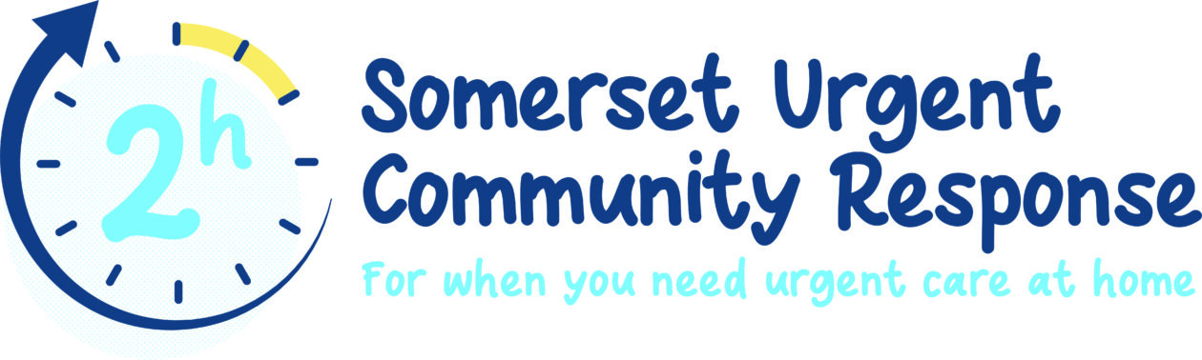
We are contacting you to let you know that we delivered posters and flyers for your staff to help them understand how they can refer into the Somerset Urgent Community Response service which will have arrived with you last month.
If you have patients who have a crisis in their health for example a fall, or a sudden deterioration in their health and need urgent care we can help. We can provide urgent care in a patient’s home within two hours of receiving a referral from you. The service is open 7 days a week 8 a.m. – 8 pm, 365 days a year.
Please could you :-
- put the staff posters up in your staff rooms and call centres
- distribute the flyers to staff who may need to refer into our service
- could GPs put the patient posters up in their waiting rooms
- include the article below in your internal staff newsletters and intranet
The article below includes a link to our video with more information about our service and how your staff can use the referral process (via Somerset Primary Link) to help your patients access Somerset Urgent Community Response.
Finally, I have attached PDF versions of the posters and referral flyers we have produced so you can print out additional ones should you need them.
Thank you so much for your continuing support.
Melanie Stovold
Somerset Ageing Well Programme Manager
Article for internal newsletters and intranet
Please could you include this article on your intranet/staff newsletters
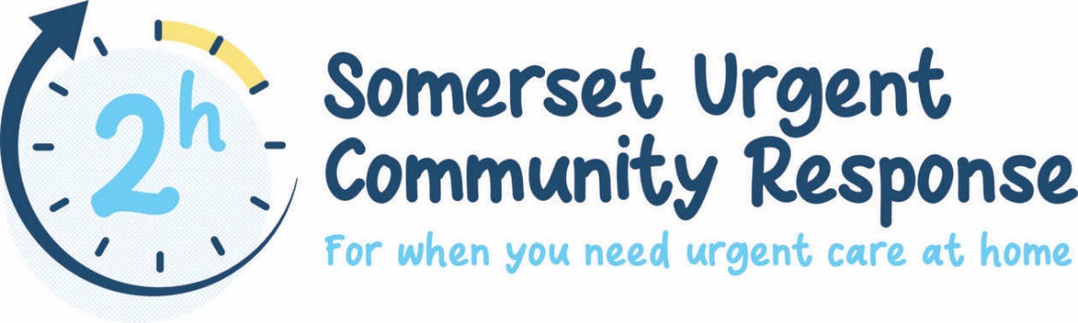
Helping your patient access urgent care in their homes within two hours of a referral
We know, given a choice, many people would prefer to be cared for at home rather than having to go to hospital. If you have a patient who is having a crisis in their health, we can help.
The Somerset Urgent Community Response team will come out to your patients within two hours of receiving a referral. We are here for anyone over 18 and are open 365 days a year from 8 a.m. – 8 p.m.

What is urgent care?
You can call us if a patient has suddenly deteriorated, for example, when they have become suddenly become less mobile, have had a fall, their informal carer or end of life arrangements have broken down, or they are experiencing confusion or delirium.
We can help a patient maintain their independence at home by sending one of our highly qualified health professionals out within two hours of receiving a referral.

Your patient is in safe hands
The NHS team at Somerset Urgent Community Response brings together a wide range of skills including advance clinical practitioners, district nurses, physiotherapists who can assess and treat your patient’s urgent healthcare needs and pharmacy technicians, who can review and help understand their medication.
Our teams have lifting equipment so we can help a patient who has fallen to get back on their feet.

We will make sure your patient gets the right help
Importantly, we don’t just treat the symptoms, but we will carry out an assessment to understand why the patient has become unwell. Where necessary, we can refer them onto other health and social care services for help to try and prevent a crisis in their healthcare happening again.

How do I make a referral as a healthcare professional?
If you are looking for more information on how you can make a referral watch our video please click here.
To make a referral please contact Somerset Primary Link 01749 836700 and press Option 1.
Please provide a summary of the patient’s condition when you contact us and where possible provide their patient number.
Want to know more?
Please watch our video to understand more about the sort of patients we can help.

