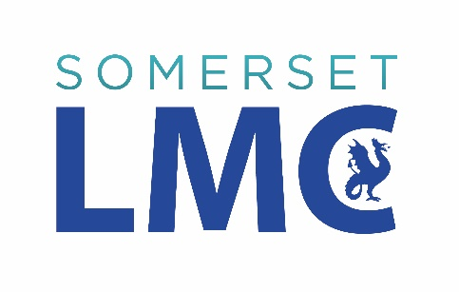

*(insert date)*

Dear Sir/Madam

**Pupil exemption letters**

This advice letter is issued from Somerset Local Medical Committee (LMC) as the official representative body of GPs across Somerset.

We are writing to youas it has been brought to our attention thatpupils, parents and carers from *(insert name of school)* are contacting their GPs asking for letters of exemption.   
  
The examples listed below are non-NHS work. It is **not** the responsibility or function of GPs to provide such letters for pupils:

* For face mask exemption
* To allow pupils to use toilet facilities during lesson time
* As evidence of dietary requirements / food intolerances
* To provide prescriptions for over-the-counter medicines
* To confirm COVID-19 diagnosis
* To confirm short-term sickness absence
* To provide sickness certification for students that that miss an exam or believe their performance was affected due to illness
* To be excused from lessons

We would politely ask that you review and update your school’s policy in line with our advice.

GPs will continue to ensure that the healthcare needs of their patients continue to be met in accordance with NHS and Government guidance.

We hope that this guidance provides some clarification that educational exemption letters are not the responsibility of general practice and are very happy to discuss further should you wish.

Yours faithfully



**Dr Justin Geddes**  
**Medical Director**Somerset Local Medical Committee