Rapid Access Chest Pain Clinic Referral Criteria
The Rapid Access Chest Pain Clinic provides timely and efficient investigation for patients with cardiac sounding chest pain of either new onset or with progressive symptoms. Emergency Department and Same Day Emergency Care Referrals will be triaged by the Acute Cardiology Assessment Team.

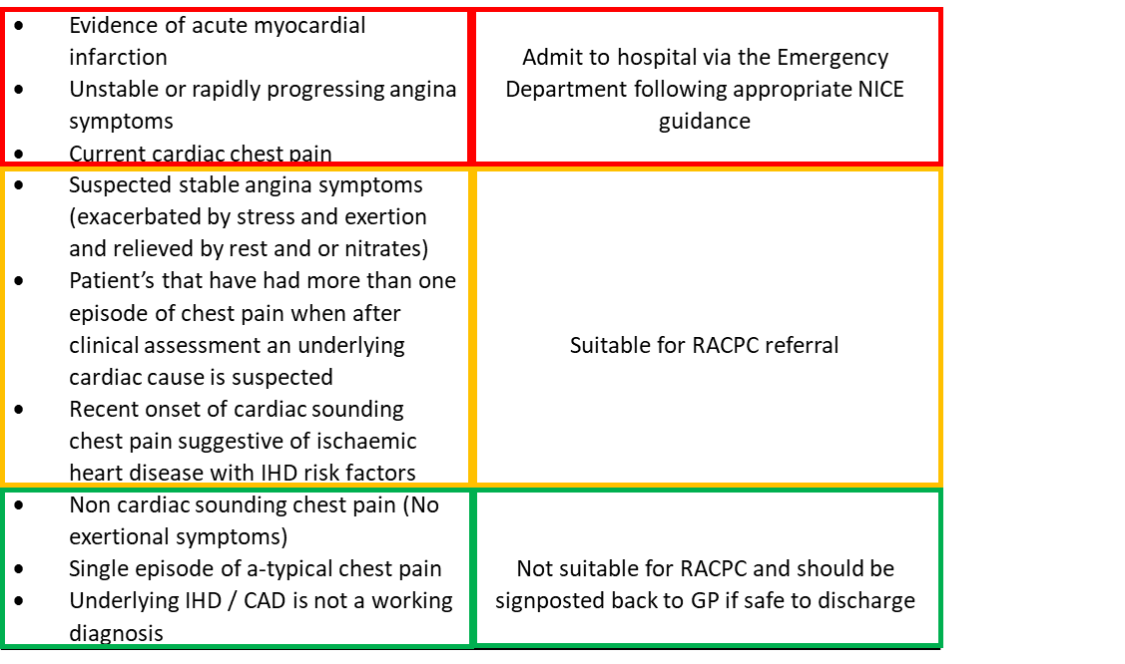Key points for further consideration:
Women under 40 or men under 30 years old have a very low prevalence of significant CAD and should not be referred to RACPC unless they have a good anginal history and/or very adverse risk factor profile.
Patients with a known chronic total occlusion, are currently being investigated by Cardiology, have been previously investigated in the last 12 months with evidenced CAD who are for medical management only, or those who have had an angiogram or CTCA in the last 2 years with negative results are unlikely to be progressed for further investigation.
Arrhythmias, palpitations, heart failure, valve disease, new murmurs and those with complex medical history or multiple pathologies should be considered for specific Cardiology referral.
N.B Please give lifestyle and specific IHD risk factor advice, consider regular bisoprolol, anti-angina medication, aspirin, statins and a GTN spray for all patients being referred to the Rapid Access Chest Pain Clinic. In all cases give red flag ACS advice and advise a low threshold to seek further medical advice if symptoms change or worsen.

