ACCESSING SIDeR VIA EMIS WEB

By using this guide you will be able to use the Somerset Integrated Digital electronic Record (SIDeR) Shared Care Record (SSCR) to view real-time health and social care data for your patient.

All user activity on SIDeR is audited, you cannot edit or delete audit trail entries.

- Open the patient summary record in EMIS.
- Click on the left-hand tab ‘View - > My Record (No shared data) The tab will turn yellow as you hover over it
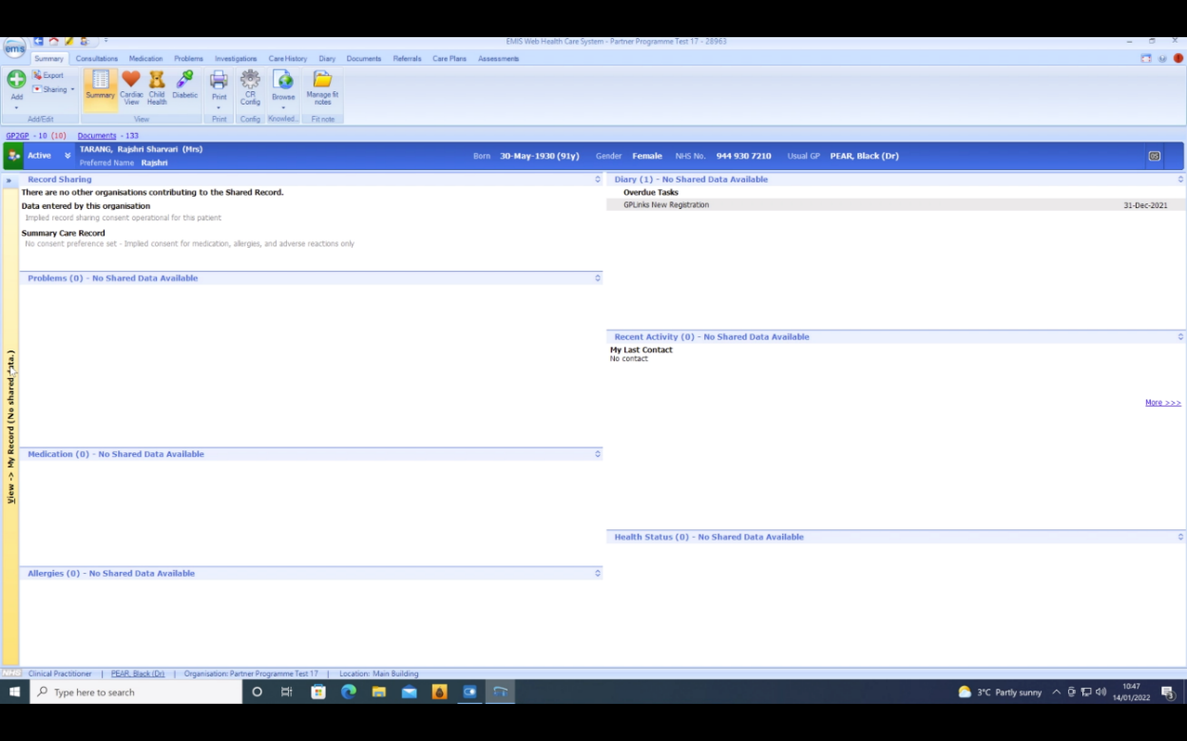

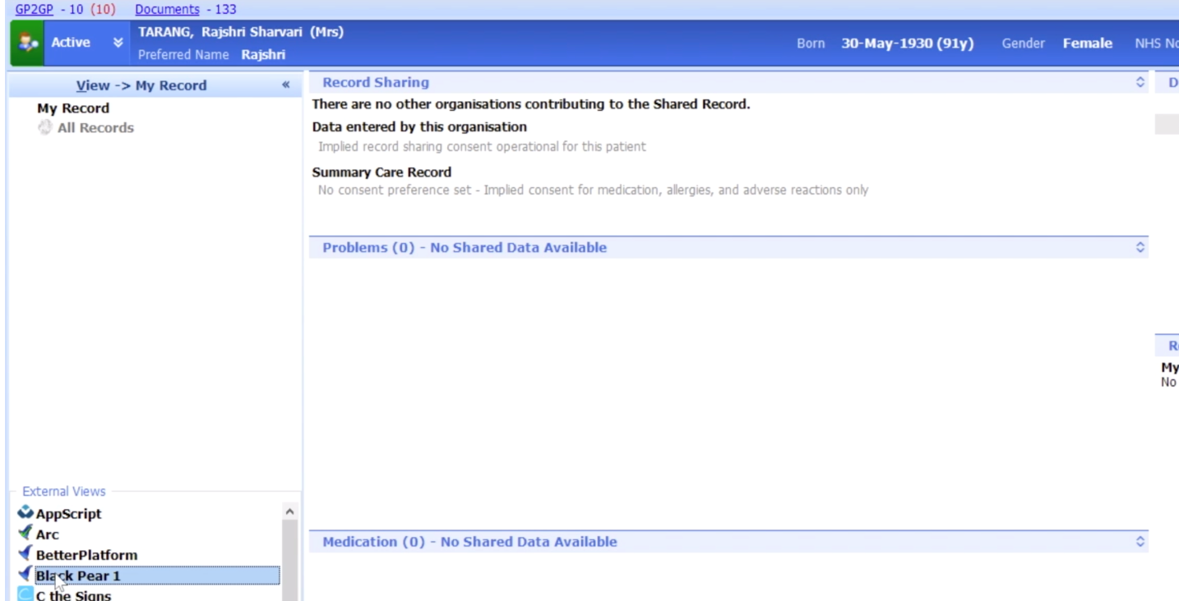
- Select ‘Black Pear Core’ from the options available

- Click ‘Launch Black Pear Core’
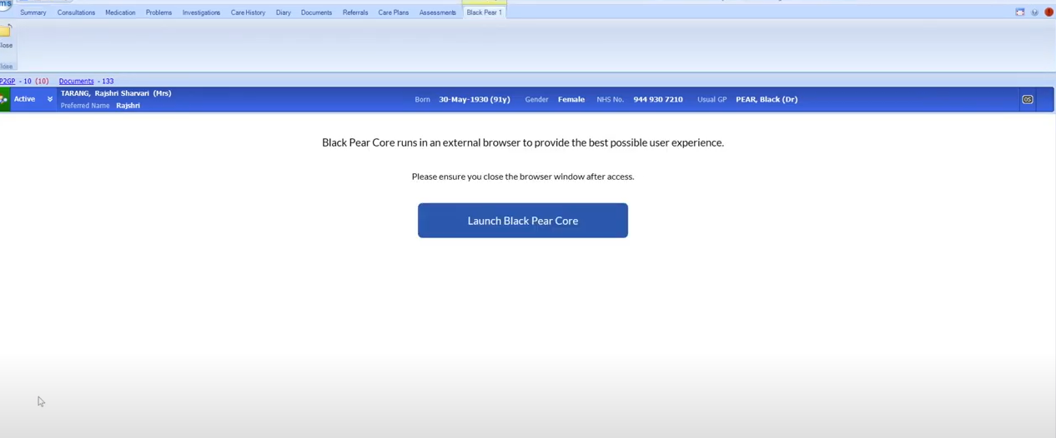
- This will open a pop-up window containing the SIDeR Shared Care Record for the patient you have open in EMIS. As SIDeR is for direct care only (which includes creation of a shared form/care plan on behalf of a clinician) the information box below will be displayed, click ‘I am providing individual care for this person’.
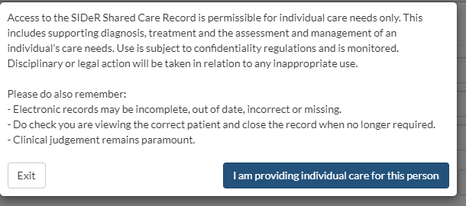

- SIDeR will open on the summary screen:
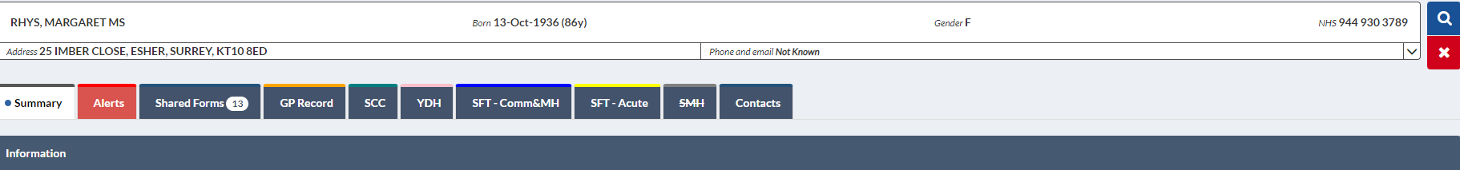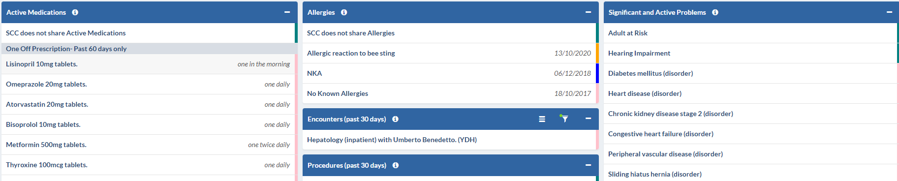
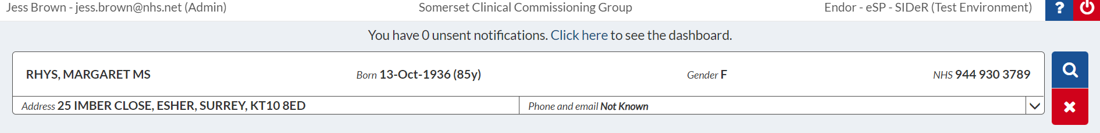
At the top of the window you can see your details, organisation, the help and close icons.

The banner contains patient demographic information pulled from the national Personal Demographics Service (PDS). The NHS number is the primary patient identifier used by SIDeR.
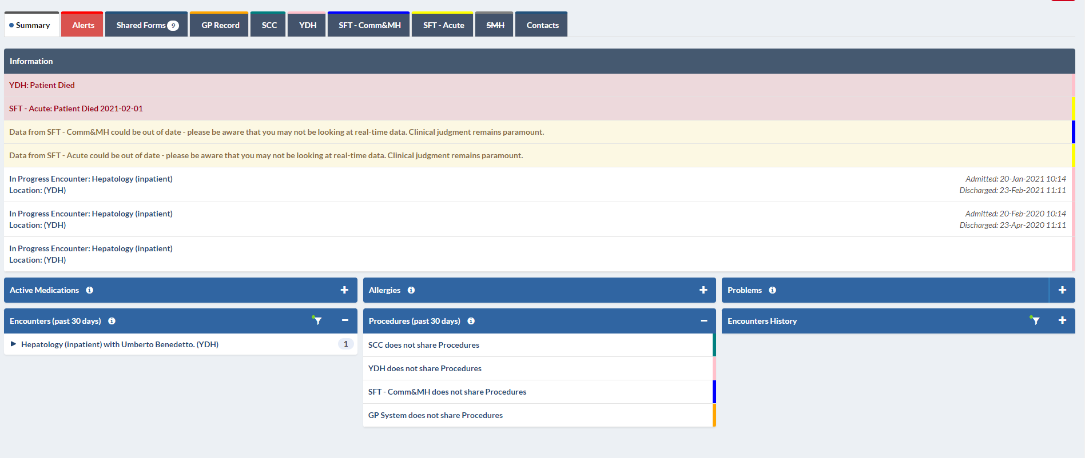
Important information will be displayed at the top of the record such as if the patient is an inpatient including the expected discharge date, or if the patient is deceased, according to the records of one or more organisation(s).
The summary screen shows one off medications (last 60 days) and repeat medications.
Encounters show all contacts for this person across all Somerset health and care organisations connected to SIDeR in the last 30 days. A colour coded graph enables you to quickly see their encounter history and identify a patient who frequently visits for support and care services. Procedures will also be displayed here.
Key allergies and problems are also displayed. Click on the I icon for a full explanation of what is displayed. Note: the summary screen only displays key allergies. To see ALL recorded allergies you will need to look in the relevant organisation tabs:
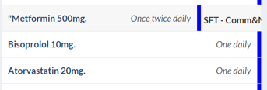
Hover over the end of the line on the colour coded strip and it will reveal which organisation provided the data (the colour matches the relevant organisation colour on their tab above):

Below the demographics bar you will see a series of tabs.
The alerts tab contains patient alerts deemed important by health and care professionals

To see more detail from each organisation, click on the relevant organisation tab. If no information exists, that organisation’s tab will be greyed out and crossed out.
GP Record (including free text) SMH = St Margaret’s Hospice
YDH = Yeovil District Hospital SCC = Somerset County Council
SFT = Somerset Foundation Trust (SFT Acute was formerly TST, SFT Comm & MH was formerly Somerset Partnership)
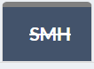
If a tab has a line through the title, there is no information populated for that patient.

SHARED FORMS
Shared Forms are the only aspect of SIDeR that is read/write and the information is retained on SIDeR. You are able to view, update or create various care plans for a patient if appropriate by clicking on an icon on the right-hand side. Separate training guides for these forms are available and can be viewed from the SIDeR help function found at the top right corner of the window
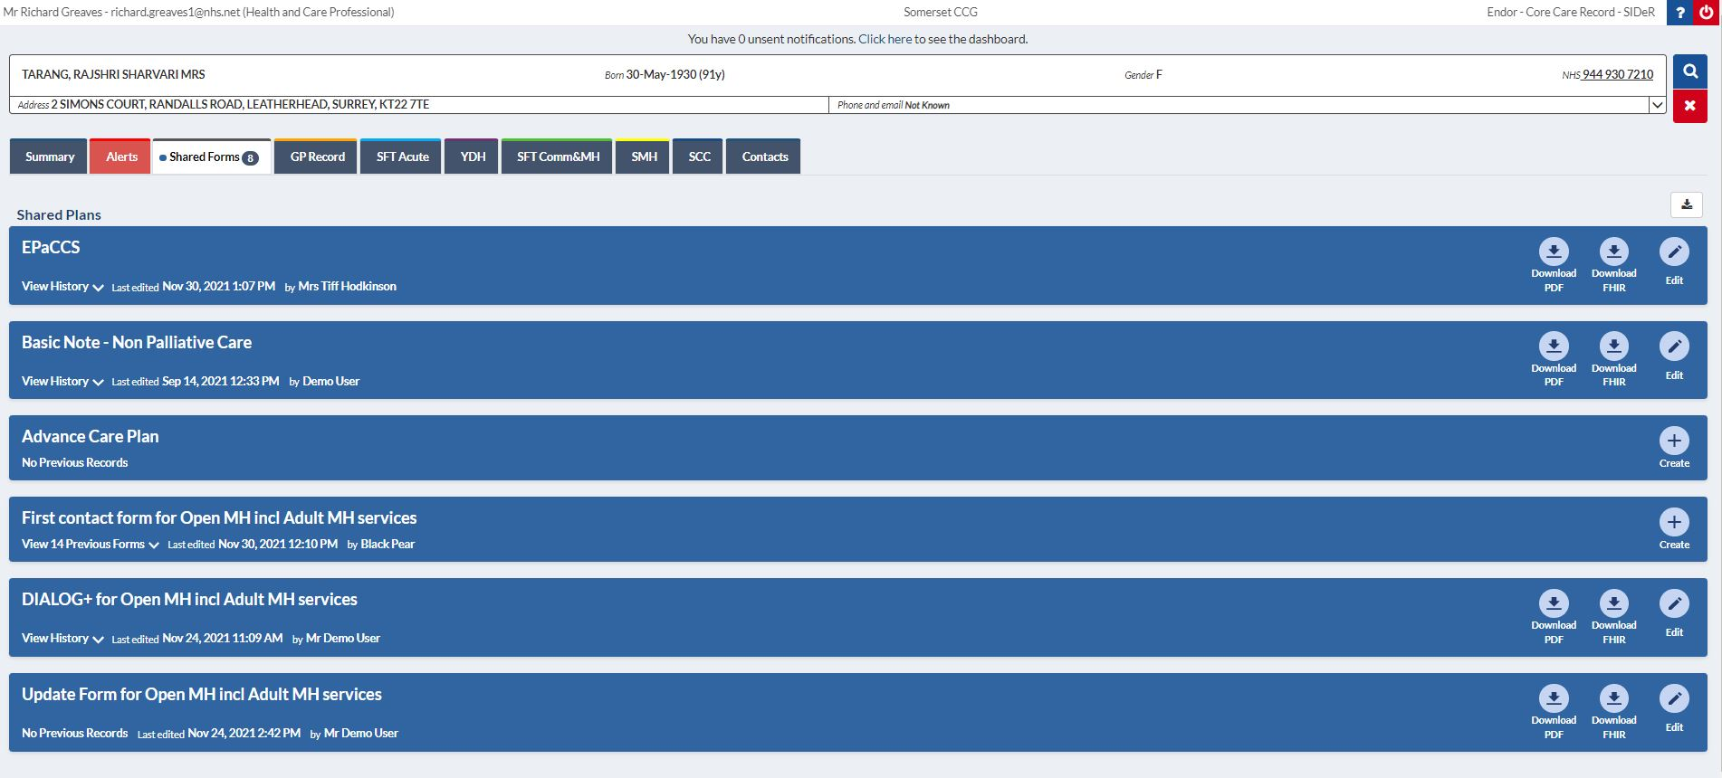
The number of Shared Forms a patient has will be indicated within the tab, if there is a line through it, the patient has no forms.

Shared Forms can be created, contributed to and seen by providers involved in that area of the patient’s care. Relevant clinical and demographic information will be auto-populated from the GP record to assist with completion of the form.

The Shared Forms currently live on SIDeR are:
- Electronic Palliative and Care Coordination System (EPaCCS) – contains key information for patients with life limiting illness (not to confused with the Somerset Treatment Escalation Plan)
- Basic Notes – Basic Notes provided by in-hours GPs to out-of-hours services to improve the care of patients who have long-term conditions
- Advanced Care Plan – Marie Curie are commissioned to ignite these conversations with Somerset patients
- Comprehensive Assessment Form – this form is based on the National Geriatric Assessment
- Community Mental Health/ Open Mental Health Forms
  - First contact form (referral)
  - DIALOG+
  - Update Form

Separate training guides for these forms are available for further information and can be viewed from the SIDeR help function.

Please Note --
You will not be able to have multiple patient records open in SIDeR. If you access another record whilst the previous pop-up is still open, it will ask you to close the previous patient and re-launch. This is to mitigate clinical safety risk.
If you have any issues accessing SIDeR, please contact support@blackpear.com in the first instance.
If you have any feedback or are interested in being involved in SIDeR development, please contact somicb.digitalteam@nhs.net

