**Important Information about Allergies to Covid-19 Vaccination**

Many of you will be aware that the AstraZeneca Covid vaccine is no longer available, but that in the past some patients may have accessed the AstraZeneca Covid vaccination because of concerns about allergic reactions. There is a new plan in place for patients with allergic reactions to mRNA vaccines.

For the small number of people known to have severe allergic reactions to mRNA vaccines, or its components, such as Polyethylene Glycol PEG, **Nuvaxovid** vaccine is available. This is only available in the hospital setting and through the special allergy clinics.

The Somerset Covid Vaccination team will be identifying and inviting all patients who have previously had a vaccine in one of the hospital allergy clinics to come forward for a Nuvaxovid vaccine. Primary care does **not** need to identify these patients. Please reassure any patients who may ask that they will be contacted.

We are aware, however that some patients may perceive themselves to be at risk of an allergic reaction, (or may have preferred to access an AZ vaccine) and may contact Primary Care asking for a referral to the allergy clinic. We wanted to give you advice of what to do if you do receive any queries (we are expecting the numbers to be small).

Firstly, look at table 5 below taken from the Green Book Chapter 14a, pg 42 [COVID-19 Green Book chapter 14a (publishing.service.gov.uk)](https://assets.publishing.service.gov.uk/government/uploads/system/uploads/attachment_data/file/1102459/Greenbook-chapter-14a-4September22.pdf)

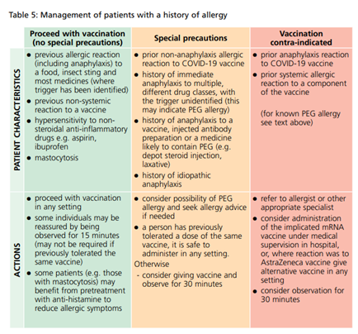

If they fall into the **Red column**:

Please refer them to the allergy clinic by sending an email to [somersetcovidvaccination@somersetft.nhs.uk](mailto:somersetcovidvaccination@somersetft.nhs.uk). Please can you mark the reason why they are a ‘red’ candidate for clarity and advise them that they will be contacted directly, but there may be a wait.

NB The text referred to in the red column is this *“The Pfizer BioNTech and Moderna mRNA vaccines contain polyethylene glycol (PEG). PEGs (also known as macrogols) are a group of known allergens commonly found in medicines, many household products and cosmetics. Medicines containing PEG include some tablets, laxatives, depot steroid injections, and some bowel preparations used for colonoscopy. Known allergy to PEG is rare. Evidence now shows that PEG allergy is implicated in only a minority of allergic reactions reported after COVID-19 vaccines.”*

If they fall into the **Amber column**:

To receive a Nuvaxovid vaccine, they will need a referral to the covid allergy clinic A&G before we can add them to the list. This is accessible via eRS and is titled: Allergy - Covid Vaccination. When you receive the response to the A&G, if a hospital Nuvaxovid is recommended, please refer them via the email address above and enclose the A&G response.

In the referral to the A&G service it is really important that the following sentence is included **“If vaccination under medical supervision is recommended as a result of this referral, please note that this can be carried out in the hospital hub in Taunton, Somerset. They would not need to travel to a central site in Bristol.”**

The new addition to the amber column is the first item “prior non-anaphylaxis allergic reaction to COVID-19 reaction” and this is ambiguous. The flow chart on page 44 of the Green Book is helpful in determining whether you need to make that referral or not and may be worth printing out and keeping close. [COVID-19 Green Book chapter 14a (publishing.service.gov.uk)](https://assets.publishing.service.gov.uk/government/uploads/system/uploads/attachment_data/file/1102459/Greenbook-chapter-14a-4September22.pdf)