QUICK REFERENCE GUIDE FOR FUTURE ACCESS TO RECORDS

What will a patient see from 1 November 2022
- Patients will see new information once it is entered or filed on to their record
- Full prospective GP health record including free text, letters, coded information and documents (including safeguarding information) unless redacted or hidden
What patients will not see from 1 November 2022
- Historic or past health record information unless they have already been given access to it by their GP practice
- Patients will not be able to see tasks, admin items, alerts, screen messaging, internal email or patient warnings. The only time this may happen is if the information has been added directly into the patient record as part of a consultation/appointment, in which case it will be visible as it forms part of the electronic patient record
- Patients can only see information that is held in their GP record and not information from third-parties that is viewable in the GP system by health professionals.
What happens if a patient moves practice
- When a patient registers at a new GP practice from 1.11.22 they will lose any access they had to historical information but will automatically get access to their future record in full form, from the date of joining the new practice
- If a patient wants access to their historical information (detailed coded record or full) they will have to request this from the new practice who will need to review and redact if necessary
Identifying and safeguarding vulnerable patients
- For the most part patients who are at risk of serious harm will belong to known high risk groups, will already have safeguarding plans in place and be known to the practice
- The list of high risk groups is not exhaustive and practices may have concerns about patients who do not fall into these groups. In this situation, consideration should be taken to turn off access to a patient if they are considered vulnerable to coercion, information contained in the record may be harmful to them or they may not be able to keep their record secure
- Enabling patients to view their medical records will be beneficial to the majority of patients, but there may be challenges for a minority
- It is important to review and redact where there is a risk to a patient.
Redacting information from a record
- As the data controller the GP practice is responsible for ensuring that any potentially harmful or confidential third-party information in the patient’s record is not visible to the patient online.
Proxy Access
- The new changes do not apply to proxy.

SNOMED codes
Pre go live codes
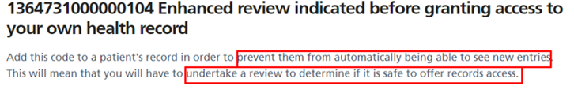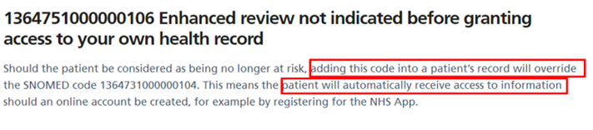
Post go live codes
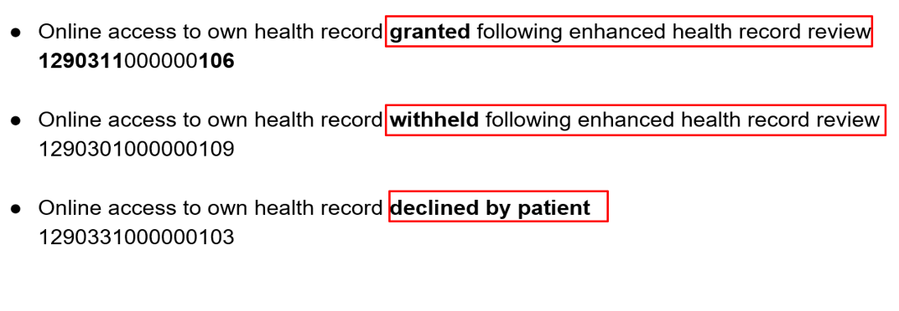

October 2022 (version 1.0)

