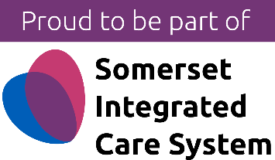

08 July 2022

Minehead GP practice in Somerset becomes the first employee-owned trust in the country with a John Lewis style employee partnership

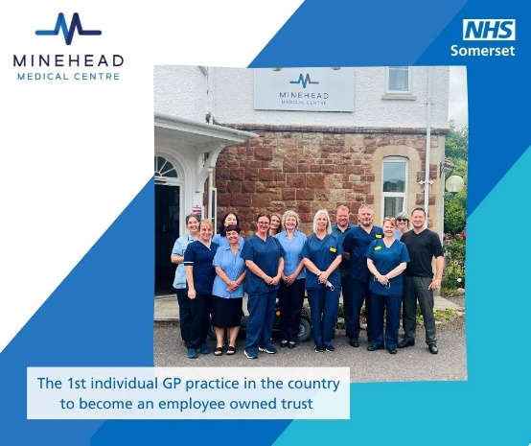
A GP practice in Minehead, Somerset; Minehead Medical Centre, has become the first individual GP in the country to operate as a John Lewis Style Employee-Owned Trust
The advantage of this model is that it enables the Practice to offer GPs and other health staff a say in how their practice is run. Staff at the Practice can also develop a leadership role without needing to have money to invest in a partnership and profits generated are invested back into the Practice to help improve services, training and wages.

A key driver in the decision by the practice to incorporate firstly as a limited company and then as an EOT is to help protect the ongoing stability and sustainability of the Practice; through making it a more attractive place for staff to work and develop their careers.
In common with many GPs, Minehead Medical Centre has found it challenging to recruit staff because of its geographic location. This is part of wider national picture in more rural areas where there are challenges in recruiting GPs, as many are nearing retirement age and there are not enough new doctors being trained who want to go into general practice..
Ed Ford, the GP who has led the development of the employee-owned trust at Minehead Medical Centre says “We have a fantastic management team and wider staff team, so partners at the practice felt we should give them more control of the business.
“We also wanted to ensure that the business structure shouldn't rely on individuals holding shares that could be difficult to transfer if people wanted to leave - hence the idea of becoming an employee-owned trust (EOT).
“EOTs offers GP practices an alternative, more flexible operational model; offering staff a greater say in how GP practices are run and opportunities for the team to develop their careers by having a greater leadership role, without needing to have the funds to invest as a partner.
“As an EOT, Minehead Medical Practice is committed to continuing to drive up standards at the practice and deliver the best standard of care to our patients”.
Minehead Medical Practice has recently been successful in recruiting additional GPs and reception staff, but currently has a number of additional GP and other health vacancies at the practice. Click here more information about the practice and current vacancies.
NHS Somerset says,“The decision to agree the incorporation of the GP practice, as an Employee-Owned Trust, has been subject to a robust and thorough evaluation and decision-making process by NHS Somerset, in line with national guidance.
“This is the first application for a GP to become an EOT in Somerset and we are aware that other organisations may be interested in pursuing a similar model. We hope that this decision enables the Minehead Medical Centre to continue to provide its patients with the best possible care”.
Postlethwaite Solicitors, a specialist practice in employee ownership, and commercial and healthcare specialists MLP Law supported the deal. MLP Law acted for the transferee company and the ongoing GP shareholders, while Postlethwaite advised on the employee ownership trust and Porter Dodson Solicitors for the transferring GPs.

ENDS

For media inquiries and interview bids please contact Helen Ashley at NHS Somerset’s communication team email: somicb.communications@nhs.net Mobile 07825 681604.

Note to editors

NHS Somerset
On 1 July 2022 NHS Somerset Clinical Commissioning Group (CCG) became NHS Somerset. This change happened to all CCGs across the country as part of the national reforms under the Health and Care Bill.

The previous functions of NHS Somerset’s Clinical Commissioning Group (CCG) transferred to NHS Somerset Integrated Care Board (ICB), following the closure of CCGs.

From 1 July 2022, NHS Somerset Integrated Care Board (ICB) became the statutory NHS organisation responsible for implementing a health and care strategy developed by the Integrated Care Partnership (ICP). Working collaboratively with primary care partners, foundation trusts, local councils, the voluntary sector and other partner organisations it also oversees the planning, performance, financial management and transformation of the local NHS. All partners working together form the Somerset Integrated Care System (ICS).

For more information https://nhssomerset.nhs.uk/

There is a group of GP practices in the North-West of England that collectively operate as an Employee-Owned Trust
Employee ownership trusts (EOT) were introduced by the UK government in 2014 to encourage businesses to move to an employee ownership model a la John Lewis. Every employee holds a non-tradable share in the company, held by trustees on behalf of and at no cost to the employee. The management of the company is accountable to all employees who, together, hold the majority share of the business. So, importantly, if GP partnerships are converted into GP-EOTs then they cannot be sold, they are a community asset, fixed by their GMS contract to the community they serve.

