Myth busting: ‘How to Share’ guide

This toolkit is a guide for LMCs and GP surgeries to take part in the Rebuild General Practice GP myth-busting activation.

The goal is to reach patients and dispel common modern myths surrounding General Practice, helping them to understand the reality of the current pressures on GPs and the General Practice system. This can be done via social media, e.g. Facebook pages and Twitter accounts, or in surgeries, e.g. on waiting room screens and posters.

Here's everything you need:
- Download assets and infographics HERE
- Suggested copy to accompany assets BELOW

If you have any questions regarding this activation, please feel free to contact hello@rebuildgp.co.uk. Thank you!

WHERE TO SHARE | WHAT TO SAY
Facebook  Share the following posts on your LMC or surgery Facebook page, alongside the visual assets provided.  The primary post included at the top is to set context for the specific myth busting posts, but is not essential. | Primary/kick-off post  General Practice has been in crisis for years, and as a result, we know that many patients have become frustrated and disillusioned. This has led to certain myths surrounding the profession, and we want to set some of these straight, to bring GPs and patients back together. After all, we’re all working towards the same goal: excellent and safe patient care.  [This week] We will be sharing common myths about General Practice vs the reality, shining light on the importance of GPs and practice staff and their desire to provide patients with the best care possible.  For more information on the effort to #RebuildGP, visit rebuildgp.co.uk.
Myth 1 – ‘GPs do not work hard enough’
It can sometimes be difficult to secure a GP appointment, and this might lead people to believe that GPs aren’t working hard enough or for long enough.

This is untrue; GPs regularly work 10-12 hour shifts in order to see as many patients as possible. The reality is, there are simply not enough GPs per patient.

We need the Government to deliver on a plan to boost the GP workforce, so that patients can see their doctor when they need to.

#RebuildGP

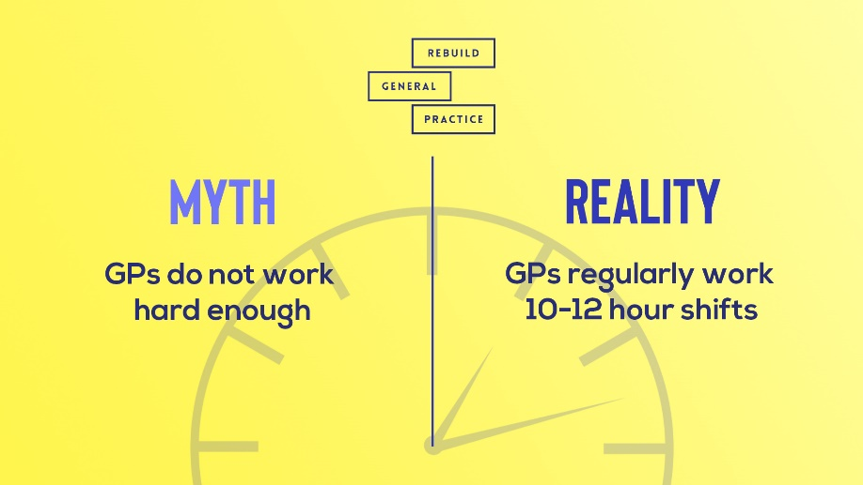

Download either:
- Static asset
- Animated infographic

Myth 2 – ‘General Practice receptionists do not want patients to see their doctor’

Receptionists are the gateway between patients and their GPs. The work they do is essential and exceptional, despite the unprecedented circumstances currently facing general practice.

Our receptionists do everything possible to get appointments in diaries. Understandably, this is sometimes far more difficult than it should be, but please be assured that connecting you to our GPs is their number one priority. #RebuildGP

#RebuildGP

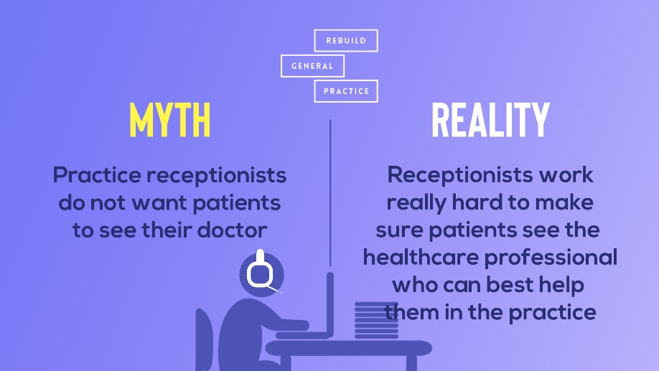

Download either:
- Static asset
- Animated infographic

Myth 3 – ‘GPs are not doing enough to treat their patients’

The number of GPs is going down while the number of patients is going up. In England, there are now 2,200 patients to every GP.

GPs and practice staff are doing everything they can to treat their patients, despite these worsening circumstances.

#RebuildGP

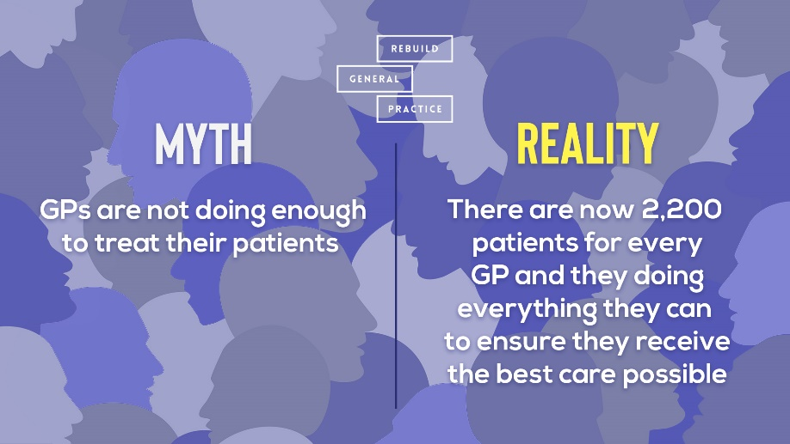

Download either:
- Static asset
- Animated infographic

Myth 5 – ‘The UK Government is actively solving the GP workforce crisis’

Government will often parade figures of GP growth to cover their backs, but let’s be clear: the Government is currently failing General Practice, and doing nothing to improve the fractured system.

Since 2015, England has lost a total of 1,565 full-time equivalent GPs, and this trend is showing no sign of changing.

The longer the Government ignores this crisis, the more patients will suffer. #RebuildGP

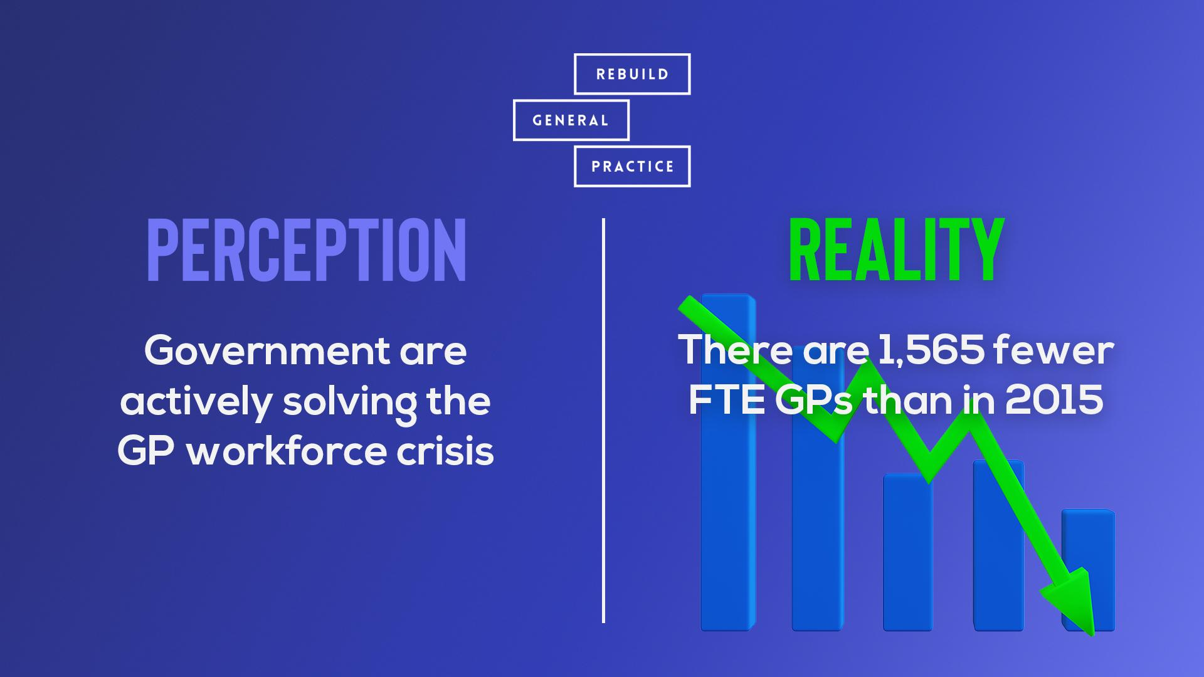

Download either:
- Static asset
- Animated infographic
Twitter  Share the following posts on your LMC or surgery Twitter feed, alongside the visual assets provided.  The primary tweet thread included at the top is to set context for the specific myth busting posts, but is not essential. | Primary tweet thread  Tweet 1/2  ‼️ General practice has been in crisis for years & as a result, we know that many patients have become frustrated and disillusioned.  💪 This has led to certain myths surrounding the profession & we want to set some of these straight, to bring GPs & patients back together.  1/2  Tweet 2/2  👏 After all, we’re all working towards the same goal: excellent & safe patient care.  💡 Here, we'll be sharing common myths about general practice, and we hope these will shine a light on the importance GPs and GP staff place on providing the best care possible. #RebuildGP  2/2  Myth 1 - ‘GPs do not work hard enough’  👎 Current difficulties in securing a GP appointment has caused the myth that GPs are not working hard enough.  ⏰ This is untrue; GPs regularly work 10-12 hour shifts in order to see as many patients as possible.  #RebuildGP  Download either:  - Static asset  - Animated infographic  Myth 2 – ‘General Practice receptionists do not want patients to see their doctor’  📞 GP receptionists are the first port of call for patients when booking an appointment.  👏 In times of unprecedented pressure, they work very hard to make sure patients see the healthcare professional who can best help them. #RebuildGP  Download either:  - Static asset  - Animated infographic  Myth 3 – ‘GPs are not doing enough to treat their patients’  ⚠️ The number of GPs is going down while the number of patients are going up.  💪 GPs are doing everything they can to treat their patients, despite these worsening circumstances.  Download either:  - Static asset  - Animated infographic  Myth 4 - Government response  ‼️ Government is not taking appropriate measures to address the ongoing crisis in general practice.  ⚠️ We are losing GPs at an unsustainable rate, and we need a plan to stop this. So, where is it? @DHSCgovuk  #RebuildGP  Download either:  - Static asset  - Animated infographic

