Health & Climate Conference
Cheese & Grain, Frome
Friday 15th July
9:30am - 5:30pm

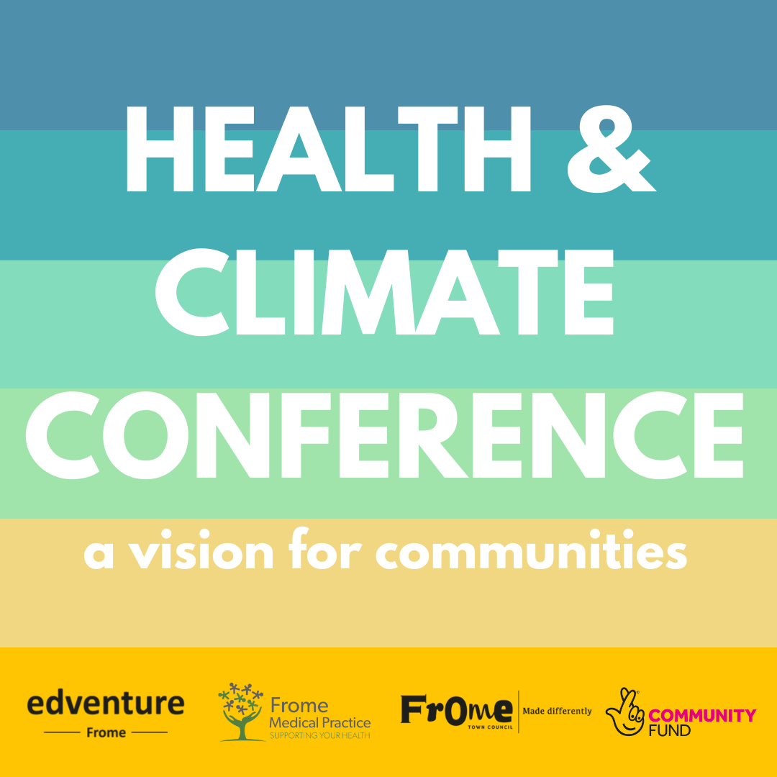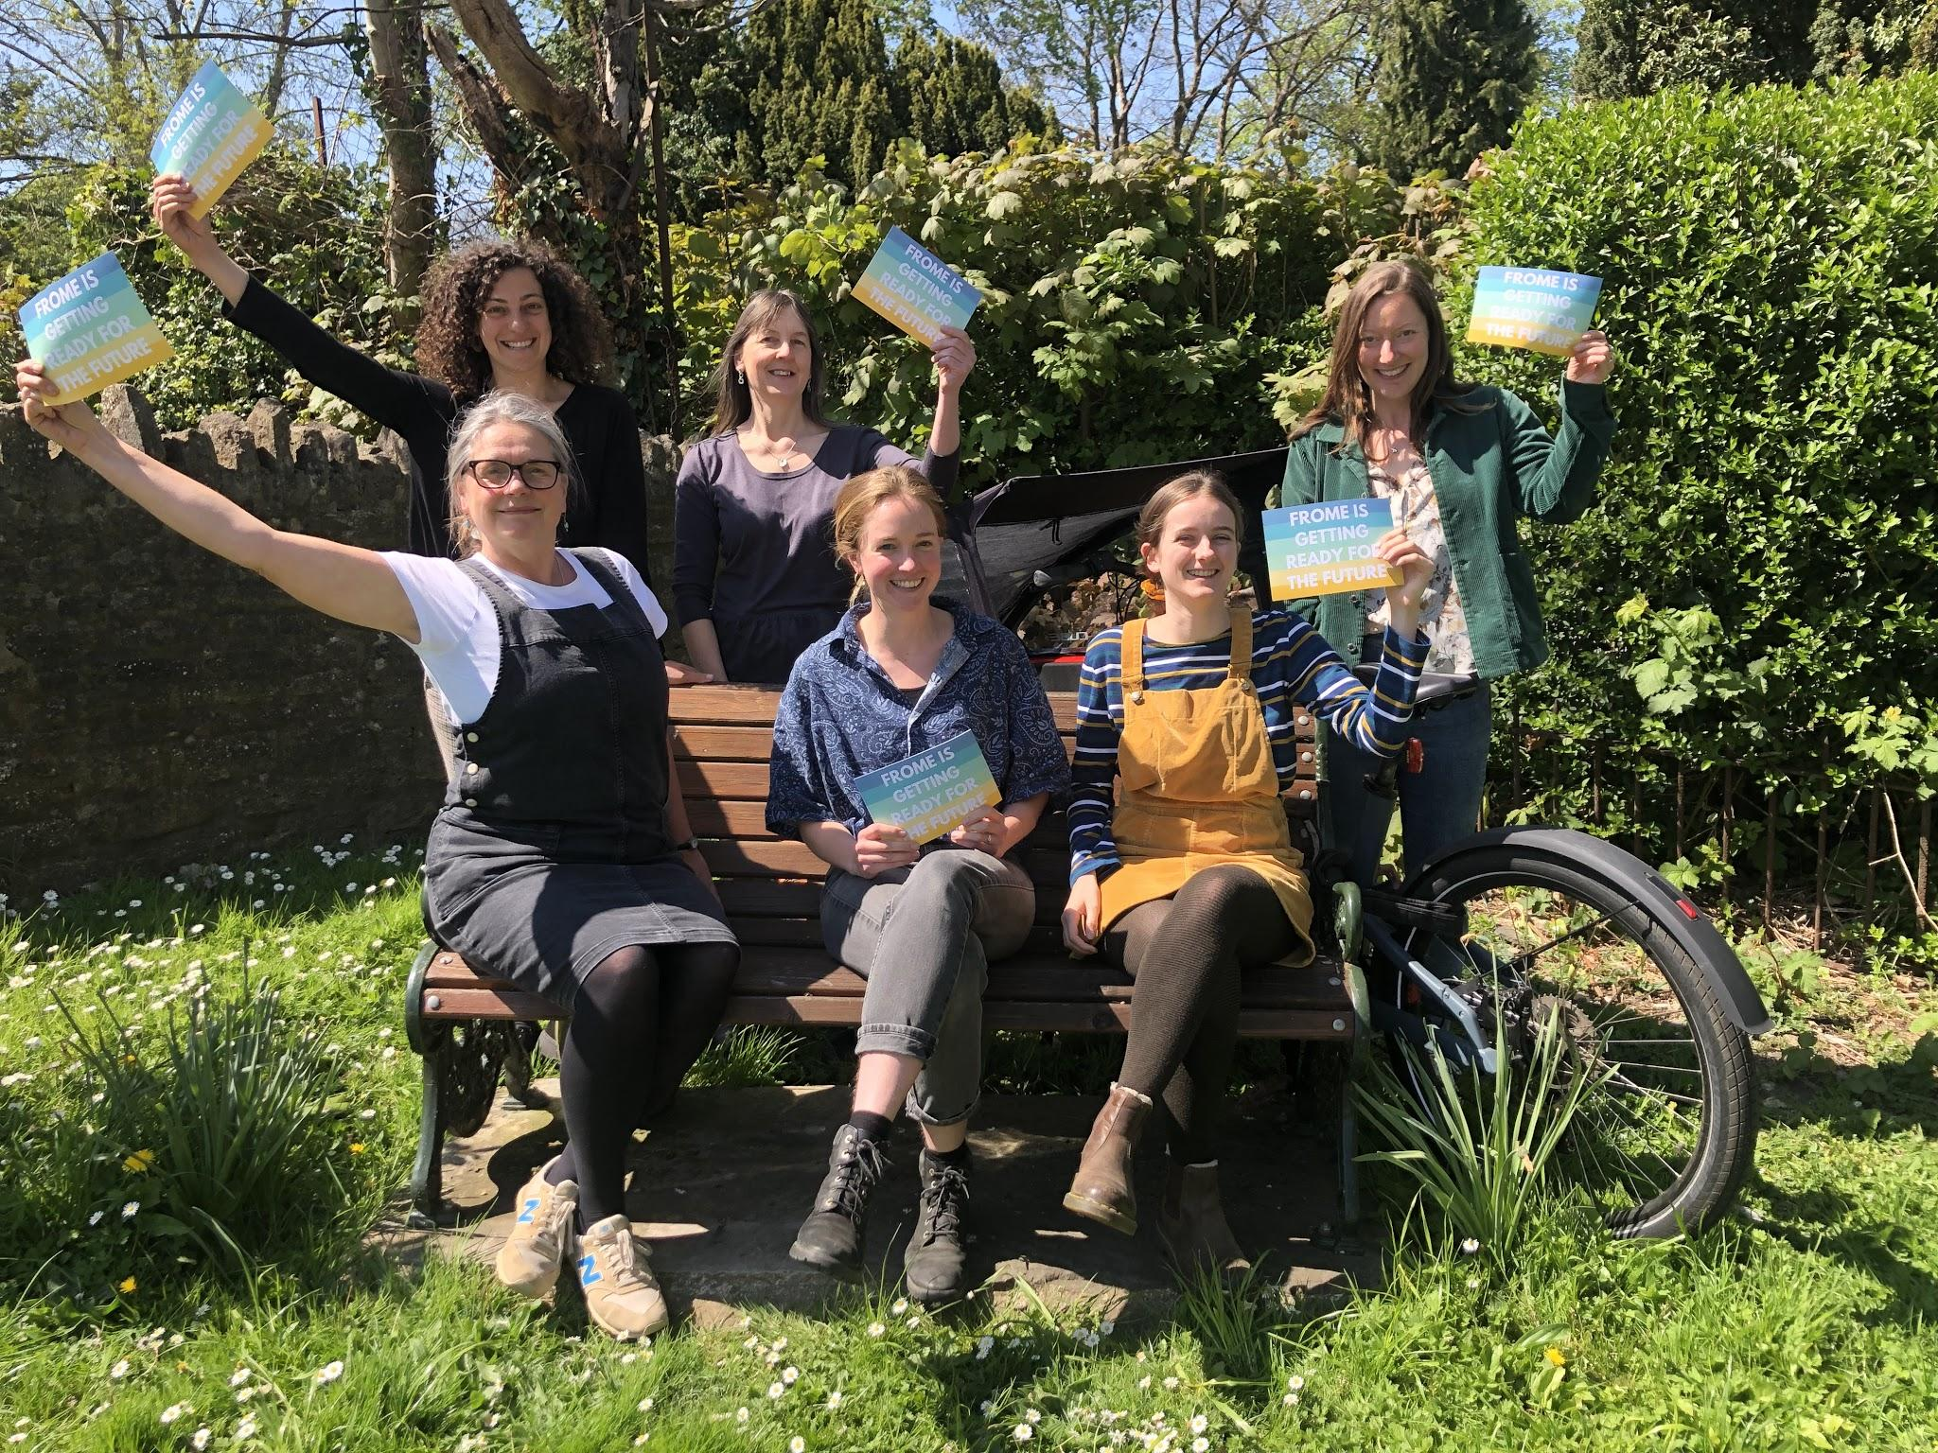

The partners of Frome’s Green & Healthy Futures programme are excited to invite you to the Health & Climate Conference! We are bringing people together from the local community and across the country for an event all about climate, health and wellbeing. This event will showcase the story of our unique partnership and how we have joined forces to make a difference in our town. Attendees will hear from inspirational speakers and there will be opportunities to be immersed in real examples of change, make new connections and share ideas to make climate action stick.

Don't miss this!

Grab your tickets now: https://www.eventbrite.co.uk/e/health-climate-conference-tickets-230833448057

