SPH
Somerset General Practice Provider Board

25 May 2022

For the attention of:

All Practice Managers and Senior Partners, Somerset GP practices

Re:

Update on the Somerset Integrated Care System (ICS) and Boar (ICB), and the General Practice Provider Board (GPPB)

Dear Colleagues

I am writing to you on behalf of the General Practice Provider Board (GPPB) in order to provide you with an update on recent GPPB developments, the progress made to date in establishing the Somerset Integrated Care System (ICS) and the Integrated Care Board (ICB). In addition, I will update you on the progress made in ensuring that the GPPB is seen by all stakeholders in the Somerset Health and Social Care System (HSCS) as the single provider voice of General Practice in the county.

GPPB:

I hope that you were able to read the previous updates I sent you, most recently in November 2021. Copies of these can be accessed through the LMC Office or through Ian Creek, who is the current Secretary of the GPPB.
The GPPB held a further development session in January. The outcomes included refining the Board’s Terms of Reference, including its membership and its remit (which is essentially to represent your interests as a group of Providers in the Somerset ICS and ICB). I have attached the current version to this letter. The Somerset System has subsequently agreed to fund the Board’s operations, including its representatives on the relevant bodies in the ICS and ICB, for the foreseeable future.

Primary Care Strategy:

Additionally, the Board was clear at the development session that the mismatch in funding between Primary Care and other providers in our HSCS, specifically in relation to Business Intelligence, support for Quality Improvement and Project Management, needed to be addressed if the ICS is to realise the full potential of General Practice to support the ICS and ICB in fulfilling the ambitions elucidated in the “Fit For My Future” Health and Care Strategy, which includes an ambition to support and appropriately resource Community and Primary Care services to enable a substantial shift in care from hospitals out into the community. The ICB is keen to support the above ambition, but wishes this to be considered, together with resilience support of General Practice, as part of the Primary Care Strategy that the ICB intends to develop. This falls within the remit of the ICB Chief Medical Officer (CMO), as does all Primary Care Commissioning and implementation of the Strategy. An appointment has been made for this role, but has yet to be approved by the Secretary of State because of a remuneration mismatch. Additionally, the successful applicant is required to give 6 months’ notice to his current employer. Whilst this may be reduced, the GPPB is clear that we cannot wait for the CMO to be fully in post prior to initiating the work of creating this Strategy. I have, therefore, written this week to Jonathan Higman, the ICB Chief Executive, strongly advising that this process is started as a matter of urgency, given the current difficulties being experienced by the majority of practices in the county relating to demand, capacity and workforce, and the resultant resilience problems. I am hopeful that the work on developing the Primary Care Strategy will begin shortly, and that GPPB members, together with other representatives from the LMC and CD Board, will have a leading role in developing this.

ICS:

This is a summary of the current proposed ICS structure in Somerset:

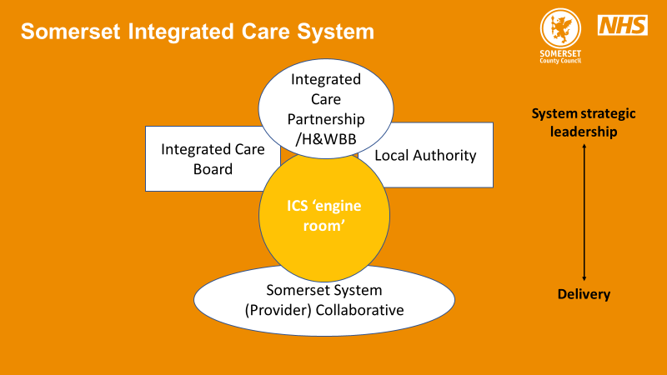

The Integrated Care Partnership is less well developed than this, partly linked to delays caused by the recent Local Elections.
ICB:

This is a current summary of the ICB structure:

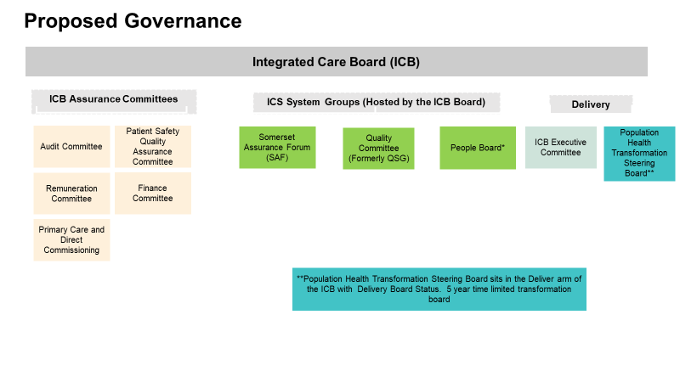
What is not clear from the above is that it is proposed that the A&E Delivery Board (AEDB) will sit alongside the Population Health Steering Board in the ICB “delivery arm”, and may have delegated responsibility for the delivery of hospital-based services. Similarly, there is a proposal that the Neighborhood Board will also sit in the “delivery arm” and may have delegated responsibility for “out of hospital” services. The Current proposal is for the Neighborhood Board to link to PCNs (and their aligned neighborhoods) via the 4 Locality Boards currently being developed across the County. Finally, work has begun on the structure required to ensure that the “clinical voice” is prevalent across the ICB, and the creation of a “Support and Clinical Care” Strategy supported by key members from across the Health and Social Care System.

ICB Board membership:

The Board will be a small Board with the following members (voting members are in bold):

- Chair: Paul von der Hyde
- Chief Executive: Jonathan Higman
- Chief Medical Officer: Appointed but not yet formally announced
- Chief Nursing Officer: Appointed but not yet formally announced
- Chief Finance Officer: Alison Henley
- 4 Non-Executive Directors: Appointed and in post
- Director of Public Health: Trudy Grant
- Foundation Trust Partner Member: Nomination process beginning, but likely to be Peter Lewis
- Local Authority Partner Member: Nomination process beginning, but likely to be the new LA CEO
- Primary Care Partner Member: Nomination process beginning (see below)
- Up to 3 other ICB Directors: ? People (HR); Strategy & Partnerships; Data & Digital; Corporate Governance
- VSCE: ? Katherine Nolan; Chief Executive, Spark Somerset
- Healthwatch: Observer status only

Primary Care Partner Member nomination:

The ICS Executives had asked the GPPB to provide a nominated individual for this role, and the Board had discussed this internally in addition to discussions by the County LMC Committee, but we have been awaiting national guidance on the nomination process. This has now been published, and requires the ICB Executive to send a nomination pack to every Provider of Primary Medical Services in the county (interestingly, there is no requirement to send packs to community pharmacy, optometry or dental providers, given that this is a Primary Care Member). Accordingly, each practice will shortly receive a nomination pack. Any GP working in a practice is able to be nominated by that practice; they must also receive nominations from two other practices in order to be eligible. The pack is unclear on the precise commitment expected, and is likely to state that the selected Member will receive remuneration of £300 per 4-hour session. I have been clear to the ICB Executive that this is likely to be a considerable deterrent to any GPs interested in the role. I advise anyone interested in the role to contact the LMC office, or any member of the GPPB including myself, for a more detailed discussion. In the event that there is more than one nominee, the ICB will establish a panel led by the Chief Executive that will select someone and the ICB Chair will need to ratify that selection.

Finally:

We believe that the GPPB is likely to have a vital role representing your interests and the collective voice of General Practice as we move into Integrated Care Systems that, unlike CCGs, are not Primary Care membership organisations. The GPPB will be better able to fulfil its remit if it is mandated by all practices to do so. We will discuss this further at the forthcoming LMC roadshow.

I am acutely aware of the pressures we are all under currently, and apologise for the length of this update, but I believe that it provides important information on the changes occurring in our Health and Social Care System, and the measures we have been taking to ensure that you are as robustly represented as possible in this new System, and to promote the value to that System of a thriving General Practice.

Kind regards

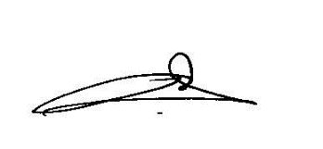
Dr Berge Balian; Chair, Somerset Primary Care Board

