Barry

Three days on from hearing the terrible news of Barry’s sudden and tragic death, I’m still numb. Even against the backdrop of current ghastly global events, the call from a shocked LMC colleague on Friday hit like a sledgehammer and has floored me. Our immediate thoughts are with Denise and their daughters, Emma and Alex, but Barry was such an eminent and well-respected figure that the grief is felt far and wide across the healthcare system in Somerset and beyond.

I knew Barry for 30 years as a neighbour, GP partner, distinguished LMC colleague and friend. Caroline and I were living in North Petherton when Barry and Denise moved in next door. A Bridgwater lad, he was proud of his roots and pleased to move back to the area having had a difficult time at a practice further up the M5. Maybe this was why he was happy with the peripatetic lifestyle as a GP locum for quite a few years before eventually joining the Creech St Michael practice. Denise had become our practice nurse and over the years significantly improved our diabetes care. In an era when it was unusual for GPs to shift around, Barry subsequently moved to work in practices in Street and Taunton before finishing his clinical career with us in North Petherton. He told me he saw his previous GP posts around the county as ‘circling the plughole’ whilst waiting for a North Petherton vacancy to come up, and I was delighted when he accepted our offer of a partnership.

Barry was already a legend in North Petherton long before joining the local practice, being active in the community with roles in the Church and also spending time on the Town council. Our first Christmas Eve together could have been our last. Denise and Caroline had headed out to the local Christingle service, leaving Barry and I to get festive with a bottle of whisky and an open fire. They returned to find us in a ‘relaxed’ state and the house filling with smoke from an errant ember. A safer tradition was hatched the following year- with Barry and Denise hosting a Christmas Eve lunchtime party that became a regular festive fixture for the local worthies, at least until Covid intervened.

It was never dull with Barry in the practice. Like all of us he found recent developments in the ways we work and the demise of our community teams frustrating and infuriating. He always arrived after me, and I’d brace myself for a brief verbal outburst once he’d managed to fire up the computer and seen what delights the day held. His care and concern for his patients was heartfelt and genuine, though, and he greeted his patients like they were old friends- which many were. The vast majority loved him, as a quick glance at comments on iwantgreatcare.org will confirm. I was glad that he was able to retire from clinical work in November 2020, with the significant reduction in stress levels that brought him. The wall in his room was testament to the most important things in his life: pictures of Denise and his girls, Emma and Alex, of whom he was extremely proud. There were also photos and a map of his beloved Sark, where the annual Moyse holiday became the centrepiece around which the rest of his year was built.

Most colleagues will know Barry from his work with the Somerset Local Medical Committee (LMC), whose principal role is to support GPs and practices across the county. As an organisation it has always punched above its weight, relying very much on two key individuals- Jill Hellens as Executive Director and Barry in the Medical Director post. The other elected roles, committee and superb office team add support but his and Jill’s role are critical. Barry was Chairman when I first joined the committee in 2007, and it was during my term as Chair that he took over as Medical Director from Harry Yoxall, who had achieved national recognition in the role. Barry’s LMC knowledge and long experience in a variety of practices across the patch left him uniquely qualified for the job, but the complexity of the system and increasing difficulties for Primary Care meant that the role needed expansion and Catherine Ievers was appointed as his deputy two years ago.

One of his duties was to translate the lengthy diktats from NHS England and others into readable briefing papers, and to summarise other important documents for the committee, which he appeared to be able to do in his sleep. He and Jill provided the majority of support to distressed doctors and practices, and would often be travelling around the county at either end of the working day to help with intractable and ingrained problems. I would have found that immensely stressful, but Barry with his strong sense of loyalty and integrity found a way to cope with it. The sensitive nature of the work meant that it was very rare that the rest of us got to know too much of what the difficulties were.

In any negotiation or meeting the LMC will always have the benefit of history, being by some way the oldest organisation in the Healthcare system, and Barry and I between us had over 60 years of frontline GP experience which added weight to our views. Barry would always take the notes and his brain was wired in such a way that he could tap away on his iPad whilst contributing fully to the discussion and then fire word-perfect notes to us by email, often before I’d actually declared the meeting closed.

You definitely wanted Barry on your side. In the pre-pandemic era when remote meetings were the exception we once had a call planned with the regional NHS England team to thrash out a problem with payments that had been running on for months. We’d discussed our strategy before gathering round the bat-phone, and introduced ourselves to the hapless NHS manager who’d been wheeled out to defend the indefensible. After minimal niceties, Barry veered off-piste and launched into a tirade that reduced the rest of us to admiring observers, and we can only guess at the effect at the other end of the line. It was certainly quiet for a while before total capitulation ensued. Barry calmly thanked him and ended the call. I’m still trying to discover what he’d had for breakfast that day.

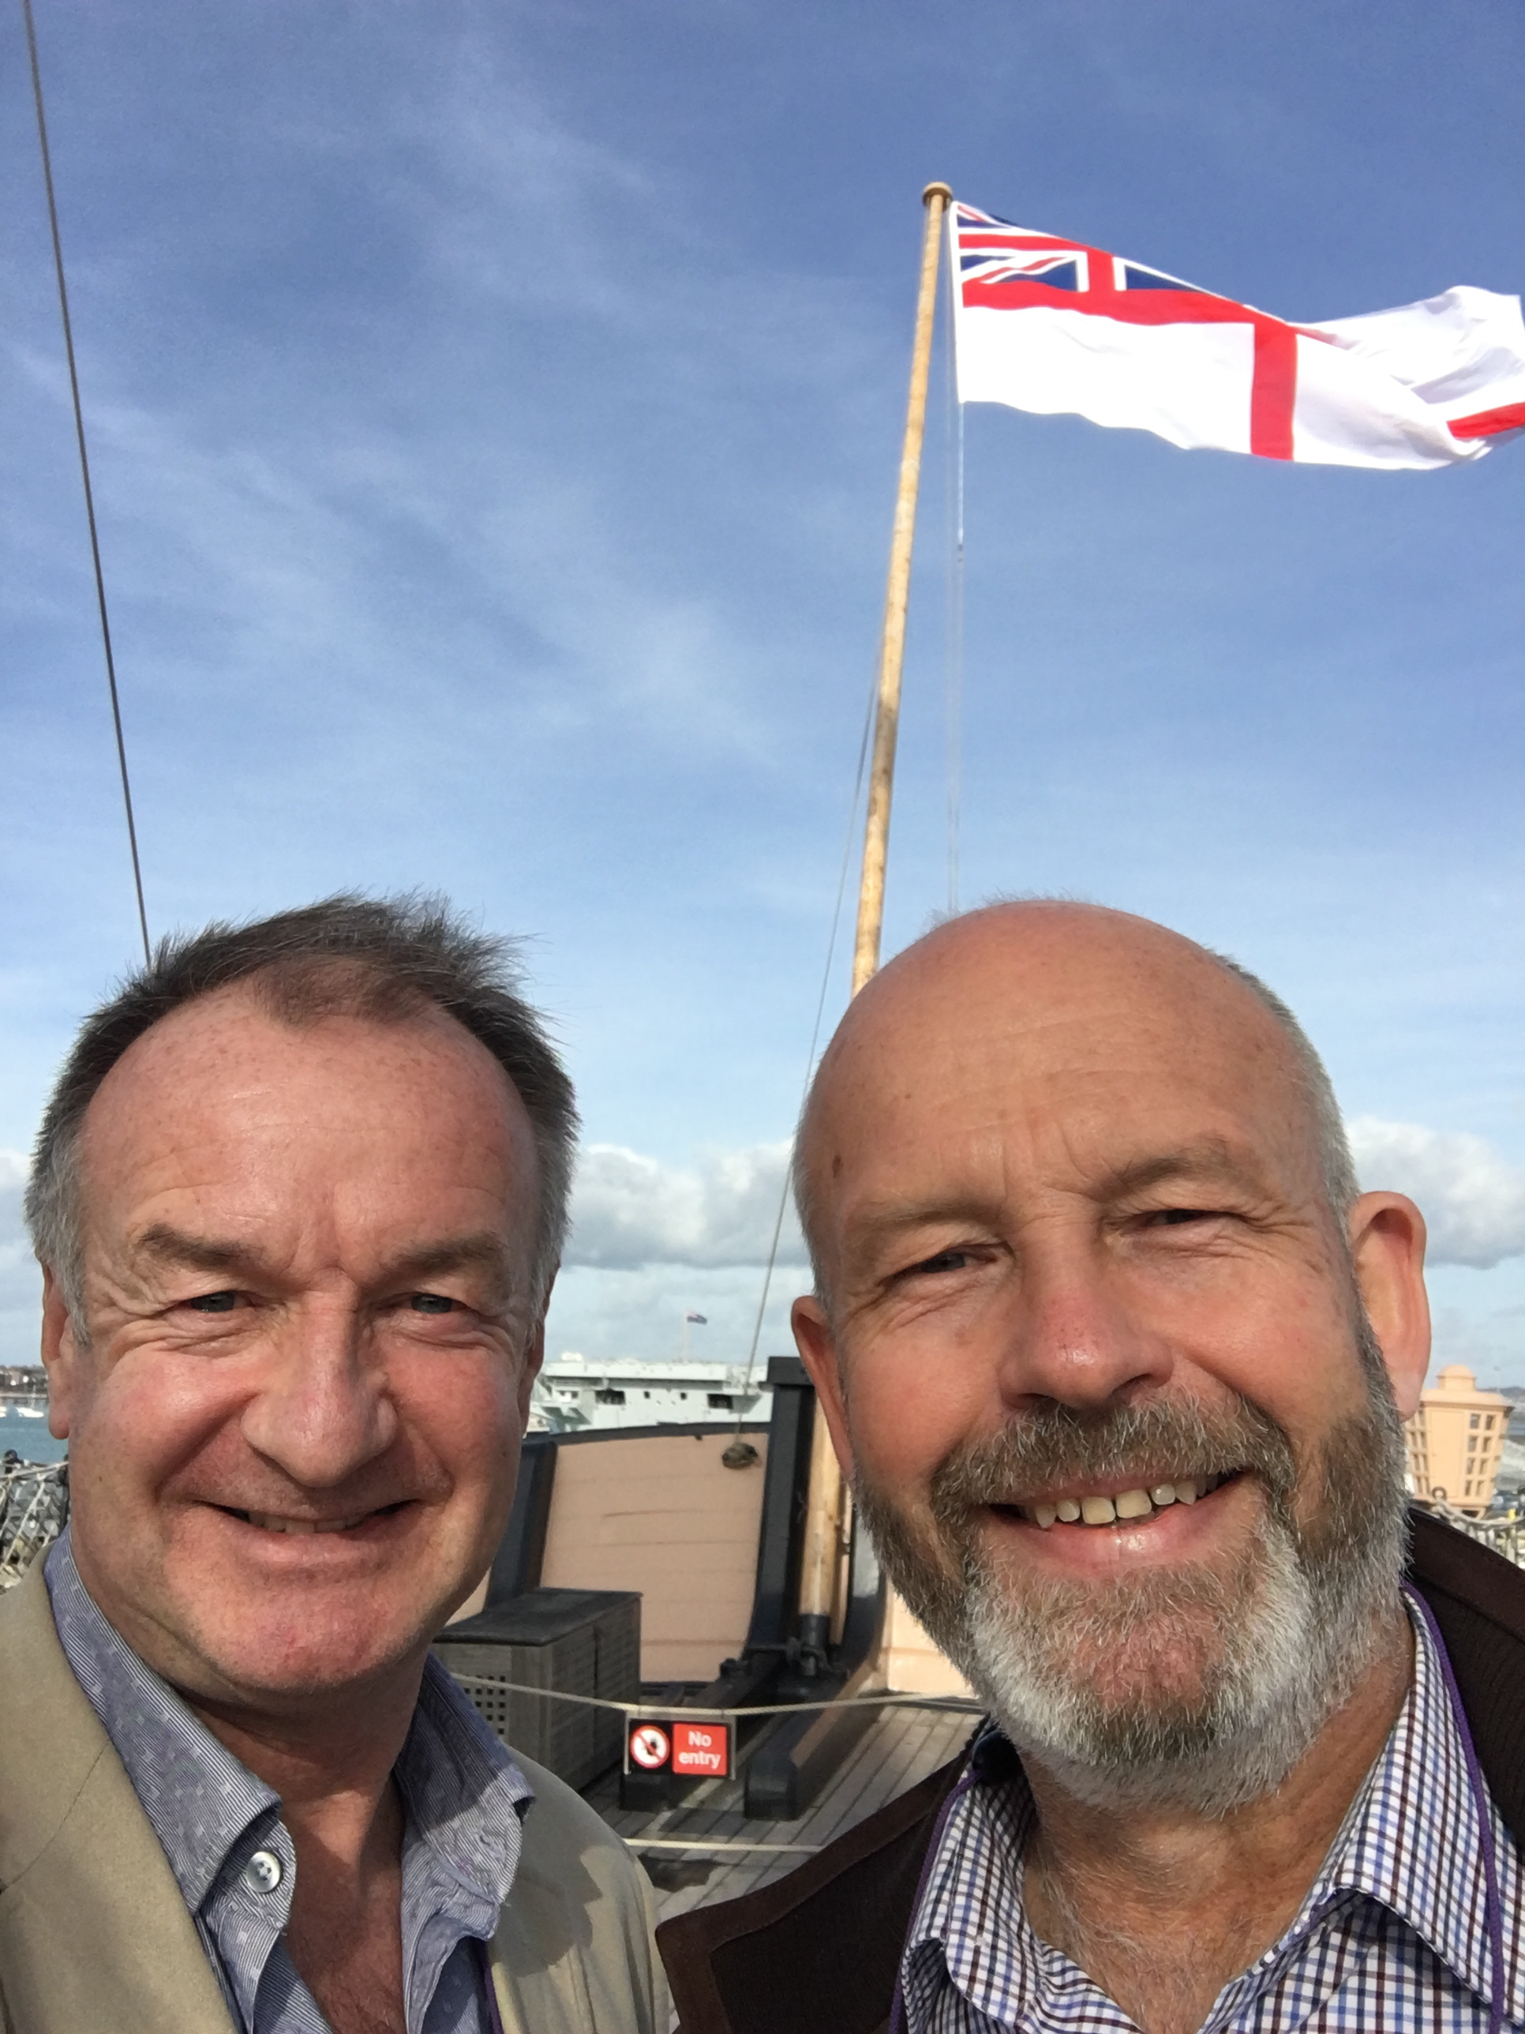
He was a keen student of history and a devotee of Nelson in particular. He introduced me to the Historic Dockyard at Portsmouth which we’d visited several times and also traipsed around the country visiting other military museums and attractions. I would drive as we wanted to get there and back in the day, and the journeys were huge fun, as long as I could keep him off politics.

Only two days before he died, he’d sent me a photo of a diary page from 1994 when he’d worked a weekend covering my patch, and we’d had some back and forth about the patients and the way that GPs used to work ‘back in the day’. Caroline bumped into him at the LMC office a fortnight ago and said how relaxed and content he seemed, and they’d exchanged family news. He’d also popped by my house to drop off a magazine he thought I’d be interested in reading. I was out at the time, but I’d give anything now to have been there to see him. He loved his racing and worked as a racecourse doctor for many years, and this was the week he should have been sharing his pension with the Cheltenham bookies.

Barry had a strong Christian faith, and it’s good to know that it provided him with comfort and succour at difficult times. Wherever he is now, I hope they let Barry take the notes.
Rest in peace, Barry.
NB March 2022

