**Top Tip - Vaccinations & Immunisations – QOF**

There are a number of Allergy, Contraindication and Adverse reaction codes that can be used to exclude patients for the denominators for VI001 – 003.  They can be found as below by going to Population Manager,

                                                                                                                                                                              **Vaccination & Immunisations Denominator Populations**

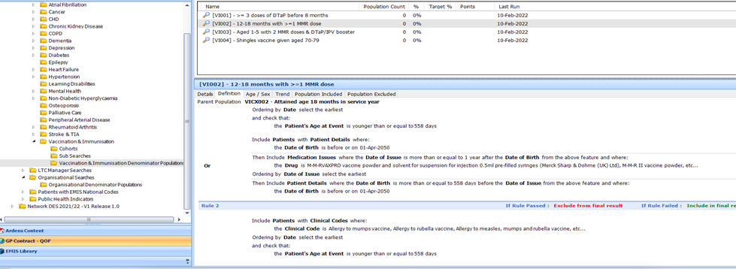                                                                                                                                                                      **SNOMED codes to exclude if applicable to the patient**.