Predicted Surge in Bronchiolitis and Viral-induced wheeze.
Bronchiolitis (caused by RSV in 60-80%) is a common winter disease predominantly affecting children under one year of age. It is a common reason for presentations to general practice and ED, frequently resulting in hospital admission, contributing to paediatric units approaching or exceeding capacity each winter.
During the SARS-CoV-2 pandemic, the circulation of RSV was dramatically reduced in the United Kingdom and Ireland. Evidence from the Southern Hemisphere and other European countries suggests that as social distancing restrictions for SARS-CoV-2 are relaxed, RSV and other URT viral infection returns, causing delayed or even summer epidemics, with different age distributions.
Public health officials believe that, because many children have missed out on normal exposure to RSV due to lockdown measures including school closures, the virus may have much more spread and impact in the coming autumn/winter season. We are expecting this to affect babies and infants traditionally unwell with bronchiolitis but also older infants and preschool age children presenting with viral-induced wheeze.
The modelling suggests the spike could begin in the UK as soon as August and at Musgrove we are planning a phased response in anticipation of increased numbers as well as severity of illness. The majority of these babies and children will be assessed and managed in the community as they will not need hospital admission. There are a number of resources below and we will be circulating an escalation pathway for advice and referral if needed.
Access to a paediatric sats probe and a thermometer will be important in ensuring appropriate assessment and management.
Resources
Healthier Together Website: https://what0-18.nhs.uk/professionals/gp-primary-care-staff/padiatric-pathways
Royal College of Paediatrics and Child Health webinar: https://www.rcpch.ac.uk/resources/managing-rsv-other-respiratory-viruses-2021-webinar-recording
HANDI app.

Pathway for the assessment and management of suspected bronchiolitis in primary care and the community in babies < 1 year of age

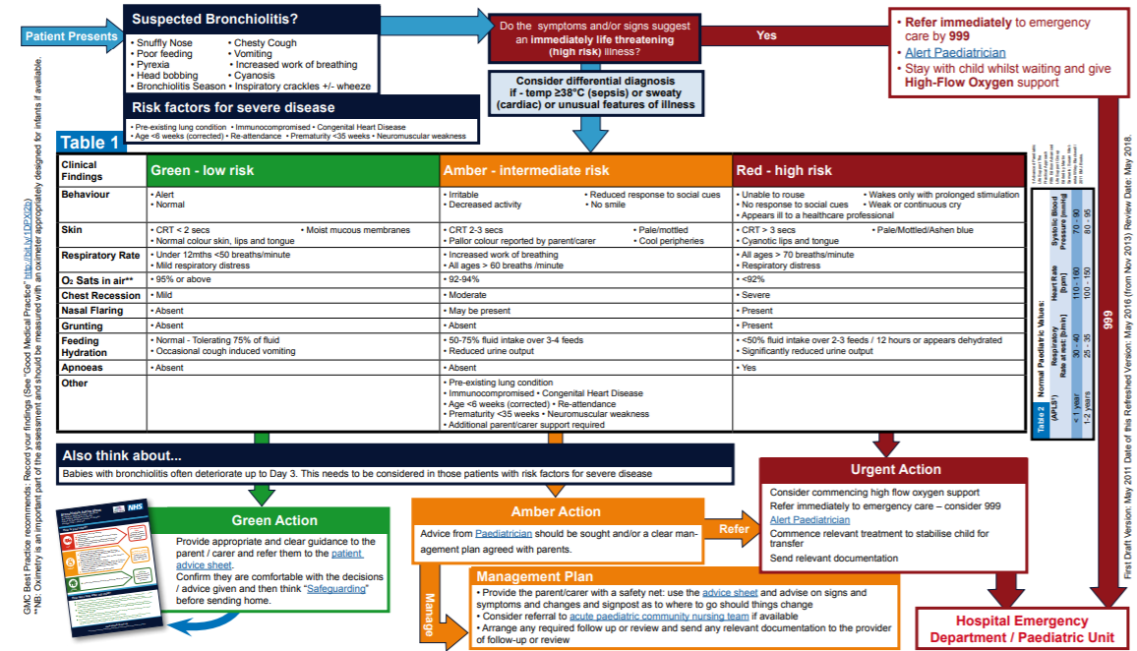

Referral pathways from Primary care to Paediatric team Musgrove Park Hospital

If you need clinical advice but do not think the child needs acute paediatric assessment

Please call consultant connect. This phone is carried between 10am to 4.30 pm by a paediatric consultant. We may be unable to answer immediately, please do try again.

Patients you think need acute paediatric assessment

Please call switchboard 01823 333444 and ask for bleep number 2439.
This bleep is held by a senior paediatric clinician – paediatric consultant or senior registrar, seven days a week, 24 hours a day

The Clinician will discuss the referral over the phone with you to:

- Offer assessment as required and advise you where to send these children – Paediatric Assessment Unit (PAU) or Acorn ward
- Provide guidance to Primary care teams and agree a plan for safety-netting children who do not require a paediatric assessment acutely

Our paediatric team are requesting that children are accompanied by one adult only without siblings, and that families wear masks whenever possible.

Please do not direct patients to self-present to the emergency department.

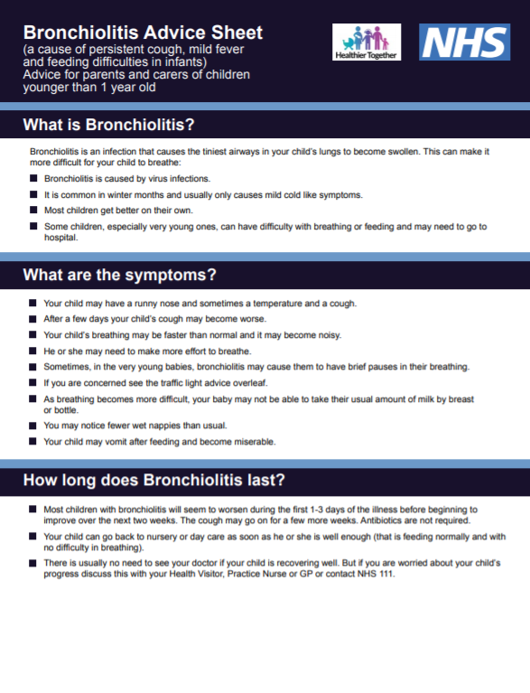
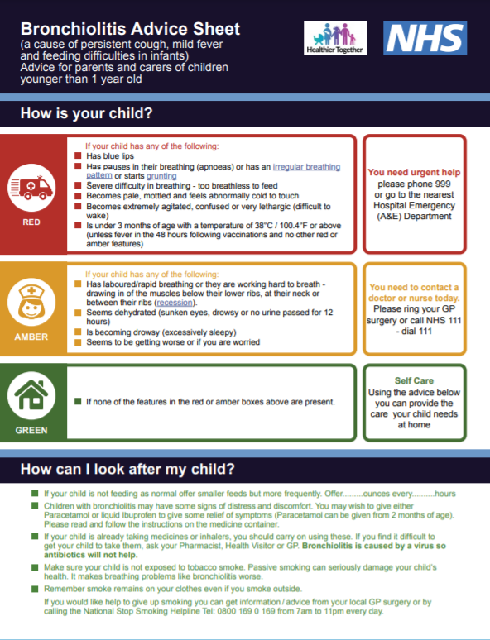

A clinical support tool to aid with remote assessment of cough and breathlessness in children <1 year age.
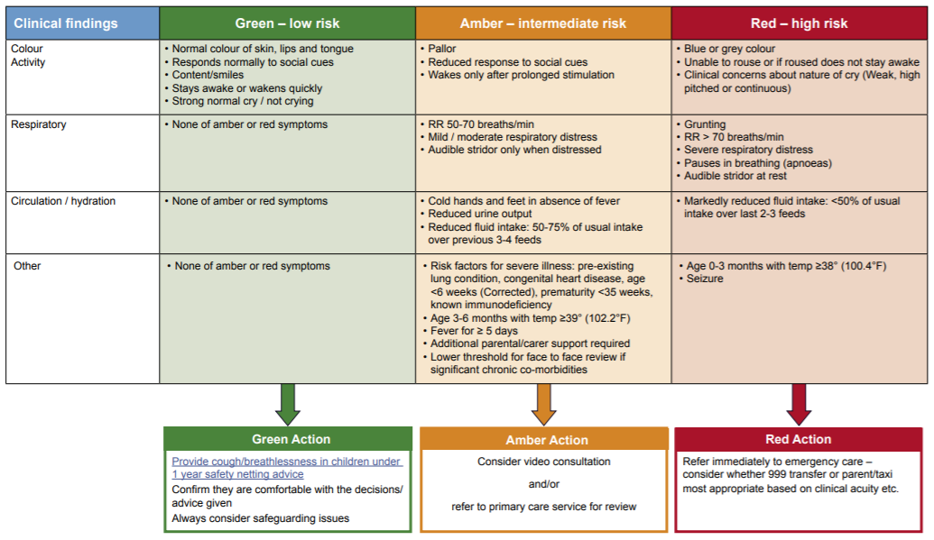
A clinical support tool to aid with the remote assessment of children with cough and breathlessness who are over 1 year of age.
