South West Regional

Healthcare Setting Covid-19 Outbreak Framework

NHS England and NHS Improvement – South West

Covid-19 Healthcare Setting Outbreak Framework

Publishing approval number: SW/EPRR/Covid-19/20200626

Version number: 8

First published: 26 Jun 20

Updated: 14 July 2021

Prepared by: Alex Thompson, Senior EPRR Manager
Ian Phillips, Regional Head of EPRR
Dean Spencer, ROC Director

This information can be made available in alternative formats, such as easy read or large print, and may be available in alternative languages, upon request. Please contact england.sw-eprr@nhs.net.

Contents

Covid-19 Healthcare Setting Outbreak Framework 1
Contents 2
1 Introduction 4
1.1 Aim 4
1.2 Objectives 4
1.3 Scope 4
1.4 Definitions 5
2 Roles and Responsibilities 6
2.1 NHS Commissioned Providers 6
2.2 NHS Clinical Commissioning Groups/ICS 6
2.3 NHS England and NHS Improvement – South West 6
2.3.1 Regional Primary Care Team 6
2.3.2 South West Regional Operations Centre 6
2.3.3 Healthcare Outbreak and Operational Pressures meeting 7
3 Intelligence and Surveillance 8
3.1 Intelligence Sharing 8
4 Notification, Activation and Escalation 10
4.1 Notification and Initial Actions 10
4.2 Escalation 10
4.2.1 Partial or Full Closure of Hospital site 10
4.2.2 Multiple Outbreaks within the Region 10
5 Serious Incident Reporting 11
6 Communications 11
Appendices:
Appendix 1: IIMARCH Template 11
Appendix 2: Provider, Commissioner and Regional Primary Care Team Actions 17
Appendix 3: Actions to be taken by Regional Operations Centre and IPC team 21
Appendix 4: Health Setting COVID-19 Outbreak – Update Report to ROC 22

Introduction

Aim
The aim of this Framework is to describe the process of notification and management of all Covid-19 outbreaks in NHS healthcare settings in the South West during the forthcoming arrangements for the Incident Response to all operational pressures for the remainder of 2020/21.

Objectives
The objectives of this Framework are to:
- Support, and not replace, extant communicable disease outbreak planning and management processes that are in place across the NHS, Local Authority Public Health, and Public Health England.
- Support the NHS in maintaining patient safety and quality of care at all times.
- Ensure that all Covid-19 cases are reported accurately daily to the NHS England and Improvement South West Regional Operations Centre (ROC) for both patients and staff.
- Ensure timely escalation of suspected outbreaks to the NHS South West ROC, Public Health England and the local Directors of Public Health.
- Describe the process for management of Covid-19 outbreaks are in line with national guidance.
- Support Patient Safety Incident Analysis or alternative investigation process.
- Ensure NHS services are supported to effectively investigate, manage and learn from outbreaks.
- Provide clarity of outbreak definitions including the declaration and ending of an outbreak in a healthcare setting.

Scope
This Framework now focuses on outbreak management of all Covid-19 outbreaks in NHS healthcare settings during the current Incident Response, which is likely to remain extant until 31 March 2022. Utilizing the principles of the Covid-19 response, as described in the letter 09 June 2020 “Minimising Nosocomial Infections in the NHS” the organisations that are included in this policy include:
- NHS Trusts and NHS Foundation Trusts
- Providers of Community and Mental Health Services
- Providers of NHS 111
- General Practices
- Opticians
- Dentists
- Pharmacy
- Health & Justice Facilities
- Independent Sector Providers undertaking NHS contracted activity
This document is not intended to replace or duplicate other guidance, frameworks, and planning that deal with communicable disease incidents and outbreaks.
All NHS organisations should be familiar with their Outbreak Control Plans, Local Resilience Forum (LRF), Local Health Resilience Partnership (LHRP) Communicable Disease Outbreak plans and PHE or NHS guidance on Outbreak Surveillance and Management.
Additionally, NHS organisations should be mindful of the interaction with Local Outbreak Management Plans for COVID-19 produced by Local Authority Directors of Public Health and the respective Local Health Protection Boards, as instructed by the Department of Health and Social Care on 22 May 2020.

Definitions
In the context of any Communicable Disease, an outbreak can be defined as the following:
an incident in which two or more people experiencing a similar illness are linked in time or place
- a greater than expected rate of infection compared with the usual background rate for the place and time where the outbreak has occurred
- a single case for certain rare diseases such as Diphtheria, Botulism, Rabies, Viral Haemorrhagic Fevers or Poliomyelitis.
- a suspected, anticipated or actual event involving microbial or chemical contamination of food or water.

The declaration of the ending of a Covid-19 outbreak in a healthcare setting, including Primary Care is as follows:
- In an inpatient setting - No confirmed cases with onset dates in the last 28 days in that setting

- In an outpatient or Primary Care environment - No confirmed cases with onset dates in the last 28 days in that environment

A service does not necessarily have to wait until the outbreak is closed before resuming services to patients (e.g. reopening a ward to admissions). The resumption of service is for local determination in line with PHE operational guidance on Communicable Disease Outbreak Management and local outbreak management arrangements including dynamic risk assessment by the “outbreak control team”.

Roles and Responsibilities
The roles and responsibilities listed herein are not exhaustive and relate only to this Framework. Key roles and responsibilities during outbreak management are listed in Outbreak Control Plans and Outbreak Management Guidance and should be understood in conjunction with this framework.

NHS Commissioned Providers
All Providers of NHS commissioned services including Acute, Community, Mental Health, Ambulance, Learning Disability and Autism, Primary Care (including General Practice, Dental, Local Pharmacies and Opticians) and Health & Justice are to ensure they have current Outbreak Control Plans, adhering to all statutory regulations and guidance as set out therein.
In response to any confirmed outbreaks, NHS Providers will bring together an Outbreak Control Team as defined by their Outbreak Control Plans.
Providers will be responsible for submitting the required initial Covid-19 Outbreak IIMARCH report (Information, Intent, Method, Administration, Risk Assessment, Communications and Humanitarian Issues) and subsequent Covid-19 Outbreak updates on to the NHS Outbreak system.

NHS Clinical Commissioning Groups/ICSs
NHS CCGs/ICSs will work with their Providers to ensure robust processes are in place for the identification and management of outbreaks within their systems.
With CCGs/ICSs now having delegated authority for General Practice, the CCG/ICS will be responsible for submitting the required initial Covid-19 Outbreak IIMARCH report and subsequent Covid-19 Outbreak updates.

NHS England and NHS Improvement – South West

Regional Primary Care Team
The Regional Primary Care team will be responsible for submitting the required initial Covid-19 Outbreak IIMARCH report and subsequent Covid-19 Outbreak updates for all Dental, Optometrist and Local Pharmacy reports in the South West Region.

South West Regional Operations Centre
The NHS South West Regional Operations Centre (ROC) will provide a focal point for the reporting of suspected or confirmed outbreaks (via the NHS Outbreak system) and will ensure all partners are informed and involved as per this document.
The ROC will produce a daily Agenda for the Healthcare Outbreak and Operational Pressures (HOOP) meeting, take action points, and record actions taken. The standing HOOP Agenda will include:
- Welcome and Matters arising
- Action Tracker
- System Surveillance
(Feedback and discussion of key issues)
(IPC/PHE/UEC/Pathology/Workforce/Communications)
  - Cornwall and Isles of Scilly
  - Devon
  - Dorset
  - Somerset
  - BANeS, Swindon and Wiltshire
  - Gloucestershire
  - BNSSG
  - South West Ambulance Service Foundation Trust (SWASFT)
- Triangulated issues
- Agreement of any areas of concern for inclusion on HOOP overview slide and further investigation/action
- AOB
- Summary of Actions from HOOP

- For information:
  - PHE – LA overview slides
  - COVID-19 SitRep
  - Early Warning Slide
  - Outbreak summary report

Healthcare Outbreak and Operational Pressures meeting
The NHS South West Healthcare Outbreak and Operational Pressures meeting (HOOP) will be brought together to respond to any reported instances of potential or confirmed outbreaks and triangulate information on operational pressures to enable a co-ordinated response to shared intelligence.
The NHS South West HOOP will comprise of representatives from the following teams:
- ROC Shift Lead (Chair)
- IPC
- Analytics
- Emergency Preparedness, Resilience and Response
- Communications
- Urgent and Emergency Care
- PHE
- Pathology
- Workforce
Depending the number and nature of the operational pressures the following may be invited to attend such as Supplies (PPE) and Primary Care.
The NHS South West HOOP will review the information available from all sources and determine in liaison with the System and Provider if any further action or support is required from the NHSE/I Regional team.
The NHS South West HOOP will report their findings, advice and decisions back through the Joint South West Regional IMT for further consideration, discussion, or action.
The role of NHS South West HOOP is:
- To co-ordinate the reporting of Covid-19 outbreaks
- To use surveillance data available from Providers, Systems, regional and national data to identify patterns that may suggest an outbreak is happening.
- To triangulate intelligence and data on operational, workforce, pathology, or communications issues that impact on winter performance or outbreak management.
- To agree how the issues identified from the surveillance data will be investigated and timescales for reporting back.
- To co-ordinate support to NHS organisations and systems for the effective management of outbreaks.
- To provide advice to the Joint SW Regional IMT on the effectiveness of the control of the outbreak and other operational pressures.
- To advise SLT on NHS organisations in the South West region with compliance with regulatory and assurance frameworks.
- To provide advice and assurance that communication to patients and the public is appropriate and timely.
The HOOP may also be established in response to any suspected Covid-19 outbreak within an NHS provider setting or be established in response to a decision point within the Joint South West Regional IMT calls based on the intelligence and data provided by NHS and PHE.
2.3.4 Regional Joint Incident Management Team (IMT)
The Joint South West IMT will provide support into systems and providers for the management of any outbreaks, as requested and agreed.
The Joint South West IMT will provide a single point of reference for assessment of any intelligence or information of interest in relation to risks of potential outbreaks.
The Joint South West IMT will receive a report from Health Outbreak Operational Pressures meeting (HOOP) at each meeting.
2.3.5 Role of SLT and the Regional Director
The Regional Director and SLT will oversee the support required to manage the outbreak at a System level and will coordinate the required resources to support the local or System Outbreak management plan.

Intelligence and Surveillance

Intelligence Sharing
Various NHSE/I Regional Cells and Teams will have sources of soft intelligence and touch points with Providers and systems that may be pertinent in identifying potential risks of outbreaks. One primary source of this data will be the daily Regional COVID-19 analytics pack.
Information and data will also be available through National routes into the ROC and other Regional teams.
Further intelligence on outbreaks is likely to be made available through regional Public Health England team.
The daily Regional Joint SW IMT will bring together this ‘intelligence’ picture by way of updates to the meeting.
Any member of the Joint SW IMT can raise concerns with regards to intelligence at the daily meetings. This information will be considered at the next HOOP or a separate HOOP convened due to the need for immediate escalation and consideration.

Notification, Activation and Escalation

Notification and Initial Actions
NHS Providers, Commissioners and the Regional Primary Care Team will notify the NHS South West ROC (england.sw-incident1@nhs.net) of any suspected or confirmed outbreak of Covid-19 within 24 hours using the NHS Outbreak system -where access is not yet established, an IIMARCH template (Appendix 1) should be completed and submitted to the ROC.
The actions to be undertaken by Providers, Commissioners and the Regional Primary Care Team in reporting outbreaks can be found at Appendix 2.
The actions required of the ROC in co-ordination of outbreak reporting and information can be found at Appendix 3.
The format of the Update Report is at Appendix 4 (NB Updates are only needed when additional cases are identified, or following an outbreak meeting).
Additionally, the ROC Director is to ensure that the Regional PHE team, relevant LRF and Local Authority Director of Public Health (DPH) is informed of any significant Outbreak, whose management is likely to result in the loss of, or closure of any NHS services in their geography. This may be undertaken by utilising the Locality Director for the LRF or via the Duty On Call Manager or Director.

Escalation

Partial or Full Closure of Hospital site
Where an outbreak is of a scale that presents a risk to patient safety it may be necessary to partially or fully close a health facility. All attempts should be made by the System to maintain services to patients and to do so in a way that balances the risks of closure and maintaining the service.
Where closure takes place, the regularity, intensity and breadth of membership of the HOOP may need to be increased and extended.
In the case of any health closures near regional borders, the ROC Director will make contact with the neighbouring Regional ICC’s to inform a discussion on the potential operational impacts. The National SPOC will also be regularly informed as part of the current Daily Covid-19 Outbreak SITREP.
Where a health closure may cause a potential impact to healthcare delivery in a devolved administration, this will be flagged with the National SPOC for escalation.

Multiple Outbreaks within the Region
Where multiple outbreaks occur within the Region, the HOOP will make an assessment on the need to establish any additional HOOP sub-groups with defined oversight of specific outbreaks.
For example, it may be necessary for a specific group of individuals to provide direct support to a particular outbreak whilst the HOOP continues its oversight of all simultaneous outbreaks within the Region.

Serious Incident Reporting
Serious incidents can extend beyond incidents which affect patients directly and include incidents which may indirectly impact patient safety or an organisation’s ability to deliver ongoing healthcare. This would be instigated by the system, with assurance being sought via the CCG. In terms of Patient Safety Incident (SI) reporting during the current Incident response, Organisations should continue to report anything of concern. Clinical and professional judgement should be taken when considering what to identify as a SI. The 2015 SI Framework promotes identification and reporting of SIs based on the potential for learning, future risk reduction and the consequences of any recurrence of the incident.
Where there is any evidence that the COVID-19 infection may have been hospital-acquired and a death from COVID-19 has resulted, then there is clearly scope for learning. This is potentially a Serious Incident (and reportable under RIDDOR) if the infection was acquired due to issues in healthcare provision, such as non-compliance with IPC processes. Whether Structured Judgement Review (SJR), Route Cause Analysis (RCA) or some other method is the correct format to generate that learning is dependent on the circumstances and is therefore for local decision. The scale and scope of resultant investigations should be proportionate to ensure resources are effectively used. Organisations will need to be sure that any decision making is defensible and taken openly and transparently, including in discussion with relevant patients’ families and the staff involved.

Communications
Effective communications (internal and external) will be crucial to supporting the management of any Covid-19 outbreak, ensuring accurate information is shared with staff, patients and stakeholders and that the risk of causing unnecessary alarm is minimised. It is vital therefore that heads of communications from Regional teams, Provider and Commissioners are involved in planning any approaches introduced to manage outbreaks. This activity will be co-ordinated by the Regional NHSE/I Communications team.

Appendix 1: IIMARCH Template

IIMARCH Template for Reporting NHS Commissioned Services Covid-19 Outbreak

This IIMARCH template to be completed for all Providers of NHS commissioned services including Acute, Community, Mental Health, Ambulance, Learning Disability and Autism and Health & Justice and all Primary Care commissioned services including General Practice, General Dental Practice, Local Pharmacists and Optometrists.

The IIMARCH template to be immediately completed on identification of any new Covid-19 outbreak. The completed IIMARCH template is to be submitted to SW Regional Operations Centre at england.sw-incident1@nhs.net by no later than 1200 the day after the outbreak has been notified.

Organisation: |  |  |  | Organisation Lead (Director of Infection Prevention and Control or equivalent) |  | Name:
Site: |  |  |  |  |  | E-mail:
 |  |  |  |  |  | Telephone:
Service / ward area or  Outbreak Location (with site): |  |  |  | Public Health Lead |  | Name:
Date outbreak identified: |  |  |  |  |  | E-mail:
Date of last positive case: |  |  |  |  |  | Telephone:
Date of next outbreak meeting: |  |  |  | System IPC Lead |  | Name:
Date and time of submission: |  |  |  |  |  | E-mail:
 |  |  |  |  |  | Telephone:
Has this outbreak resulted in the suspension of an essential service within your organisation, or closure of patient admissions to a service? (Yes/No)
Notification to PHE: |  |  |  |  |  | Yes/No
Date of Notification to PHE:
Please RAG rate the box on the right as to the post mitigating actions status of the outbreak:
Red = Critical service (as per BCP) not available (due to outbreak)
Amber = Services running but with disruption or significant additional strain on organisation
Green = Services running with no operational impact (due to the outbreak)
Element | Key questions and considerations |  | Action / Response
Information | What, where, when, how, how many, so what, what might?  Timeline and history (if applicable), key facts (including outline description of any facility affected), rationale for workplace transmission e.g breach in PPE, lack of social distancing etc
Next steps:
What actions do you plan to take?
 | - Initial outbreak information (1.1 to 1.11 for completion when reporting a Covid-19 outbreak for the first time)
 | 1.1 Has the organisation completed all the locally required actions in the organizations outbreak plan flowchart?
 | 1.2 Last positive case date (patient/staff)
 | 1.3 Cumulative number of positive patients with Covid-19?
 | 1.4 Number of patients in isolation - swabbed/blood tested awaiting result?
 | 1.5 Total number of patients in the area
 | 1.6 Total number of patients who are indeterminate (diagnosed at 3-7 days)
 | 1.7 Total number of patients who are probable healthcare onset (diagnosed at 8-14 days)
 | 1.8 Total number of patients who are definite healthcare onset (diagnosed at 15+ days)
 | 1.9 Number of staff affected and tested positive for Covid-19?
 | 1.10 Number of staff swabbed/blood tested awaiting result?
 | 1.11 Number of staff self-isolating as a result of this outbreak excluding those who have tested positive  (% of total organisation staff number)? |  | No Self-Isolating
 |  |  | % of Organization
 | 1.12 Number of staff showing symptoms?
 | Capacity/Impact on:
 | 1.13 Number of areas affected (e.g. ward, bay, care home, clinic rooms, beds etc)?
 | 1.14 Number of wards/areas closed to new admissions?
 | 1.15 Number of empty beds that cannot currently be utilised?
 | 1.16 Number of bed days lost?
INTENT | Why are we here, what are we trying to achieve?  Strategic aim and objectives, joint working strategy  What are your immediate interventions attempting to achieve with regard to the outbreak, in order of priority?
METHOD | How are we going to do it?  Command, control and co-ordination arrangements, tactical and operational policy and plans, contingency plans  Please include operational governance process including detail of outbreak control meetings and frequency
ADMINISTRATION | What is required for effective, efficient and safe implementation?  Identification of commanders, tasking, timing, decision logs, equipment, PPE, welfare, logistics  Please include a clear timeline for actions and interdependences including resources, capacity and confidence to deliver and mobilise actions
RISK ASSESSMENT | What are the relevant risks, and what measures are required to mitigate them?  Risk assessments (dynamic and analytical) should be shared to establish a joint understanding of risk.  Risks should be reduced to the lowest reasonably practicable level by taking preventative measures, in order of priority. Consider the hierarchy of controls and clear process for escalation.
COMMUNICATIONS | How are we going to initiate and maintain communications with all partners and interested parties?  Comms strategy including understanding of inter-agency communications, information assessment, media handling and joint media strategy and frequency of updates
HUMANITARIAN ISSUES | What humanitarian assistance and human rights issues arise or may arise from this event and the response to it?  Requirement for humanitarian assistance, information sharing and disclosure, potential impacts on individuals’ human rights
When using IIMARCH, it is helpful to consider the following:
- Brevity is important - if it is not relevant, leave it out
- Communicate using unambiguous language free from jargon and in terms people will understand
- Check that others understand and explain if necessary
- Consider whether an agreed information assessment tool or framework has been used

Appendix 2 Provider, Commissioner and Regional Primary Care Team Actions

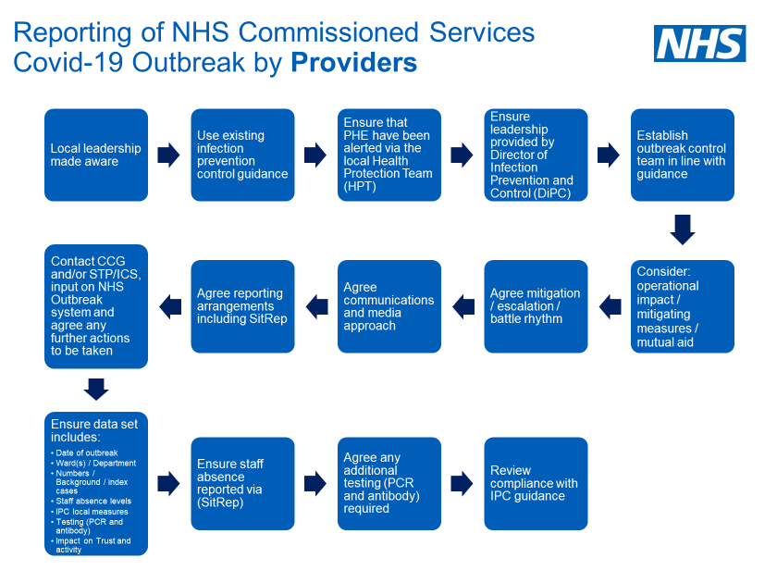
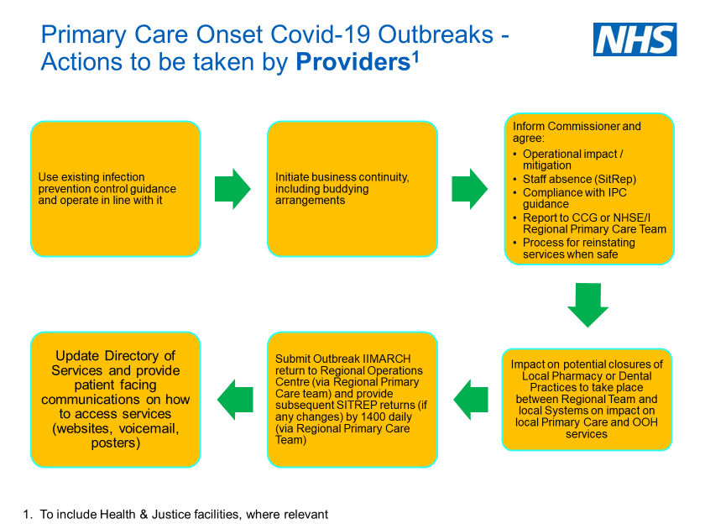
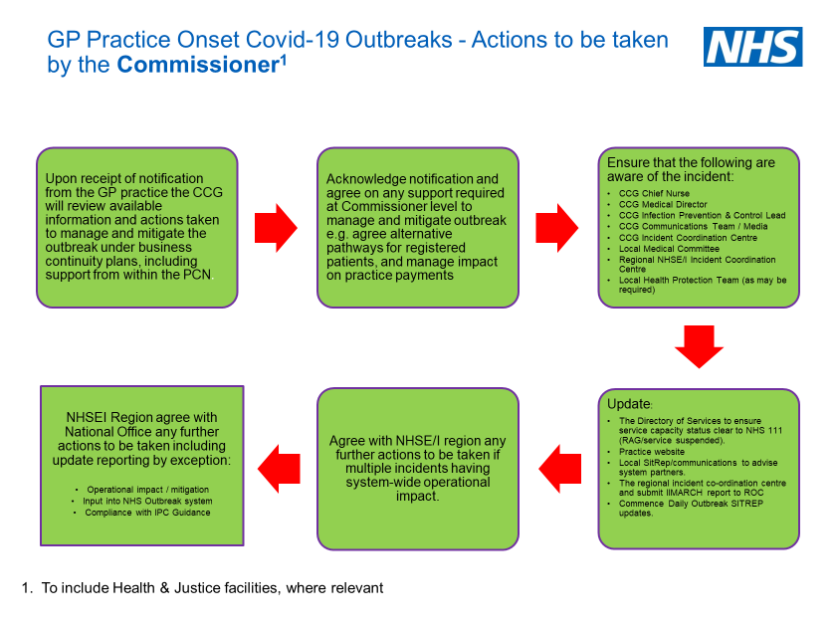
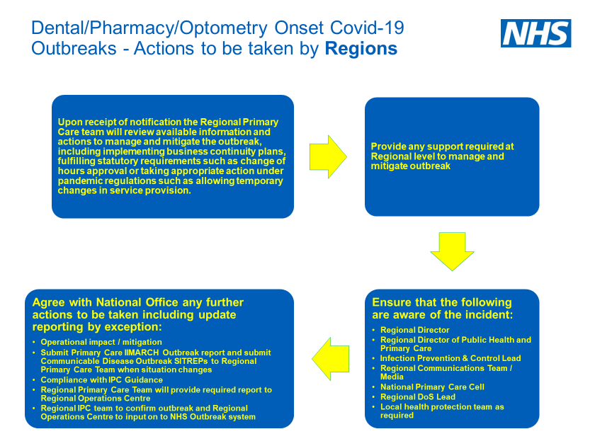
Appendix 3:
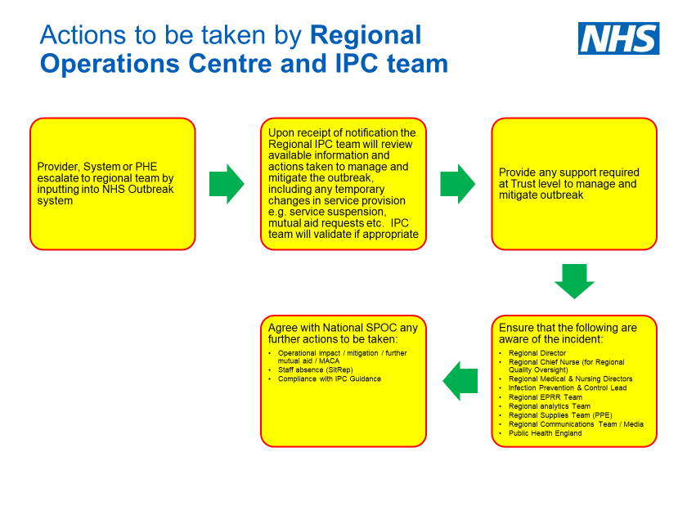

Appendix 4: Health Setting Covid-19 Outbreak – Update Report to ROC

Updates are needed when additional cases are identified, or following an outbreak meeting

Name of Provider:

Ward/Area:

Speciality

Date:

Date of next outbreak meeting (if applicable)

Reported prepared by name and job title:

Contact Details (should we need to get in contact Email and phone number): | Mobile
 | Email
Date of Outbreak Commenced/Closure of area

Date of last positive Covid-19 test
(staff or patient)
Planned Date for Opening Ward/Area
Planned Date for Formally Closing Outbreak
(28/7 after last positive test)
Has this outbreak resulted in the suspension of an essential service within your organisation, or closure of patient admissions to a service? (Yes/No)

Update

- Number of Patients Testing Positive for this outbreak (as at 1200 today)
Total number of patients or customers who have tested positive during this outbreak
- Number of Patients in Isolation (as at 1200 today)
Total number of patients who are in self isolation (excluding the ones above from Question 1)?
- Number of Staff Testing Positive for this outbreak (as at 1200 today)
Total number of staff who have tested positive during this outbreak?
- Number of Staff in Isolation (as at 1200 today)
Total number of staff members who are in isolation due to this outbreak (excluding the above from Question 4)?
- Are you on trajectory on your outbreak control plan?
What actions have you taken

What actions do you plan to take (Next steps)
- Have you closed or partially closed/reduced services as a result of this outbreak?
If Yes - Please give details of the services that have been disrupted and the impact on delivery/business continuity
Please RAG rate the box on the right as to the post mitigating actions status of the outbreak:
Red = Critical service (as per BCP) not available (due to outbreak)
Amber = Services running but with disruption or significant additional strain on organisation
Green = Services running with no operational impact (due to the outbreak)

Please provide the following information and return to the Regional ROC england.sw-incident1@nhs.net by no later than 14:00, when updates are required.

The Regional Operations Centre replaces the roles and functions undertaken by the Regional Incident Coordination Centre, from 14 Sep 20.
Links: PHE guidance on defining and managing communicable disease outbreaks https://www.gov.uk/government/publications/communicable-disease-outbreak-management-operational-guidance

