By using this guide GP practice staff will be able to log in to the SIDeR Shared Care Record using the Pyrusium browser.
If you do not have Pyrusium installed on your device, please contact the SCW service desk to get this installed or download from: http://www.pyrusium.com/downloads/pyrusiumbundle.exe and enter the practice NACS code and EMIS CDB number.

Pre-requisites:
The EMIS EMAS Manager has been configured for each user as per these instructions: https://support.blackpear.com/hc/en-us/articles/360038364131-API-configuration-for-EMIS-per-user-

If this is your first time logging into SIDeR and you have already used EPaCCS, you will need to logout of EPaCCS to see this screen. EPaCCS is now part of the SIDeR Shared Care Record.
- Launch Pyrusium which is installed on your PC

- If you cannot find it, Pyrusium can be located by typing it in the Windows tool bar at the bottom left of your screen.

- Click on ‘Sign in to SIDeR’ on the login screen:
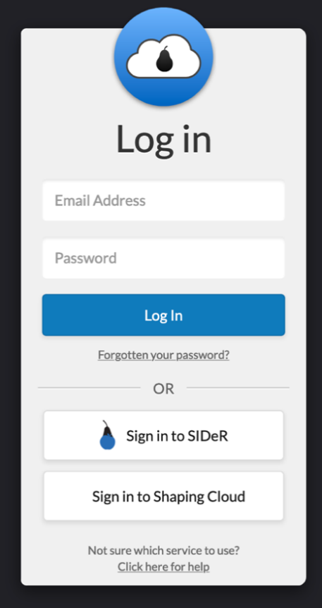

- Enter your username, this will be firstname.surname@somersetccg.nhs.uk
Enter your password (the one you use to login to windows / your device)
Note: the domain field is automatically populated so do not change this
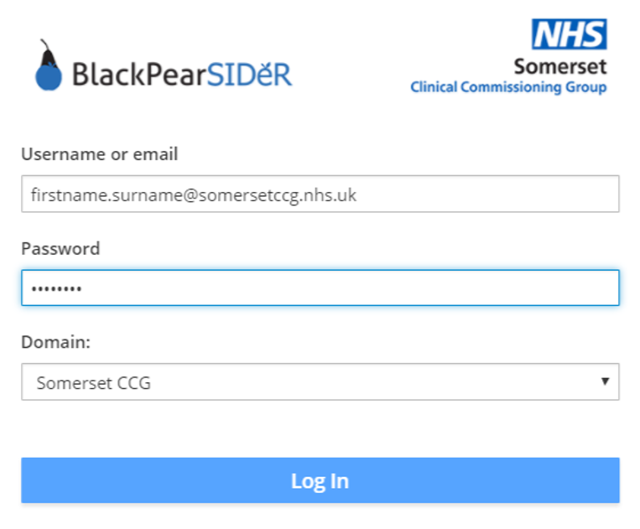

- This will take the user to the Black Pear landing page (it may take a few moments to load). Click on the ‘Core – SIDeR’ icon
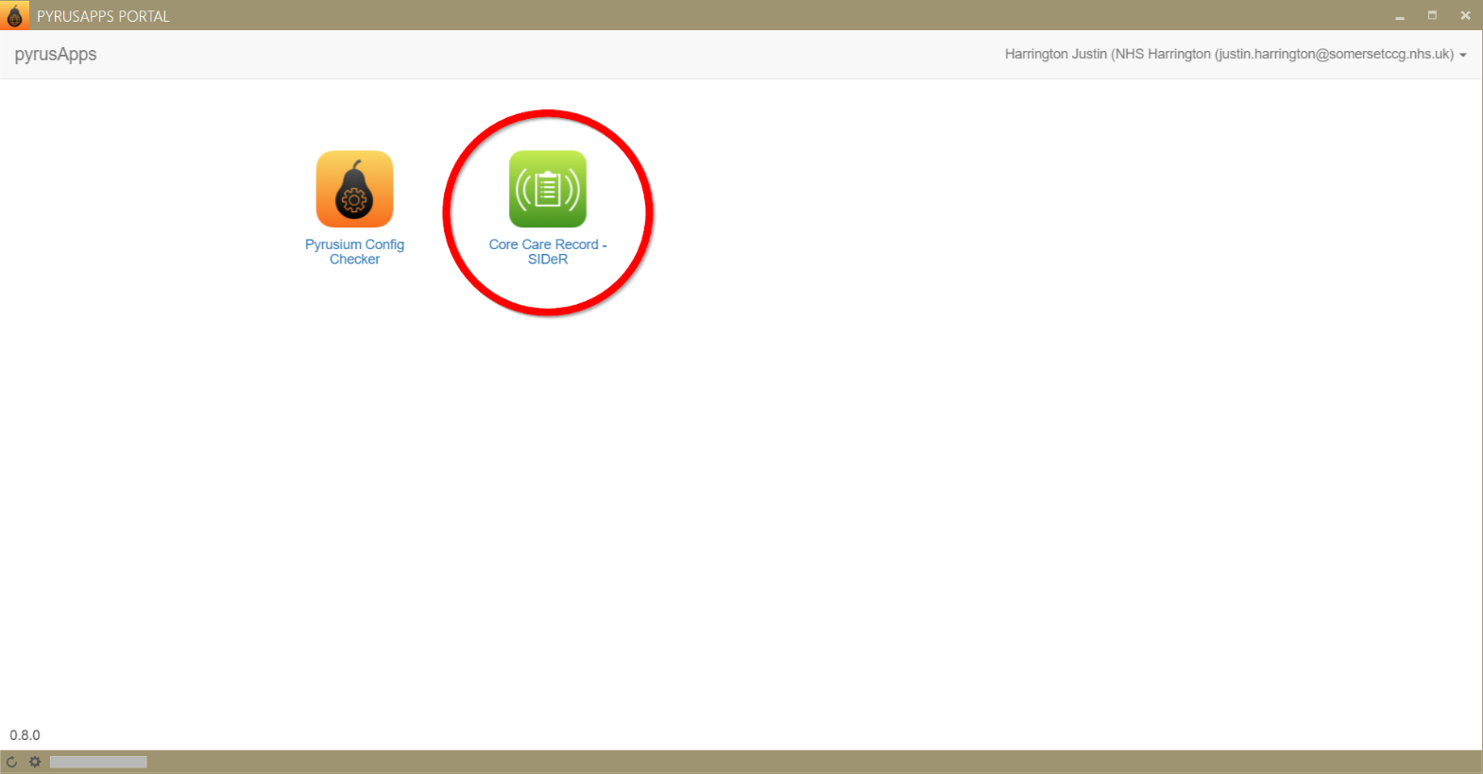

- The SIDeR Shared Care Record home screen will be displayed, if you are already logged into EMIS Web, the currently viewed patient will be displayed. You may wish to search a for different patient to view their Shared Care Record.
Any issues with logging into SIDeR please contact the SCW service desk via TOPDesk.
If you still have issues after contacting the SCW service desk, please raise to support@blackpear.com

