JOB DESCRIPTION

JOB DETAILS:
Job Title: | Community Sub-Dean, Taunton / Somerset Site
Organisation: | Somerset NHS Foundation Trust
Location: | Somerset
Accountable to: | Associate Dean, Taunton
Tenure: | 3 years, subject to review after 12 months
Funding: | 1 PA or 4 hours / week
Date: | ASAP

Job Purpose:
The Peninsula Medical School is seeking to appoint an experienced General Practitioner, who is passionate about medical education and community care, to the role of Community Sub-Dean for the Somerset area. The post-holder will work closely with the Peninsula Medical School team in Plymouth and at Musgrove Park Hospital.

The role of Community Sub-Dean is pivotal in sustaining and improving a collaborative approach between healthcare professionals and Peninsula Medical School in the delivery of undergraduate education, primarily within general practice in Taunton and Somerset. The post-holder will be supported by the Community Sub Dean for Plymouth and Torbay and the Medical Education Team in Taunton.

It is important that the post-holder knows and has a good relationship with GP practices and supporting services in the Taunton / Somerset area.

This is an important medical school role in developing, maintaining and quality assuring the delivery of the community curriculum across years 3-5 in the Taunton area. Recruitment of, and engagement with, GP and community healthcare providers will be key, as well as working closely with Bristol Medical School representatives who will also be placing students with local practices.

This is an exciting period of curriculum innovation and refinement due to medical school student expansion and the current challenges facing general practice provision. The post-holder will need to acquire a good understanding of the undergraduate medical curriculum and will model the values, educational principles and pedagogic approaches of the Peninsula Medical School.

Date of Job Description: March 2021

Key Roles and Responsibilities
- Curriculum & Education
- Contribute to the delivery, evaluation and further development of the curriculum with special reference to the community dimension in conjunction with the Director of Clinical Studies, other Community Sub Deans, the Medical Education Team in Taunton and the relevant committee or groups.
- Liaise with individual GP Practices, Social Enterprises, Clinical Commissioning Groups, Local Medical Committee and other community placement providers / commissioners regarding the provision of community educational experiences.
- Identify and explore novel community experiences that meet the programme’s learning objectives.
- Quality Assurance
- Monitor quality of educational provision in community placements, in part by undertaking quality assurance visits to teaching GP Practices on a regular basis, as well as taking remedial action if needed.
- Staff Development & Training for Providers
- To help deliver and contribute to the staff development programme (including induction and update training for years 3-5), particularly in the areas of clinical teaching and assessment.
- To assist in the development and recording of clinical assessment benchmarking resources.
- Student Induction
- To attend student induction for years 3, 4 and 5 in Taunton to explain the curriculum and community assessments to students.
- Student Support
- Being available to deal with individual student problems (typically those outside the remit of academic tutor, pastoral tutor).
- Other Duties
- To be a member of a core group carrying out second attempt assessment of clinical skills in the clinical environment including in-vivo assessments and CEX.
- To be an Academic Tutor.
- To contribute to assessment by assisting in the development of ISCE stations and writing, reviewing and validation of questions for the Progress test. This includes standard setting activities.
- To undertake additional roles such as ISCE Examiner etc. as may be from time to time required.
- Generic roles in relation to the community programme as assigned by the Director of Clinical Studies or Associate Dean (Taunton).

Key working relationships:
- Director of Clinical Studies
- Community Sub Dean, Plymouth & Torbay
- Associate Dean, Taunton
- Hospital Sub Dean, Taunton
- Medical Education Manager, Taunton
- Undergraduate Lead (PMS), Taunton
- Clinical Liaison Manager and Clinical Liaison Team, Plymouth
- Associate Head of School for Medical Education
- Head of Medical School
- Other Sub Deans / Academic staff
- Somerset Academy Bristol Medical School Faculty
- Undergraduate Lead (Bristol Medical School), Taunton

The post-holder will be line managed by the Associate Dean, Taunton.

Contract
Exact contractual arrangements will be negotiated with the successful candidate and their current employers. The sessional allocation for the post of the Community Sub Dean is 1 PA or 4 hours / week. The successful candidate will be awarded an honorary academic contract with Plymouth University. If already employed by the University, the role will be included in, or as an extension of, your present contract.

The post-holder will be expected, on an ad hoc basis, to be available for key meetings within the School (Wednesdays), although this is subject to negotiation on appointment. Changes to fixed sessions will be required on occasion, with appropriate notice (for example in order to attend staff development and student induction activities).

Person Specification
This is a specification of the Qualifications, Skills, Experience, Knowledge, Personal Attributes and Other Requirements which are required to effectively carry out the duties and responsibilities of the post (as outlined in the Job Description).
Requirement | Essential / Desirable | How Assessed
BEHAVIOURS ALIGNED WITH TRUST VALUES  - Outstanding care  - Listening and leading  - Working together | E  E  E | Interview & Application
EMPLOYMENT  - Current employment in General Practice within the Taunton / Somerset area  - Fully registered with the GMC.  - Good clinical links / working relationships with the services and GP Practices in the area. | E  E  E | Interview & Application
QUALIFICATIONS & TRAINING  - Interest and enthusiasm for improving the delivery of Undergraduate education and continued professional development.  - Aspiration to develop further skills and qualifications in either medical management or medical education.  - To be committed to a high quality provision of patient care and clinical education.  - Previous experience of undergraduate education e.g. clinical teacher, Academic Tutor. Knowledge of the Medical School undergraduate curriculum and share and support the ideals.  - Participation in education training and an interest in obtaining a higher qualification in medical education.  - Higher Degree | E  E  E  D  D  D | Interview & Application
MOTIVATION  - Demonstrate commitment to and advancement of undergraduate education.  - To provide leadership for medical education.  - Able to motivate clinical teachers to provide high quality medical and education.  - Commitment to personal development e.g. through appraisal.  - Previous demonstration of motivation in a similar context. | E  E  E  E  D | Interview & Application
SKILLS  - Ability to manage change.  - Good interpersonal skills.  - Good verbal presentation skills.  - Approachable.  - Counselling skills.  - Teaching skills.  - Understands the use of IT in education.  - Ability to co-operate with other healthcare professionals to develop multi-professional education. | E  E  E  E  E  E  D  D | Interview & Application
MANAGEMENT  - Leadership skills.  - Knowledge of management structures and recent changes that relate to medical education.  - Previous management training or experience. | E  D  D | Interview & Application
OTHER  - Ability to travel  - Flexibility to work at different times of the week, as required, and to attend relevant Medical School meetings. | E  E | Interview & Application
SUPPORTING BEHAVIOURS
To carry out this role successfully the post holder needs to be fully aware of and adhere to Trust values/standards and reflect these as their behaviours:

Outstanding Care:
- I treat everyone with dignity, kindness and respect.
- I involve patients, relatives, carers and colleagues in decision-making.
- I ensure that my actions contribute to outstanding care, regardless of my role.
- I admit mistakes, apologise and learn from them.
- I champion the health, safety and wellbeing of patients, relatives, carers and colleagues.
- I speak up when others cannot.

Listening and Leading:
- I lead with empathy, taking responsibility for how my emotions and actions affect others.
- I inspire others to embrace change, encouraging them to see their part in the bigger picture.
- I strive to be the best I can be.
- I value the opinions and contributions of colleagues, patients and others.
- I encourage innovation and am open to new ideas.
- I listen with interest and take action if I am able.

Working Together:
- I collaborate with others to achieve shared goals.
- I communicate clearly and appropriately.
- I work together to overcome challenges.
- I ask for help and always assist those in need.
- I thank colleagues for their contributions and celebrate shared successes.
- I use resources effectively, treating every £ as if it were my own.

Plymouth University’s Behaviours:
- Demonstrates Self-Leadership
- Develops self and others to deliver
- Leads and operates in times of change and ambiguity
- Builds and secures value from relationships
- Drives innovation and action
- Creates and contributes to a shared vision
- Uses sound business judgement

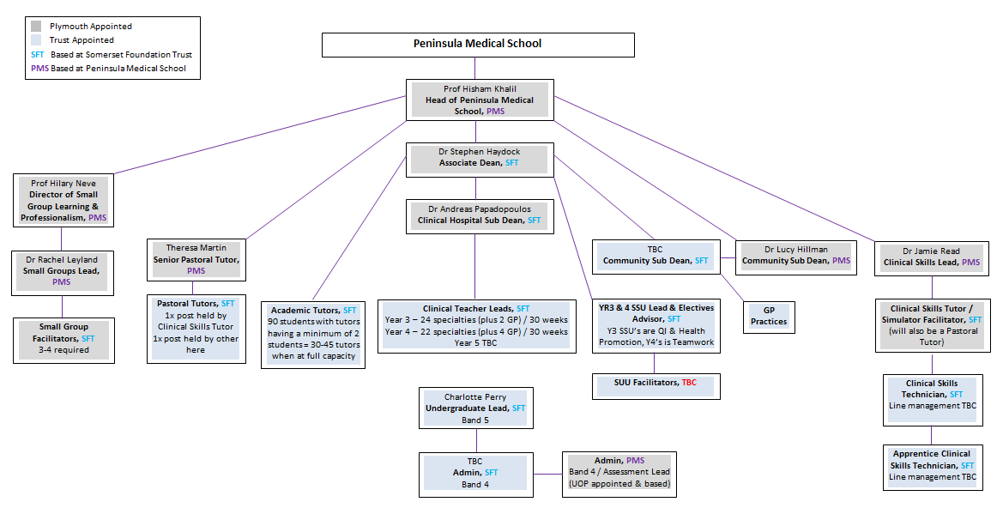
Department of Medical Education, Musgrove Park Academy,
Somerset NHS Foundation Trust, Taunton, Somerset, TA1 5DA
Tel: 01823 342430 Email: PenMedSchool@SomersetFT.nhs.uk
Follow us on Twitter @MPHAcademy

