GP toolkit – Priority groups 5 and 6 version 1
16/02/21

GP practice website –suggested text

NHS COVID-19 VACCINATION PROGRAMME UPDATE

Our health and care colleagues have achieved an important milestone in Somerset, by offering a COVID-19 vaccination to people in the first four priority groups as identified by the Joint Committee on Vaccination and Immunisation (JCVI)

We are now expanding our vaccination programme to include priority groups 5 and 6. This includes people aged 65 and over (Group 5) and people who are aged 16 to 64 with underlying health conditions, which may put them at higher risk of serious disease from COVID-19 (group 6)

People who fall in to the next priority groups will be contacted in a variety of ways which may include letters from the NHS if you are aged 65 and over - or you will receive a phone call, letter or text message from our GP primary care network team.

We are now inviting people who are 65 and over to book an appointment through the national booking service; online http://www.nhs.uk/covid-vaccination or by ringing 119. As soon as you receive your letter, you can book a vaccination appointment at either of our large vaccination centres at the Bath & West Showground, Taunton Racecourse or a pharmacy-led site in Taunton, Yeovil or Bruton.

As part of our primary care network, we will be contacting people in group 6 who have underlying health issues as specified by the Joint Committee for Vaccination and Immunisation (JCVI). We will contact you directly to arrange a vaccination appointment – there is no need to contact the practice.

We understand that everyone is anxious to know when they might get their vaccination and want to be vaccinated as quickly as possible. You can help us to run the vaccination programme as efficiently as possible by following the guidance above and please don’t contact the surgery to ask about your vaccination.

We are working through our patient lists as quickly as we can to identify patients who fit into priority group 6 and to ensure that they are offered an appointment as quickly as possible.

For more information on eligibility, visit the JCVI. Or you can find out more information on the Somerset NHS vaccination programme

Thank you for your continuing support and patience.

Suggested GP practice text message – to group 5

To encourage people who are aged between 65 and 69 to book through the national booking service, you could send a text message if you have the facility to do this. Depending on text character limits, suggested wording:

From XXX GP Practice. If you are aged 65-69 you will receive a letter from the NHS inviting you to book your COVID-19 vaccine – you can now book straight away online: www.nhs.uk/covid-vaccination or call 119. There is no need to call your GP surgery. Thank you.

Example Social media messages
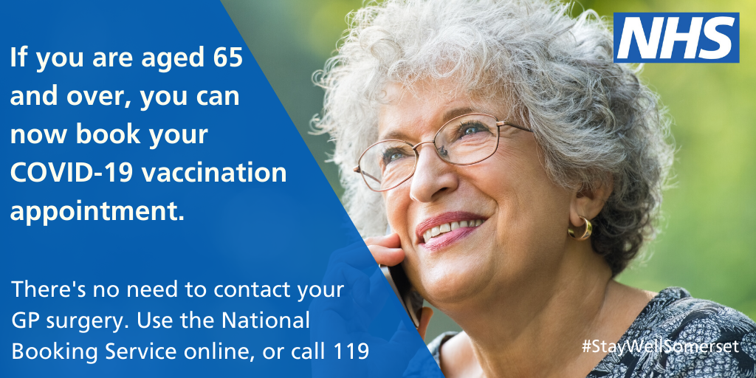
If you are aged 65 and over – you can now book your #COVID vaccination at one of our large vaccination sites; the Bath and West Showground, Taunton Racecourse or one of our pharmacy sites in Yeovil, Taunton or Bruton. As soon as you receive your letter, go online: http://www.nhs.uk/covid-vaccination or call 119.
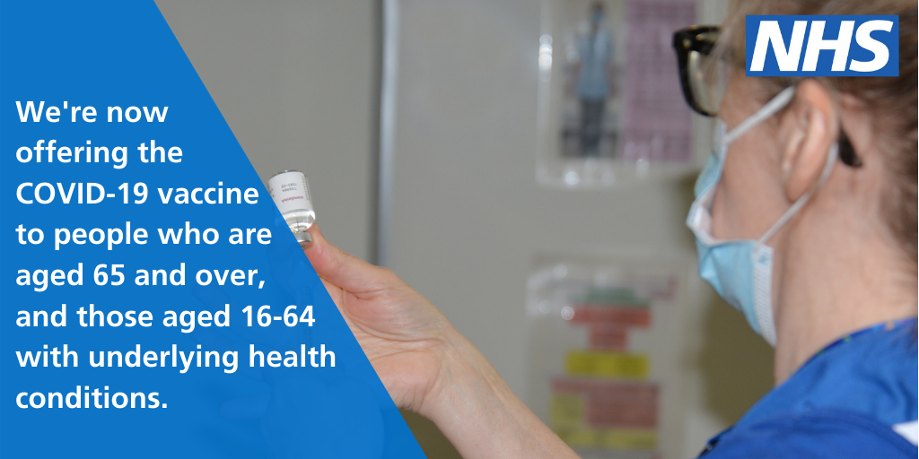
We want to offer the #COVID vaccination to as many people in priority group 5 and 6 as possible. If you are aged 65 and over, you will receive a letter from the NHS – please help us by using the national booking service to book your appointment as soon as possible – please don’t call your GP surgery.
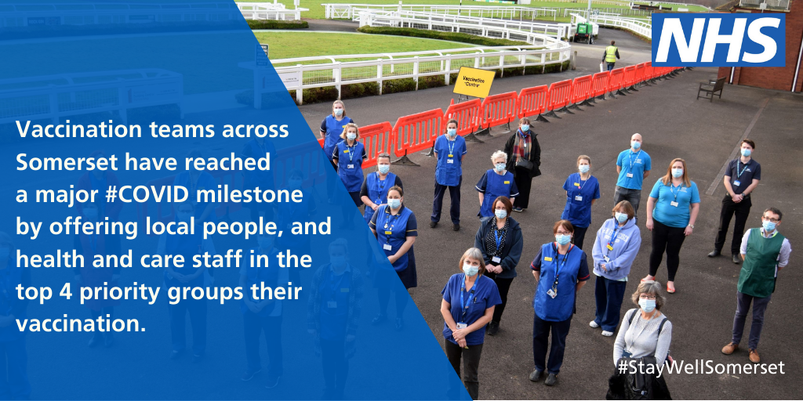
Vaccination teams across Somerset have reached a major #COVID milestone by offering local people and healthcare staff in the top 4 priority groups their vaccination. We’re now extending our programme to over 65s and people aged 16-64 who have underlying health conditions. Read more
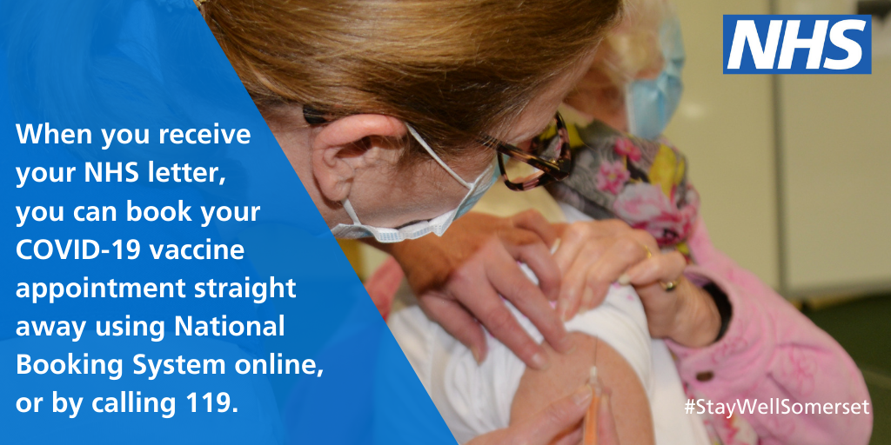
We’re now inviting people who are aged 65 and over to book their #COVID vaccination. Don’t delay – as soon as you receive your letter, book your appointment today. We’re looking forward to seeing you. Please don’t call your GP practice
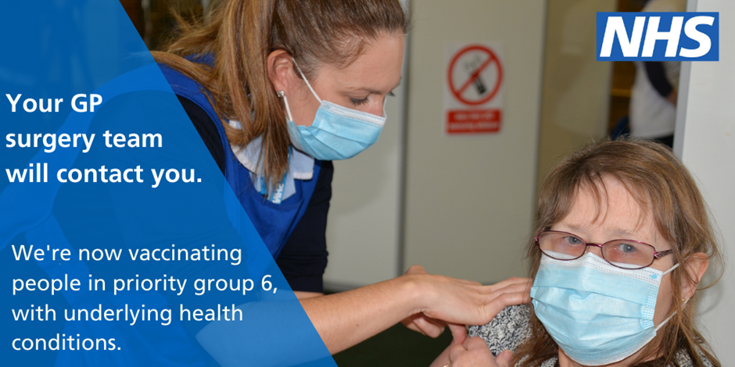
We’re now inviting people in priority group six to come for their vaccinations. We are working through our patient lists and we will invite eligible people to an appointment as soon as possible. There is no need to contact your GP surgery
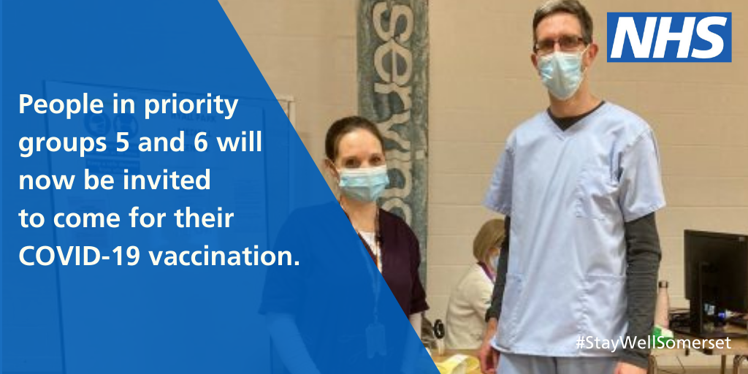
People in priority groups 5 and 6 will now be invited to come for their #COVID-19 vaccination. To find out more about eligibility visit the Joint Committee for vaccination and Immunisation website.
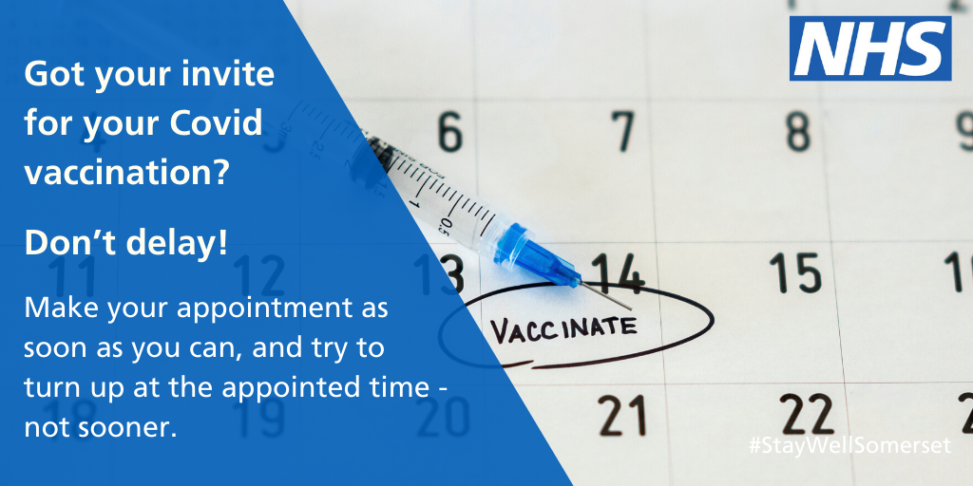
If you have received your #COVID invitation, please make your appointment as soon as possible. To find out more about the NHS vaccination programme visit: https://www.somersetccg.nhs.uk/health/local-services/health-services-during-coronavirus/covid-19-vaccinations-in-somerset/

