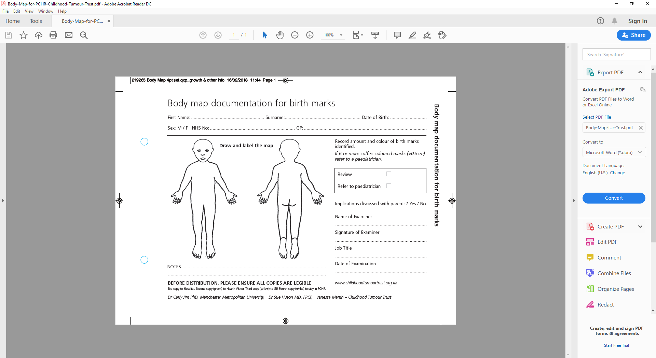

- Record all skin marks on body map, stating size and colour.  
- Please discuss any unusual appearance of skin marks with a Paediatrician

- Record all skin marks on body map, stating size and colour.  
- Please discuss any unusual appearance of skin marks with a Paediatrician

- Record all skin marks on body map, stating size and colour.  
- Please discuss any unusual appearance of skin marks with a Paediatrician

- Record all skin marks on body map, stating size and colour.  
- Please discuss any unusual appearance of skin marks with a Paediatrician

No marks noted Signature …………………………. Date …………………

No marks noted Signature …………………………. Date …………………

No marks noted Signature …………………………. Date …………………

No marks noted Signature …………………………. Date …………………

No marks noted

No marks noted

Body map documentation for birth marks / trauma

Body map documentation for birth marks / trauma

Body map documentation for birth marks / trauma

Body map documentation for birth marks / trauma

Body map documentation for birth marks / trauma

Body map documentation for birth marks / trauma

Body map documentation for birth marks / trauma

Body map documentation for birth marks / trauma