## How to log in to the SIDeR Shared Care Record – GP Practice Staff

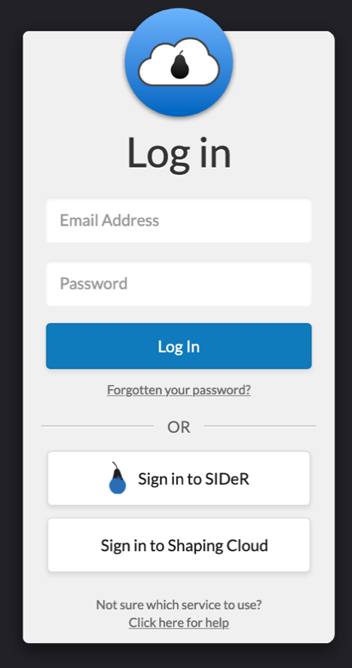Launch from a Pyrusium browser

*Pre-requisites:*

The EMIS EMAS Manager has been configured for each user as per these instructions: <https://support.blackpear.com/hc/en-us/articles/360038364131-API-configuration-for-EMIS-per-user->

If this is your first time logging into SIDeR and you have already used EPaCCS, you will need to logout of EPaCCS to see this screen. EPaCCS is now part of the SIDeR Shared Care Record.

1. User launches Pyrusium
2. User is taken to the log-in screen
3. User clicks on ‘Sign in to SIDeR’ and then enters login details. Your login will be [firstname.surname@somersetccg.nhs.uk](mailto:firstname.surname@somersetccg.nhs.uk) (this is your Active Directory username) plus your Active Directory password (the one you use to login to windows/ your device)



1. This will take the user to the Black Pear landing page. Click on the ‘Core – SIDeR’ icon
2. The user will be taken to the SIDeR Shared Care Record home screen, from which they can search for the patient they wish to view the Shared Care Record of. Alternatively, the app will pick up the currently open patient from EMIS Web

If you do not have Pyrusium installed on your device, please contact the SCW service desk to get this installed or download from:  <http://www.pyrusium.com/downloads/pyrusiumbundle.exe> and enter the practice nacs code and Emis CDB number.

Any issues with logging into SIDeR please contact the SCW service desk.

If you still have issues after contacting the SCW service desk, please raise to [support@blackpear.com](mailto:support@blackpear.com)