Somerset FT logo

Learning Disability Deaths and Covid-19
Evidence and the Somerset Response

Recent national reports and local data highlight the vulnerability of this group in relation to Covid-19 and we need to ensure that people with a learning disability in Somerset are supported to stay as healthy as possible during the coming months.
Primary Care plays a vital role through the Learning Disability registers they hold and carrying out Annual Health Checks particularly for those who are most vulnerable.

LeDeR and Public Health England reports
The PHE report shows a death rate from Covid-19 at least 4.1 times higher than the general population (up to 692 per 100,000 as compared to 109 per 100,000); for the 18-34 age group is was 30 times higher.

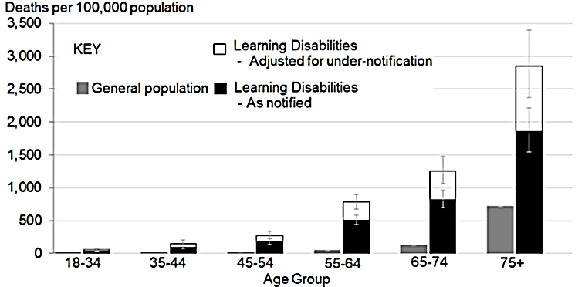
Graph from PHE report

The LeDeR report shows a striking difference in age for Covid-19 deaths, with about half occurring in those aged 50 – 69 (general population half over 85). The report also highlights the main long-term health conditions of those who died providing opportunity for preventative measures to be put in place.
LeDeR – existing conditions of those who died from Covid-19
- Mobility impairment 74%
- Respiratory conditions 72%
- Epilepsy 48%
- Cardiovascular disease 34%
- Hypertension 33%
- Obesity 33%
- Down’s syndrome 20% - now on extremely clinically vulnerable list (shielding)

Local Data
Somerset CCG
The CCG has compiled data regarding learning disability deaths in Somerset. The graph below illustrates that deaths have doubled this year so far to 50, compared to 25 in the whole of last year and 28 in 2018. Numbers directly attributable to Covid-19 are low, however in many cases may not be confirmed as a cause of death.
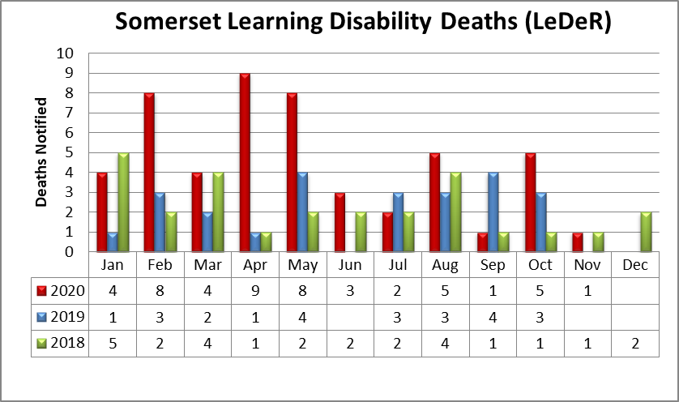

Somerset Foundation Trust
Somerset Foundation Trust is working with the CCG to identify those who are vulnerable to Covid-19 and additional data has been gathered. This confirms an increase in the main cause of death recorded as a respiratory issue such as pneumonia in the table below.
Main Cause of Death (LeDeR) | 2020 (Jan-Oct) | 2019
Aspiration Pneumonia | 18% | 12%
Pneumonia | 12% | 20%
Chest/Respiratory Infection | 4% | 0%
COVID-19 Suspected/Confirmed | 8% | 0%
Total % | 42% | 32%

Respiratory related deaths | 2020 (Jan-Oct) | 2019
Main cause (1a) | 22 | 10
Contributing (1b,c) | 4 | 1

Somerset Foundation Trust Learning Disability services are using data to identify those most vulnerable and are planning to give additional focussed support for people during winter and the pandemic.
Referrals to the LD Specialist Health Team can be of great benefit to improving outcomes for patients who need additional care and support. Referrals can be made using the referral form on e-Templates a copy of the updated form can be found attached. There is also a Learning Disability Register Inclusion tool to support GP in identifying a person in this vulnerable group.

NHS report
LeDeR Action from Learning: deaths of people with a learning disability from COVID-19
This report, which you are likely familiar with outlines actions the NHS is putting in place across the system to maximise learning.
One area of focus asks GP practices across England to use their clinical judgement to determine who, on their GP register, should be considered at a higher risk of serious illness from COVID-19 and to take appropriate action to advise those individuals and their carers (as appropriate) of the need to take additional precautions.
Risk of diagnostic overshadowing is highlighted, as the presentation of people with a learning disability with COVID-19, or another condition which causes health to rapidly deteriorate may be different to the general population, considering this will help ensure opportunities are not missed in provision of appropriate and timely health care.

Annual Health Checks in Somerset
Recently the CCG circulated a suite of documents including a guide for practices on Annual Health Checks.
The LeDeR report on deaths highlights the importance of Annual Health Checks, which we are emphasising again. Recommendations from the report include the following:
‘Annual health check needs to note all health issues and their management and be linked to a health action plan'.
‘Ensure that GP practices use correct coding for patients with learning disabilities to ensure they are on the practice Learning Disability register and can therefore be easily identified’.

We hope the information and data provided here along with the previous guidance will assist you in prioritising people with learning disabilities who are most vulnerable to Covid-19 and ensure that an Annual Health Check is completed to further identify needs and consider any additional support that is required.

References:
PHE report https://www.gov.uk/government/publications/covid-19-deaths-of-people-with-learning-disabilities
LeDeR report http://www.bristol.ac.uk/sps/leder/news/2020/leder-covid-19-reviews.html
NHS Learning Action From Learning (from LeDeR report) https://www.england.nhs.uk/wp-content/uploads/2020/11/C0843-Covid-LeDeR-report-131120.pdf

