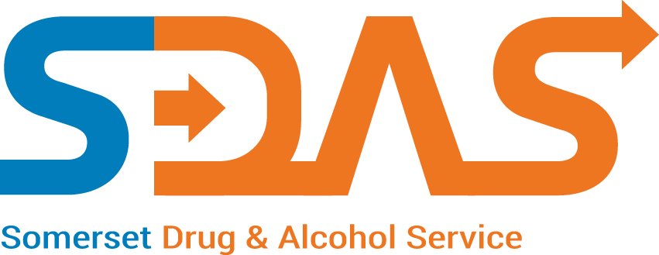
Practice Name _________________________
Shared Care Local Enhanced Service
Payment Claim Form
2018/2019
Name of person
Completing form ___________________________
Months
Claiming for _________________________

  - Start date means the first appointment with either the specialist drugs worker or GP after agreement has been reached with all parties including the patient to pursue this form of treatment
** Hep C data – please enter date only

Patient Initials | Date of Birth | Input date |  | See Key and input code |  |  | Input date |  | Name of Specialist Drugs Worker i.e. Shared Care Nurse only
 |  | Start date (dd/mm/yy) of  shared care treatment | Finish date (dd/mm/yy) of shared care treatment or ‘ongoing’ if appropriate | Treatment Outcome  (A-D) | Hep B  Intervention status  (A-D) | Hep B  Vaccination count  (1-3 or C) |  | Hep C latest test date (dd/mm/yy)**
Key:
Treatment Outcome | A – Treatment complete and planned goals met  B – Treatment complete and planned goals not met  C – Treatment terminated and patient referred on  D – Unplanned treatment termination | Hep B Intervention status | A – Offered and accepted  B – Offered and refused  C – Immunised already  D – Not offered | Hep B vaccination count | 1 – One vaccination  2 – Two vaccinations  3 – Three Vaccinations  C – Course completed

Please complete and return to: Shared Care Payments, SDAS, Bridge House, 30 Taunton Road, Bridgwater, TA6 3LS or email to: Julie.barnard@turning-point.co.uk

